

University of Bolton

|  |  |
| --- | --- |
| **Student Name** | Thomas Plumpton |
| **Student Number** | 1500936 |
| **Student Email** | TP2AMT@Bolton.ac.uk |

|  |  |
| --- | --- |
| **Programme** | Computing |
| **Module Code** | CPU6001 |
| **Module Title** | Major Project |
| **Assignment Title** | Final Report Dissertation |
| **Date of Submission** | Thursday 3rd May 2018 |
| **Word Count** | 28998 |

|  |  |
| --- | --- |
| **Tutor Name** | Amanda Dewhurst |
| **Project Supervisor** | Abdul Razak |
| **Project Title** | Analysing the Random Nature of Social Media |

# Abstract

Randomness is used in a myriad of industries including; video games; politics; science; cryptography and more. It is important to continuously alter the method in which randomness is generated to make it harder to predict. This project studies the randomness of the social media platform ‘Twitter’, by producing a random number generator from the Tweets of several different users. Tweets are used to produce values that control the AI (Artificial Intelligence) of Robots in the programming game ‘Robocode’ in order to determine the random nature of these values. The project aims to understand the difference between pseudo and truly random number generation and gain a greater appreciation of the applications of randomness in real world industries. This report describes the concept of a new method of generating random numbers using the aforementioned sources and stimuli.

This study employs the use of several technical elements, the majority of which are programming orientated. Java SE 9 with Twitter API integration is used to download and parse the Tweets, control the robots’ AI and store the data in the cluster. Several web technologies, including the MEAN Stack (MongoDB, ExpressJS, AngularJS, NodeJS) are used alongside Mike Bostock’s D3.JS Data Visualisation library. Additionally, statistical mathematical techniques such as linear regression, standard deviation and quartiles are used during the analysis to determine the random nature of the collected data.

In this report I have documented background research that was conducted before development had started and research that was discovered during the project itself. Furthermore, each stage of the projects agile process is documented. Including; approach & methodology, analysis & design, program development, testing, evaluation and conclusion.

The ultimate conclusion of this project is that the numbers produced from the data are pseudo-random. The mathematical analysis displayed clear signs of trend and correlation in the data which was deemed to be caused by both the bias is the frequency of character usage in the English language, and calculation of score in Robocode. Although the data did display some form of visual sparsity within the range of score data, the numbers generated were still considered pseudo-random due to their correlation, trends and deterministic nature.

# Acknowledgements

My final year at University has been the most challenging of the three. I may have written more reports and conducted more research during this seven months than I have in the entirety of my life. I worked very hard on this project and invested a lot of time. However, I would like to reflect on the people whole supported me throughout this time as they helped me greatly.

First a foremost, I’d like to thank my project supervisor, Abdul Razak. He was tasked with the responsibility of overseeing my Major Project development throughout the final year. We agreed on weekly one-to-one meetings to regularly assess the development of the project. He provided useful information and advice and was always very response to emails.

Next, I would also like to thank Andrew Parker, my Software Engineering & Advanced Databases lecturer. During the final semester of the second year, we started thinking of ideas for our Major Project. I had a few in mind, but wanted something unique, instead of a mobile app or a website like most. Given his past experience working at IBM and with Java, he mentioned a programming game called Robocode. Vinesh Mistry, a fellow student and friend, also mentioned controlling the game with an external influence like Twitter. This idea formed the catalyst of my project which I then took into my own hands.

Additionally, I have to send my regards to Flemming N. Larsen, one of the original contributors to the source code of Robocode. He took the time to respond to my forum correspondence, answer my questions, and take a look into my code to solve a problem that could have been detrimental to the project if it had not been resolved. Flemming was kind enough to release a patch for the game that helped me overcome the obstacle.

Finally, I would like to thank all my tutors and University peers as a collective. They are always happy to meet up and discuss any information or issues I may have. Furthermore, not only were all able to support one another with our work, but we could also talk about things other than just our assignments.

Thank you very much, everyone!

Thomas Plumpton

December 30, 2017.

Table of Contents

Abstract 2

Acknowledgements 3

Table of Figures 7

Formatting Key 9

External Resource References 9

[1] Introduction 10

[1.1] Overview 10

[1.2] Report Structure 10

[1.3] Objectives 11

[2] Background Research 12

[2.1] Twitter 12

[2.1.1] Twitter API & Rate Limiting 12

[2.1.2] Importance of Sample Size 13

[2.1.3] Frequency of Letters in the English Language 13

[2.2.2] Emoticons, Emoji & Fitzpatrick Modifiers 14

[2.3] Robocode 15

[2.3.1] Game Physics, Coordinates & Directional Systems 15

[2.3.2] Anatomy of a Robot 16

[2.3.3] Robocode Processing Loop 17

[2.3.4] Creating My Own Robot 17

[2.3.5] Robots vs Advanced Robots 18

[2.4] Data Visualisation & NodeJS 19

[2.4.1] Past Experience 19

[2.4.2] Model, View, Controller Architecture 19

[2.5] Mathematics of Randomness 19

[2.5.1] Linear Regression 19

[2.5.2] Standard Deviation & Variance 20

[3] Approach & Methodology 21

[3.1] Agile Software Development 21

[4] Analysis & Design 21

[4.1] Twitter 21

[4.1.1] Java Standard Edition 21

[4.1.2] Association, Aggregation & Composition 22

[4.1.3] Single Responsibility Principle (SRP) 23

[4.1.4] Formatting & Sanitisation of Tweets 23

[4.1.5] Java Documentation (Javadoc) 25

[4.1.6] Final Twitter Package UML Class Diagram 26

[4.2] Robocode 27

[4.2.1] Parsing Tweets from the TweetReader 27

[4.2.2] Battle Results Data Structure 28

[4.2.3] Final Robocode Package Class Diagram 31

[4.3] Data Visualisation & NodeJS 32

[4.3.1] MVC Folder Structure 32

[4.3.2] Page Structure 32

[4.4] Mathematical Analysis 33

[4.4.1] JavaScript Functions 33

[5] Program Development 33

[5.1] Twitter 33

[5.1.1] Twitter Authentication & API Connection 33

[5.1.2] Mongo Atlas Cluster Connection & Inserting Documents 35

[5.1.3] Sanitising Tweets 39

[5.1.4] Analysing Tweets 40

[5.1.5] Serialising Tweets 41

[5.1.6] Parsing Tweets 42

[5.2] Robocode 43

[5.2.1] Integrating Robocode with IntelliJ 43

[5.2.2] Creating an Advanced Robot Class 44

[5.2.3] Overcoming Security Exceptions 45

[5.2.4] Controlling the Robots 46

[5.2.5] Utilising the Robocode Engine 48

[5.2.6] Adding a BorderSentry 50

[5.2.7] Automating Battles & Data Collection 51

[5.3] Data Visualisation & NodeJS 52

[5.3.1] Configuring NodeJS & ExpressJS Framework 52

[5.3.2] Automating NodeJS Runtime in JetBrains WebStorm 54

[5.3.3] Creating the Page & Integrating D3.JS 55

[5.3.4] Twitter Analysis Overview 56

[5.3.5] Scatter Plot & Simple Linear Regression (JavaScript) 57

[5.4] Mathematical Analysis 58

[5.4.1] Calculating the Regression of Least Squares 59

[5.4.2] Calculating Standard Deviation & Variance 60

[5.4.3] Calculating Score Quartiles 61

[6] Testing Phase 61

[6.1] Twitter 62

[6.1.1] Accessing the MongoDB Atlas Cluster 62

[6.1.2] Committing Twitter Status Objects to the MongoDB Atlas Cluster 62

[6.1.3] Sanitising Tweets 63

[6.2] Robocode 64

[6.2.1] Adding Custom Robots to Robocode 64

[6.2.2] Robot Controller Random Values 64

[6.3] NodeJS Web Application 65

[6.3.1] Website Loading Performance 65

[6.3.2] SSL Certificate & HTTPS 70

[6.4] Mathematical Analysis 71

[6.4.1] Validating the Regression Line 71

[7] Results 71

[7.1] Tweets Collected 71

[7.2] Data Visualisation 72

[7.3] Statistical & Mathematical Data 73

[8] Evaluation 74

[8.1] Tweet Analysis 74

[8.1.1] Frequency of Characters 74

[8.1.2] Twitter Users 75

[8.2] Scatter Plot Diagram 76

[8.2.1] Visual Analysis 76

[8.2.2] Regression of Least Squares 79

[8.2.3] Data Sample Size 80

[8.2.4] Median, Range & Quartiles 80

[8.2.5] Standard Deviation & Variance 81

[8.3] Robocode Vs JavaScript Random 81

[9] Conclusion 81

[10] Reflection 82

[10.1] Issues & Limitations 82

[10.2] The Positives 83

[10.3] What Have I Learnt? 83

[10.4] What Would I Improve/Change? 84

[11] Glossary of Terms 85

[12] Bibliography 86

[13] Appendices 93

[13.1] Terms of Reference 93

[13.2] Literature Review 95

[13.3] What is Twitch? 110

[13.4] What is Robocode? 110

[13.5] What is Twitch Plays Pokémon? 111

# Table of Figures

Figure 1 - Frequency of Letters (Oxford Dictionary vs Tweet Sample) 13

Figure 2 - Emoji Operating System Interpretation 14

Figure 3 - Emoji Usage Statistics (U.S 2016) 15

Figure 4 - Fitzpatrick Skin Phototype Scale 15

Figure 5 - Robocode Directional & Rotational Convention 16

Figure 6 - Robocode Robot Anatomy 16

Figure 7 - Avoiding Firing Pitfall in Robocode Processing Loop 17

Figure 8 - MajorProjectv2 Compile Output Path 18

Figure 9 - Java SE 8 Lambda Expression 22

Figure 10 - Original Twitter Java Program UML 23

Figure 11 - Twitter Tweet JSON Object 24

Figure 12 - Twitter Hexadecimal Byte Sequence Differentiation 24

Figure 13 - Initial Design of Tweet Object Document 25

Figure 14 - Javadoc Example Method 25

Figure 15 - IntelliJ Contextual API Documentation 26

Figure 16 - Java Program Twitter Package Class Diagram 27

Figure 17 - Robocode Results Data Structure Example 29

Figure 18 - Java Program Robocode Package Class Diagram 31

Figure 19 - Adding Twitter4J .JAR to IntelliJ Project 33

Figure 20 - Java External Library Import Statements 34

Figure 21 - Twitter Developer Application Access Tokens 34

Figure 22 - Twitter ConfigurationBuilder Method 35

Figure 23 - MongoDB Atlas Cluster 36

Figure 24 - Asynchronous CompletableFuture Method 37

Figure 25 - Private Visibility MongoConnection Member 37

Figure 26 - User Defined MongoConnection Class 38

Figure 27 - MongoDB Compass Collection with 6400 Tweets Inserted 39

Figure 28 - TweetSanitiser Class Snippet 40

Figure 29 - TweetAnalyser Class Console Output 41

Figure 30 - TweetAnalyser Class saveToDatabase() method 41

Figure 31 - TweetSerialiser serialseTweets() method 42

Figure 32 - TweetParser Class 42

Figure 33 - Start Robocode Application Run Configuration 43

Figure 34 - TwitterRobot Class with Default Template 44

Figure 35 - IntelliJ Project Structure Pane 45

Figure 36 - Adding TwitterRobot's to Battle 45

Figure 37 - Robocode Security Manager Destroying Robots 46

Figure 38 - Robocode Security Manager Logging Violation 46

Figure 39 - RobotController Class Members (Robot Values) 47

Figure 40 - RobotController randomiseValues() Pseudo Code 47

Figure 41 - RobotController Setting Fire Power 47

Figure 42 - RobotController Create Double Method 48

Figure 43 - GameConfigurer BattleSpecification Constants 49

Figure 44 - GameConfigurer Robocode Engine Configuration 49

Figure 45 - GameConfigurer Battle Specification Setup 49

Figure 46 - Game Configurer Serialise Robot Tweets 50

Figure 47 - GameConfigurer Start Battle 50

Figure 48 - TwitterSentry (BorderGuard) in Battle 51

Figure 49 - Windows Batch Script - Automating Data Collection 51

Figure 50 - MongoCompass Robocode Results 52

Figure 51 - Configuring HTTP Server in NodeJS 52

Figure 52 - Installing ExpressJS Framework via NPM Command Line 53

Figure 53 - Configuring Middleware Stack & Page Routing in NodeJS 53

Figure 54 - NodeJS package.json file contents 54

Figure 55 - Running NodeJS Application from NPM Command Line 54

Figure 56 - JetBrains WebStorm NodeJS Application Run Configuration 55

Figure 57 - Running NodeJS Application from WebStorm 55

Figure 58 - D3.JS Script Tag 56

Figure 59 - Web Application GET Request with Database Access 56

Figure 60 - Character Analysis POST Request 56

Figure 61 - Web Application Statistical Analysis Overview 57

Figure 62 - simpleLinearRegression.js Scatter Graph Variables 57

Figure 63 - simpleLinearRegression.js renderSimpleLinearRegression(data) 58

Figure 64 - simpleLinearRegression.js calcLinear() 59

Figure 65 - Calculating Standard Deviation in JavaScript 60

Figure 66 - Testing with MongoConnection Main Method 62

Figure 67 - MongoDB Compass Test Document 62

Figure 68 – MongoDB Compass Displaying 19200 Documents 63

Figure 69 - TweetSanitiser JUnit Test Method - downloadTweets() 63

Figure 70 - TweetSanitiser JUnit Test Pass 64

Figure 71 - TweetSanitiser JUnit Test Fail 64

Figure 72 - RobotController JUnit Tests Passing 65

Figure 73 - RobotController JUnit Console Print 65

Figure 74 - Pingdom.com Summary 66

Figure 75 - Nginx Content Expiry Map 66

Figure 76 - Pingdom.com Performance Insights 67

Figure 77 - Pingdom.com Content Size & Content Type 67

Figure 78 - Pingdom.com Content Size & Requests by Domain 67

Figure 79 - Pingdom.com Network Performance Waterfall 68

Figure 80 - Adobe Photoshop CC 2018 Save for Web Tool 69

Figure 81 - Google Chrome Dev Tool - Network Performance 70

Figure 82 - Nginx Reverse Proxy Service Configuration Testing 70

Figure 83 - Mozilla Firefox HTTPS recognition 71

Figure 84 - Google Chrome HTTPS recognition 71

Figure 85 - Safari (iOS) HTTPS recognition 71

Figure 86 - Tweet Statistics Overview 71

Figure 87 - Overview of MongoDB Atlas Collections 72

Figure 88 - Frequency of Characters Results 72

Figure 89 - Robocode Battle Data Results 73

Figure 90 - Battle Statistics Results 73

Figure 91 - Statistical Analysis Results 74

Figure 92 - Tweet Character Frequency Bar Chart (Sorted Descending) 75

Figure 93 - Twitter User Analysis (CNN) 75

Figure 94 - Twitter User Analysis (Ed Byrne) 76

Figure 95 - Robocode Battle Data Statistics 76

Figure 96 – Scatter Plot Graph (96 Battles) 77

Figure 97 - Scatter Plot Graph (700 Battles) 77

Figure 98 - Scatter Plot Graph (700 Battles Zoomed) 78

Figure 99 - Scatter Plot Graph (1110 Battles) 78

Figure 100 - Scatter Plot Graph (1381 Battles) 79

Figure 101 - Simple Linear Regression (All Battles) 79

Figure 102 - Robocode Score Data (Scores & Quartiles) 80

Figure 103 - Robocode Score Data (Standard Deviation & Variance) 81

# Formatting Key

|  |  |
| --- | --- |
| **Bold Purple** | Referencing method signatures from the project source code |
| Underlined Blue | Hyperlinks to chapters or sections in this report. Ctrl + Click to use |
| [X] 16pt Calibri | The largest blue headings preceded by numbers are main chapters |
| [X.Y] 13pt Calibri | The smaller blue headings are sub-chapters of the main ones |
| [X.Y.Z] 12pt Calibri | The smallest blue headings are detailed sub-chapters of the above |
| Black Bold | These are sub-chapter headings. Not displayed in the contents |

# External Resource References

****Data Driven Documents (D3) JavaScript Library****

<https://github.com/d3/d3>

****Easy Pie Charts JavaScript Library****

<https://github.com/rendro/easy-pie-chart>

PugJS Template Engine

<https://github.com/pugjs/pug>

Twitter4J Java Library

<https://github.com/yusuke/twitter4j>

MongoDB Java Driver Library

<https://github.com/mongodb/mongo-java-driver>

Emoji Java Library

<https://github.com/vdurmont/emoji-java>

Robocode Programming Game

<https://github.com/robo-code/robocode>

Live NodeJS Web Application

<https://www.major-project.tomplumpton.me>

JetBrains Software Development Suite

<https://www.jetbrains.com/>

# [1] Introduction

## [1.1] Overview

Randomness is a mathematical concept that is commonly misunderstood. Computer-generated random numbers are not *truly* random, they are actually *pseudo*-random. This means that although they appear to be random, they are really pre-determined. Pseudo-Random Number Generation (PRNG) is efficient and deterministic, however, these are not desirable attributes in scenarios that require True-Random Number Generation (TRNG). Such scenarios include the generation of data encryption keys and cryptography or simulation of natural phenomena like weather.

This project aims to analyse and determine the random nature of the social media platform ‘Twitter’ by parsing Tweets and using them to control the robot AI in a programming game called ‘Robocode’. The data produced will be analysed to determine whether it is pseudo or truly random in an attempt to create a new method of generating truly random numbers. The inspiration for this project originates from a social experiment called ‘Twitch Play Pokémon’.

## [1.2] Report Structure

This report is structured into several logical chapters of which contain their own sub-sections. The main chapters document the entire process of the project in chronological order. However, the major sections of Background Research, Analysis & Design, Program Development and Testing are split up into 4 sub-chapters each. These sub-chapters correspond to one of 4 major phases of the agile development and did not occur in the order shown. The 4 phases are Twitter, Robocode Programming Game, Data Visualisation & NodeJS and Mathematics of Randomness. Below are short explanations of what to expect from each main chapter.

Introduction

The current chapter. It provides a descriptive overview of the project, the structure of the report and the objectives of the project.

Background Research

This chapter documents additional research that was carried during the project as new elements were discovered or as further knowledge was required. The initial background research that was carried out prior to the project is documented in the Literature Review.

Approach & Methodology

The third chapter describes the approach that I took to the project and the methodologies used for development. Nothing has changed from the original research into the use of agile development methodologies that was carried out in the Literature Review.

Analysis & Design

This chapter documents the design phase of the project involving data structures, Java standards, object-orientated programming concepts and principles, program design and any other plans for design and analysis.

Program Development

This chapter is one of the largest as it documents the program development stage of the project. This includes the development of the Java code for accessing the Twitter API and downloading Tweets; saving the Tweets to the database and serialising them to local storage; parsing the Tweet characters and producing numbers; controlling the robots with these values and storing the Robocode results in the database.

It also documents the development of the web application in NodeJS and creating the data visualisations in JavaScript with the D3.JS library. Also, the statistical analysis programming for standard deviation, variance and quartiles is described here too.

Testing

The sixth chapter describes and illustrates the testing phases that occurred at the end of each agile sprint. Such testing includes manual testing, Junit testing and performance testing.

Results

The seventh chapter simply displays the results of the project. This includes the Tweets that were collected from Twitter and stored in a MongoDB Atlas Cluster. It shows the results that were output from the Robocode battles and stored in the same cluster. Finally, it shows the results of the mathematical and statistical analysis from the JavaScript code in the web application.

Evaluation

The eighth chapter of this report evaluates the results from the previous chapter. The Tweets are evaluated here with regards to the bias or skew that they provide. It also discusses the meaning of the data and interprets the data to form possible conclusions.

Conclusion

The ninth chapter concludes the project and comes to a decision regarding the random nature of the values produced by the robot battle results.

## [1.3] Objectives

Differentiating Pseudo-Random vs Truly-Random

One of the project objectives is to understand the difference between pseudo and true random numbers. This knowledge is crucial as it will ultimately determine the conclusion of the project that is made following the evaluation of the results.

Create a Random Number Generator

This is the major part of the project. The goal is write a Java program that interfaces with both the Twitter API and the Robocode Game Engine. It should be able to take Tweets as input, parse the characters of the string into values, program the AI of the robots to take action and battle to produce data for the results.

Visualise & Analyse Data

Another major section of the project is the data visualisation and mathematical analysis of the collected data. The goal here is create a web application in NodeJS, access the data from the MongoDB Atlas Cluster and use the D3.JS library to graphically visualise the results from Robocode. Both a visual and statistical analysis needs to be performed in order to form a conclusion.

Form a Conclusion

The final, seemingly obvious section is the conclusion. The decision of whether or not the data is pseudo or truly random. Subject to the results of the project, this decision will either be very easy or very difficult to make. If the data shows any obvious trends or correlation, it will be deemed pseudo-random. However, if the data appear sparse and without patterns, further analysis will need to be conducted in order to make a decision.

# [2] Background Research

This section documents research that was conducted either at the outset, or during development as new information was discovered. A large quantity of this research was done prior to the project start date and is documented in the Terms of Reference. However, only a certain degree of research could have been conducted at that point in the project and so this chapter is a continuation of that research during the project.

## [2.1] Twitter

Twitter Inc. provide developer access to their API which allows registered developers to write server-side scripts that interact with the Twitter platform and access data. Research has shown some limitations and constraints set by Twitter Inc and raises other considerations as a result.

### [2.1.1] Twitter API & Rate Limiting

The Twitter API has a restriction called ‘Rate Limiting’. Each user has an access token that allows them to request data from the API. These tokens have 15 requests using the HTTP GET protocol in a 15-minute rate limit window. (Twitter, 2017) Furthermore, this particular method only allows a maximum of 3200 status objects to be returned per API call. Therefore, assuming every Twitter account used has a posted at least 3200 tweets, a maximum of 48,000 (15 x 3200) Tweets can downloaded per 15 minutes.

To overcome the obstacle of rate limiting, the official Twitter documentation suggests methods such as streaming or caching. ‘Caching’ is the process of temporarily storing data locally to a system, so that a website or application doesn’t need to download resources or assets each time it accessed. Caching increases the speed and efficiency of the application as it can access the locally stored data (Bell, 2017). Whereas, the Streaming API, also provided by Twitter Inc., has rate limiting and access levels that are appropriate for long-lived connections. (TwitterInc., 2018)

Given the mathematical nature of the project, a large dataset is desired in order to ensure the accuracy of the data for the analysis

### [2.1.2] Importance of Sample Size

Sample size is important as it can determine the reliability and margin of error produced by the study. If the size is small, a larger sample size is required otherwise the effect will be masked by the randomness of the samples. Conversely, a larger sample size provides more reliable results with greater precision. Therefore, the more Tweets that can be downloaded and parsed and the more Robocode battles that can be simulated, the more reliable the data produced will be. (Anon., 2017)

Furthermore, due to an increase in the accuracy of the data, database analysis will be a lot more reliable. This includes producing statistics such as the average Tweets’ length, usage of emoji and frequency of letters used. This information will taken into account during the analysis and evaluation as it can tell us a lot about the skew or bias that the data produces.

### [2.1.3] Frequency of Letters in the English Language

One factor that immediately comes to mind with regards to the random nature of this project is

the alphabet of the language used. The problem is that the frequency distribution of letters introduces a bias into the system. The graph below shows the relative frequency of letters used from two sources. The first is from the Concise Oxford Dictionary and you can see that the vowels are some of the highest, where other letters such as J, X and Z are not used even half as much. (Anon., n.d.) The second source is sampled from 13,200 downloaded Tweets from different Twitter accounts. We can see that there is some deviation from all the words in the dictionary, but nonetheless, there is still a very similar distribution.

Figure 1 - Frequency of Letters (Oxford Dictionary vs Tweet Sample)

This was considered at the outset of the project and is the reason why Robocode was introduced into the system. By parsing the characters in the tweets, the behaviour of the robot and results of the match is what will be analysed to determine the random nature. Technically, a higher frequency of one character will mean a higher frequency of parsing on the character. But the algorithm used to randomise the values of the robot parameters will be designed in such a way to reduce the amount of bias as much as possible. This analysis will be conducted again at the end of the project when the Tweet sample size is much greater.

### [2.2.2] Emoticons, Emoji & Fitzpatrick Modifiers

Emoticons are typographic displays of facial representation that are used to convey emotion in a text only medium. For example, a basic smiley face “:)”. Unlike emoticons, emoji are actual pictures displayed in-line with a message, typically used on social media. Emoji are extensions to the Unicode character set that is used by most operating systems. Given that each emoji has its own Unicode value, each operating system interprets and displays the emoji differently. For example, the figure below shows the dancer emoji and how various operating systems and platforms interpret the code. (Hern, 2015)

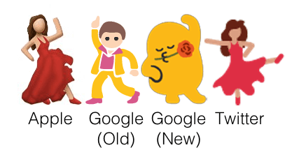

Figure 2 - Emoji Operating System Interpretation

The usage of emoji has drastically increased over the last few years. Roughly 92% of the online population uses them and brands have also standard incorporating them into marketing. According to Swyft Media, in the U.S in 2016, 41.5 billion messages and 6 billion emoji were sent every day on mobile messaging apps. Nearly half of all Instagram posts contain at least one emoji, and Facebook has change it’s ‘reactions’ feature to emoji. Research from the Emogi’s Emoji Report showed that 63 percent of people are use emojis frequently, 29 percent are occasional users, and 8 percent don’t use them at all. (Dua, 2016) (Emogi, 2016)

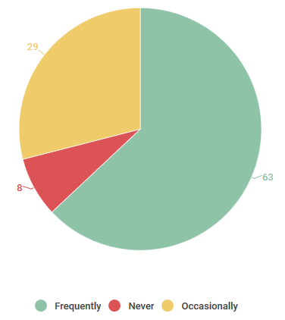

Figure 3 - Emoji Usage Statistics (U.S 2016)

There are in total, 2,666 emojis in the Unicode Standard as of June 2017. This number has increased due to the introduction of the Fitzpatrick Scale of skin tones. Due to ethnic and cultural issues surrounding emojis, human or body orientated emojis have received updated version that add various colours of skin tone from the Fitzpatrick Scale. (Emojipedia, 2018)

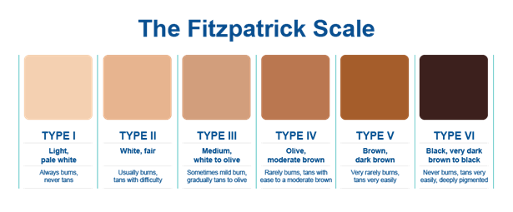

Figure 4 - Fitzpatrick Skin Phototype Scale

Due to this surge of emoji usage, a lot of Tweets downloaded for this project will have emoji in their text element, subject to the Twitter user. This adds a huge level of complexity to the structure of the Tweets as the text element would need to be queried for Unicode symbols and then cross-referenced across a library of Unicode emoji to detect which image they should portray.

## [2.3] Robocode

### [2.3.1] Game Physics, Coordinates & Directional Systems

Robocode uses the Cartesian coordinate system, which means that that the (0, 0) coordinate is located at the bottom-left corner of the battlefield. The rotational directional system uses a clockwise direction convention where 0°/360° is North, 90° is East, 180° is South, and 270° is West. The figure below illustrates the information.

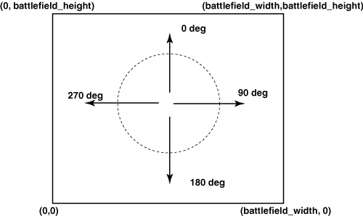

Figure 5 - Robocode Directional & Rotational Convention

Robocode time is measured in "ticks". Each robot gets one turn per tick. Regarding distance measurement, Robocode's distance units are measured with double precision, so you can move a fraction of a unit. Generally, 1 Robocode distance unit is one pixel, except when Robocode automatically scales down battles to fit on the screen. Acceleration is measured at the rate of one pixel per turn, every turn. Robots decelerate at the rate of two pixels per turn, every turn. The game itself determines the acceleration based on the distance the robot is trying to move. Velocity is measured as ($acceleration × time$). Velocity cannot exceed eight pixels per turn. Given that velocity is a vector, meaning it has both magnitude and direction, Robocode simply assumes the direction of the vector to be the robot’s heading. Distance is again based off real physics using ($velocity × time$). (Robowiki, 2017)

### [2.3.2] Anatomy of a Robot

Robocode robots consist of three individual parts. The body, which carries the gun with the radar on top. The body is used for moving the robot back and forth, as well as turning left or right. The gun, which is mounted on the body and is used for firing energy bullets. The gun can turn left or right and carries the radar on top. Finally, the radar, which is mounted on the gun, is used to scan for other robots when moved. It can turn left or right and generates **onScannedRobot()** events when robots are detected. The developer can tell the robot to execute code upon this event firing. (Robowiki, 2017)

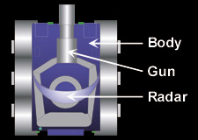

Figure 6 - Robocode Robot Anatomy

### [2.3.3] Robocode Processing Loop

Robocode runs a series of consecutive processing actions, indefinitely, in a loop until the match is over. It is important to understand how this loop works in order to integrate my own programs code with Robocode. The order that Robocode runs is as follows:

1. The battle view is (re)painted.
2. All robots execute their code until they take action (and are then paused).
3. Time is updated (time increments by one).
4. All bullets move (including the bullet fired in the last tick) and are checked for collisions.
5. All robots move (Gun, Radar, Heading, Acceleration, Velocity, Distance, in that order. Gun heat is also decreased in this step).
6. All robots perform scans (and collect team messages).
7. All robots are resumed to take new action.
8. Each robot processes its event queue.

One problem with this loop is that because bullets are fired before the gun is moved, calling **setFire()** will cause the bullet to leave the gun at its current heading. For most of the time, this error will be negligible, but it can nonetheless affect robot accuracy. The Robocode wiki provides an example code structure on how to get the bullet to leave after turning the gun. (Robowiki, 2017)



Figure 7 - Avoiding Firing Pitfall in Robocode Processing Loop

### [2.3.4] Creating My Own Robot

Normally, when creating your own robot in Robocode, you would use either the built-in editor, or an IDE of your choice to write the code that dictates how the robot acts in certain situations. You would declare a new class, extend either the Robot or AdvancedRobot class and add a **run()** method that loops and executes every game tick.

However, because Robocode simply accepts a .class file inside the ‘robots’ directory of the source file root, it makes it very difficult to develop the specific custom functionality for this project. Robocode handles the compilation of the class into a .java file and then manages the robots itself. This means that when writing my TwitterRobot class, the one that will be used with random values from Twitter, I must consider that an Object of that class can never be instantiated in my code. This prevents me from invoking both accessor and mutator methods upon the TwitterBot Objects, as it would never *really* exist from the developers’ point of view. This adds a huge layer of academic challenge to the project as it strips away a lot of the core features and benefits of using an object-orientated programming language such as Java.

To overcome the .class file directory problem, I copied the entire Robocode source file master repository into my IntelliJ project and then set the project ‘production out’ directory to ‘robocode_master/robots’ so that upon building the project, IntelliJ would put the .class files from my project source into the correct ‘robots’ folder so Robocode can see them.

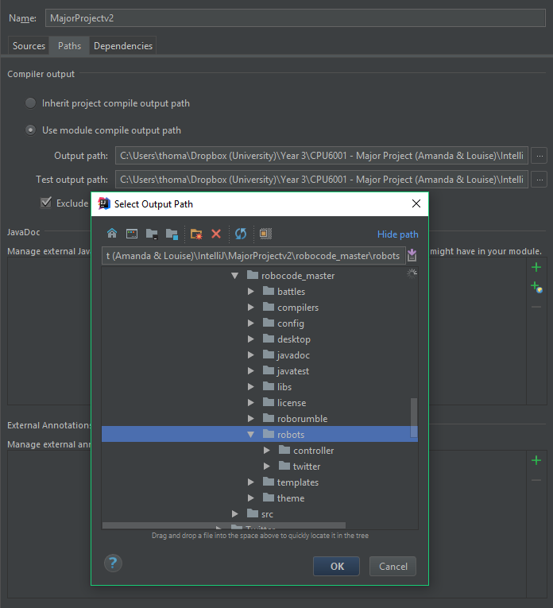

Figure 8 - MajorProjectv2 Compile Output Path

### [2.3.5] Robots vs Advanced Robots

The Robocode API provides two classes which can be extended by user created Robot classes. These are ‘Robot’ and ‘AdvancedRobot’. How do they differ?

Robot Class

The standard ‘Robot’ class allows only one action per turn. It cannot access the **setXXX()** methods. For example, a class inheriting from the Robot class can only call **fire()**, not **setFire()**. (Robowiki, 2017)

AdvancedRobot Class

The more complex ‘AdvancedRobot’ class allows multiple actions per turn. It also has the ability to call **setXXX()** methods. These types of methods end the turn when you call them and block the robot’s thread until the command finishes. This class also implements several interfaces that extend the AdvancedRobots functionality even more, making it a lot more versatile than the regular Robot interface. However, there are no significant advantages on the battlefield, these classes simply change the development of the robot. You can view the AdvancedRobot Class Documentation at the API [here](http://robocode.sourceforge.net/docs/robocode/robocode/AdvancedRobot.html). (Mathew Nelson, 2017)

## [2.4] Data Visualisation & NodeJS

### [2.4.1] Past Experience

I have had lots of prior experience with NodeJS and the MEAN Stack in general. The MEAN Stack is a collection of JavaScript technologies including MongoDB, ExpressJS, AngularJS and NodeJS. MongoDB is a document-based database program that uses the document model opposed to the traditional relational model. ExpressJS is a framework built for NodeJS, designed for building web applications. AngularJS is a JavaScript library used for front-end development, primarily used to address many of the challenges encountered when developing single-page applications. Finally, NodeJS is a runtime environment built upon Google Chromes’ V8 JavaScript engine that executes JavaScript code on the server-side.

I deliberately chose this stack of technologies for this part of the project as I was familiar with it. I felt that the rest of the project provided more than enough academic challenge and that picking something entirely new for this part would ultimately be detrimental to the project as it would require me to learn an entire stack of technologies. There were, however, some new NPM (Node Package Manager) packages that I needed to use that I had no previous experience with.

### [2.4.2] Model, View, Controller Architecture

MVC, or Model-View-Controller is an architecture model used in software engineering and programming. It splits the contents of an application into the three categories. Models represent knowledge, usually via an object or a structure of objects. There should be a one-to-one correspondence between the models’ parts, and how that object would be perceived by the owner in the real world. A view is a visual representation of its model. A view queries its model for the necessary data required for presentation and may update it by sending appropriate messages. Finally, a controller is the link between a user and the system. It provides them with an input by arranging relevant views in such a way that it provides means for user output. This is usually done via menus, buttons and other means of giving commands and data. The controller receives user output and translates it into the appropriate messages for the views. (Atwood, 2008)

## [2.5] Mathematics of Randomness

### [2.5.1] Linear Regression

Linear regression is a basic and commonly used type of predictive analysis. It aims to examine two things; does a set of predictor variables do a good job in predicting an outcome? And which variables in particular are significant predictors of the outcome variable and I what way do they impact the outcome variable? The three major uses for regression analysis are;

* Determining the Strength of Predictors
* Forecasting an Effect
* Trend Forecasting

There are also several types of linear regression that involve different numbers of independent and dependent variables. An independent variable is one that constantly changes throughout the experiment. Whereas, the dependent variable is the one that is measured and tested against the independent variable. Some examples of linear regression analyses are;

Simple Linear Regression

1 Dependent Variable (Interval or Ratio), 1 Independent Variable (Interval or Ratio or Dichotomous)

Multiple Linear Regression

1 Dependent Variable (Interval or Ratio), 2+ Independent Variable(s) (Interval or Ratio or Dichotomous)

Logistic Regression

1 Dependent Variable (Dichotomous), 2+ Independent Variable(s) (Interval or Ratio or Dichotomous)

Ordinal Regression

1 Dependent Variable (Ordinal), 1+ Independent Variable(s) (Nominal or Dichotomous)

Multinomial Regression

1 Dependent Variable (Nominal), 1+ Independent Variable(s) (Interval or Ratio or Dichotomous)

(Solutions, 2013)

The simplest form of regression, in the form of a mathematical equation, with one dependent and one independent variable is defined as;

$$y=c+bx$$

Where $y$ is the estimated dependent variable score, $c$ is the constant, $b$ is the regression coefficient and $x$ is the score on the independent variable. I will be using simple linear regression (regression of least squares) as a starting point for the statistical analysis of the project results. If there is still time towards the end of the project, further and more comprehensive analysis will be conducted.

### [2.5.2] Standard Deviation & Variance

Another relevant statistical technique useful for this project is standard deviation and variance. Standard deviation is simply defined as the measure of how spread out numbers are. It is denoted by the Greek letter Sigma ($σ)$. Variance is defined as the average of the squared differences from the mean. The formula, therefore, is simply the square root of the variance. This means that variance is denoted by sigma squared ($σ^{2})$. The mathematical equations for standard deviation and variance are shown below respectively from left to right.

$σ= \sqrt{\frac{Σ{\left|x- \overline{x}\right|}^{2}}{n}}$ $σ^{2}= \frac{Σ{\left|x- \overline{x}\right|}^{2}}{n}$

To calculate the variance, you must first calculate the mean (average of all values). Then for each number; subtract the mean; and square the result. Finally, calculate the average of all the squared differences. Then we can square root the variance to get the standard deviation. (MathsIsFun, 2017)

# [3] Approach & Methodology

## [3.1] Agile Software Development

The project was split into 4 major sections in order to make it more manageable and adhere to the chosen ‘Agile’ development methodology. Nothing has changed about my approach from when it was originally documented in the Literature Review. The project was split up into the following four parts;

Twitter

The first section is all about <https://www.twitter.com> as it is the source of control and values to be parsed for the Robocode AI in Java. Functionality is needed in order to access Tweets from given account usernames. The Tweets will then need to be parsed so that Robocode can send instructions to the virtual robots. (Twitter, 2017)

Robocode

The second section involves primarily Robocode. It is the intermediary platform that is fed input from Twitter and provides the output of data for analysis. Research into the workings of Robocode is necessary to understand how the underlying Java code controls the robots. Custom AI functionality that needs to be written in order for the robots to battle one-another using only the values generated from the Tweet parser. (Robocode, 2017)

Data Visualisation & NodeJS

This section involves creates the web application in NodeJS and visualising the data from Robocode in a graphical format, so it can be analysed both visually and mathematically to help form a conclusion. Research into dynamically graphing data with the D3.JS JavaScript library had to be done. (Bostock, 2017)

Mathematical Analysis

The final section is the study of randomness as it is the core element of the project. Understanding the differences between Pseudo-Random Number Generation (PRNG) and Truly-Random Number Generation (TRNG) was crucial, as differentiating between them is a common misconception. Research into further understanding how randomness differs on a mathematical level was required as it was ultimately used to conclude the project. (Haahr, 2017)

# [4] Analysis & Design

This section illustrates the design stages of the project whereby I considered future development and how programs should be designed. There are sub-chapters for each stage in the agile software development process, all of which have their own respective sub-sections.

## [4.1] Twitter

### [4.1.1] Java Standard Edition

Oracle is a global provider of enterprise cloud computing solutions and provides leading-edge capabilities in software, platform, infrastructure and data as a service. (Oracle, 2017) They acquired Sun Microsystems in 2010 along with their Java platform which was original created by James Gosling and released in 1995. The Java platform has evolved over the last 20 years as teams of software engineers have improved and extended the languages functionality. The original JDK Beta, 1.0 and 1.1 were released in 1995-1997. The next release was renamed to J2SE through versions 1.2 to 5.0 in 2004. Finally, the Java SE (Standard Edition) version 6 was released in 2006 and it has been incrementing ever since. Currently, as of writing this report, the latest commercially available and stable version is Java SE 9.

Each SE Version of the language introduced new coding standards, programming syntax and functionality. As software engineering practices and methods evolve, so does the etiquette. To illustrate, Java SE 8 introduced Lambda expressions which is Java’s first step into functional programming. A Java lambda expression is a function that can created without belonging to any class and can therefore be passed around as if it was an object. To illustrate, the following **.addStateListener()** method invocation contains a lambda expression. The expression is matched again the parameter type of the interface that the StateOwner Class implements.



Figure 9 - Java SE 8 Lambda Expression

The hypothetical Interface in the above example has a single method that is called whenever the state of the StateOwner Class changes. Previously, in Java SE 7, you would have to implement the interface and create an event listener with an anonymous interface implementation. The Java compiler is essentially using type inference on the method signature to guess the parameter type. (Jenkov, 2015)

I have adhered the latest Java standards where possible in my Java program.

### [4.1.2] Association, Aggregation & Composition

There are myriad types of relationships in Object-Orientated Programming (OOP) and by extension, Universal Mark-up Language (UML) types. Three commonly associated relationships are Association, Aggregation and Composition. Although technically, aggregation and composition are subsets of association, meaning they are specific cases of association.

Both aggregation and composition refer to a relationship whereby one object has ownership of another class. In the case of aggregation, the child can exist independently from the parent. For example, if the parent was a lecture, and the child was a student. Removing the lecture class would mean the student would still exist. However, in the case of composition, it implies the opposite. The child cannot exist independently without the parent. (VisualParadigm, 2017)

These relationships are important to keep in mind when designing applications. Before any code is written, UML diagrams are drawn up to visualise the structure of the program and decide the fundamental elements such as methods and return types. The following UML diagram represents the early, original program structure I envisioned. However, the design was superseded by a different one when changes were made.

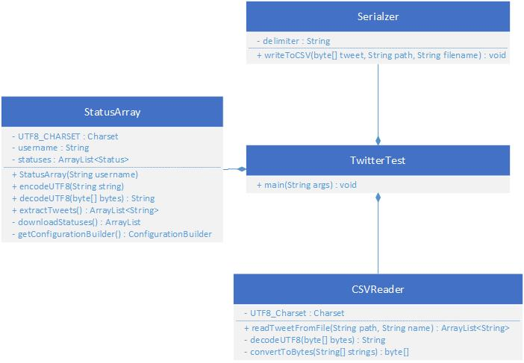

Figure 10 - Original Twitter Java Program UML

You can view the final UML Class Diagram in Chapter 4.2.3.

### [4.1.3] Single Responsibility Principle (SRP)

As discussed in the Literature Review, The Single Responsibility Principle (SRP) is one of the five fundamental S.O.L.I.D Principles. To quote such research;

“The Single Responsibility Principle says that a class should have one and only one reason to change, meaning that a class should only have one job.”

I therefore ensured that each class in the program had only one role. As I regularly revised the codes structure, I re-arranged particular methods and split up classes where possible in order to adhere to the principle. This ensured that my program was modularised so it was easy to work with and refactor as necessary.

### [4.1.4] Formatting & Sanitisation of Tweets

What is a Tweet? By definition, it is the chirp of a small young bird. However, in the context of the social media platform ‘Twitter’, it refers to a post on the microblogging service. Tweets aren’t very long, limited to a maximum of 280 characters. They are short and sweet like the chirp of a bird. (Nations, 2017)

On the surface, Tweets seem relatively simple. However, they aren’t simply just text, they can contain images, videos, geo-location, mentions, re-tweets and polls. Regarding the Tweets’ use-case in this project, the ‘types’ of Tweets aren’t concerning, as the text will be extracted from the Tweet anyway. The problem lies in the myriad of possible characters that could appear in the Tweet itself. Below is an example of a JSON object retrieved from a Twitter users’ timeline. It contains information such as the date posted, the unique id number of the user, and of course, the text element of the Tweet itself. (Nations, 2017)



Figure 11 - Twitter Tweet JSON Object

The ‘text’ property of the object is the element which will be parsed for Robocode to autonomously control its robots. As previously mentioned, the text can contain up to a maximum of 280 characters. However, the definition of a ‘character’ is a somewhat ambiguous. For the vast majority of Tweets, each character is a single byte. Using anything else beyond basic letters, numbers and punctuation, causes things to get a little more complicated. The example below is taken from the Twitter Developer documentation and explains one exception to this rule;

|  |  |  |
| --- | --- | --- |
| **Word** | **UTF-8 Bytes (Hex)** | **Description** |
| café | 0x63 0x61 0x66 0xC3 0xA9 | Using the “é” character, called the “composed character”. |
| café | 0x63 0x61 0x66 0x65 0xCC 0x81 | Using the combining diacritical, which overlaps the “e” |

Figure 12 - Twitter Hexadecimal Byte Sequence Differentiation

The word “café” actually has two byte sequences that look exactly the same, but use a different number of bytes. To the human eye, both instances of the word “café” have a character length of four. However, they *really* have lengths of 5 and 6 bytes respectively. Thankfully, Twitter doesn’t want to penalise users for the fact they have chosen the UTF-8 Charset and so regardless of which representation is used, it will always be counted as 4 characters. (Twitter, 2017)

Considering the vast number of supported language, and by virtue, the number of possible characters available, it was decided that only Twitter accounts using the English language will be used. Although this reduces the possible number of characters and combinations, it vastly reduces the complexity of the programming and error handling involved in the project, making it manageable for a single developer and their time constraints.

|  |  |  |  |  |
| --- | --- | --- | --- | --- |
| **Twitter Constraints** | |  | **Developer Constraints** | |
| Tweet Length | 280 Characters |  | Language | English Only |
| Character Set | UTF-8 Charset |  | Whitespaces? | Remove All |

I also needed to decide on which attributes I wished to take from the Twitter status objects. MongoDB automatically creates a unique **_id** field. I then decided to store the Twitter Tweet ID, the post date, the text itself, the username and the language. The stored document object would look something like this;



Figure 13 - Initial Design of Tweet Object Document

### [4.1.5] Java Documentation (Javadoc)

Javadoc is an extensible documentation generation system which reads specially formatted comments in Java source code and generates compiled documentation. It is typically used to produce API documentation in the form of HTML web pages. (StackOverflow, 2018) IDEs, such as JetBrains IntelliJ that is being used for this project, can generate contextual API descriptions for user-defined methods. This means that when invoking a method, for example, inputting Ctrl + Q in IntelliJ will display a window explaining the method, what it does, and what arguments (with data types) that it accepts. These features can increase programming productivity and efficiency if utilised properly.

Javadoc is similar to multiple line comments, except it is denoted by the double asterisk after the initial forward slash. Most IDE’s automatically open a Javadoc comment with the parameter names when the user types /** and returns. The example below shows the constructor for the TweetHandler Class, with Javadoc explaining what it does.



Figure 14 - Javadoc Example Method

When instantiating a TweetHandler Object from the above Class, hitting Ctrl + Q in IntelliJ then displays the Javadoc in a pop-up window for the user.

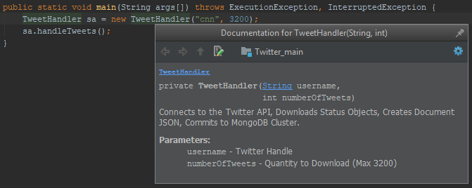

Figure 15 - IntelliJ Contextual API Documentation

### [4.1.6] Final Twitter Package UML Class Diagram

Below is the class diagram for the ‘twitter’ package in the Java program. It shows members, constructors, methods and dependencies. All the classes in this package are related to Twitter. This involves download Tweets, sanitising, reading, writing and parsing.

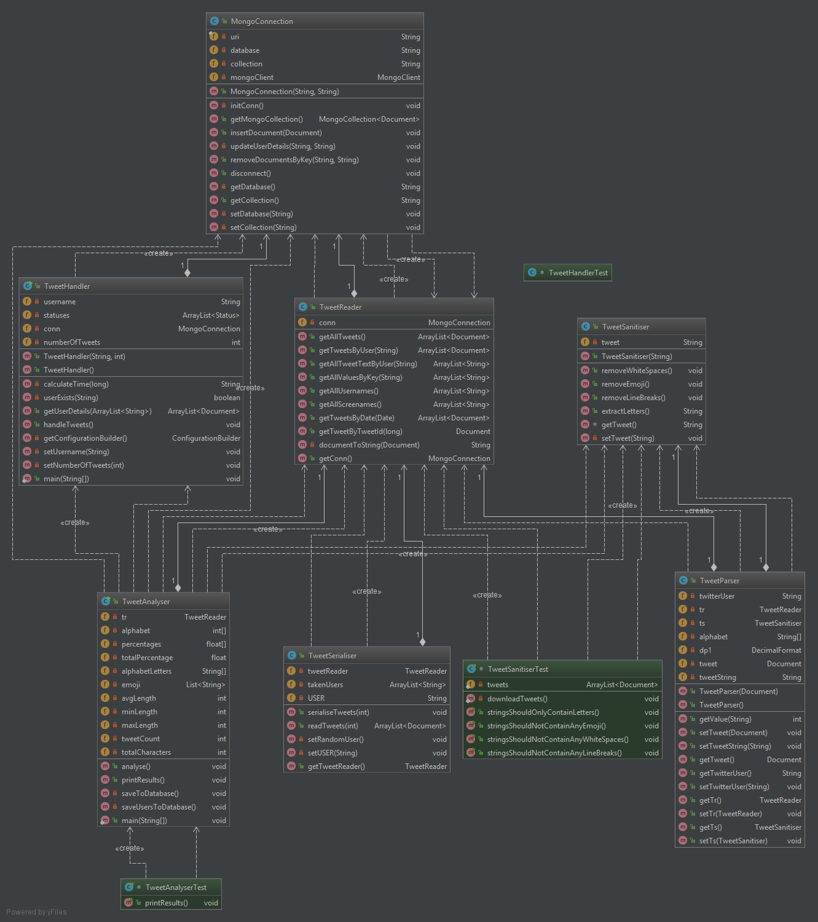

Figure 16 - Java Program Twitter Package Class Diagram

## [4.2] Robocode

### [4.2.1] Parsing Tweets from the TweetReader

A TweetParser class will be created that contains the functionality for parsing the characters in the Tweets. Below is a complete list of constraints for values that are either defined by Robocode or set by the project developer. These will need to be adhered too otherwise it will cause exceptions during the battle if the robot is passed a value that either out of range or the wrong data type.

|  |  |  |
| --- | --- | --- |
| **Robocode Constraints** | | |
| **Development Language** | Java or .NET |
| **Fire Power** | 0.1(Min) to 3.0 (Max) |
| **Starting Position** | Has to be within battlefield dimensions |
| **Starting Health** | 100 (Default) |
| **Energy** | Returns 3 x Fire Power to firing Robot |
| **Energy Return** | 3 x Fire Power (After hitting another Robot) |
| **Bullet Damage** | (Fire Power x 4) + (max(0, Fire Power - 1) x 2) |
| **Gun Heat** | 1 + (Power / 5) after firing a bullet |
| **Bullet Velocity** | 20 – (3 x Fire Power) |
| **Robot Velocity** | 8 Pixels per Turn |
| **Robot Acceleration** | 1 Pixel per Turn |
| **Robot Deceleration** | 2 Pixels per Turn |
| **Robot Base Rotation** | Max (10 – 0.75 x abs(velocity)) Degrees per Turn |
| **Gun Rotation** | Max 20 Degrees per Turn |
| **Radar Rotation** | Max 45 Degrees per Turn |
| **Collision with Robot** | 0.6 Damage |
| **Collision with Wall** | AdvancedRobots take abs(velocity) x 0.5 – 1 damage |

|  |  |
| --- | --- |
| **Developer Constraints** | |
| **Battlefield Size** | 1000 x 1000 pixels |
| **No. of Rounds** | 1, 3, 5, 8 and 10. |
| **No. of Robots** | 2 (1v1) |
| **Gun Cooling Rate** | 0.1 per Game Tick |
| **Inactivity Time** | 1000 turns before being zapped by the system. |
| **Sentry Border Size** | 100 px from the battlefield edge, all around. |

### [4.2.2] Battle Results Data Structure

In order to store the results of a Robocode battle in the MongoDB Cluster, a data structure or ‘model’ is required. Each battle can contain *n* robots, and each robot has a number of attributes relating to the results that can be accessed upon completing a battle.

These attributes are;

1. **Team Leader Name:** packageName.RobotName (e.g. sample.Corners)
2. **Bullet Damage:** Robots score 1 point for each point of damage done to enemies
3. **Bullet Damage Bonus:** When a robot kills an enemy, it scores an additional 20% of all the damage it did to that enemy.
4. **Ram Damage:** Robots score 2 points for each point of damage they cause by ramming enemies.
5. **Ram Damage Bonus:** When a robot kills an enemy by ramming, it scores an additional 30% of all the damage it did to that enemy.
6. **Survival Score:** Each robot that's still alive scores 50 points every time another robot dies.
7. **Last Survivor Bonus:** The last robot alive scores 10 additional points for each robot that died before it.
8. **Score:** This is everything else added up. It determines each robot's rank in this battle.
9. **Rank:** A position based upon the score value.
10. **Firsts:** Number of rounds the robot finished in first place at the end of a round.
11. **Seconds:** Number of rounds the robot finished in second place at the end of a round.
12. **Thirds:** Number of rounds the robot finished in third place at the end of a round.

I also wanted to store the configuration of the battle, also known as the ‘rules’. As follows,

1. **Number of Rounds:** An integer representing the number of rounds in a battle.
2. **Battlefield Width:** An integer, in pixels, representing the width of the battlefield.
3. **Battlefield Height:** An integer, in pixels, representing the height of the battlefield.
4. **Sentry Border Size:** The size of the sentry border that prevent robots from leaving it.
5. **Gun Cooling Rate:** The value the dictates the rate at which a gun cools after firing.
6. **Inactivity Time:** The maximum time in which a robot can do nothing or be ‘inactive’.
7. **Hide Enemy Names:** A Boolean variable that shows or hides the names of enemies.

Finally, I added some custom-made statistics that I wanted in the data structure;

1. **Duration:** An integer, in milliseconds, equal to the length of the battle.
2. **Turns:** The collective number of turns taken across all rounds in a battle.
3. **Date:** A date-time object of the system time the battle was run.

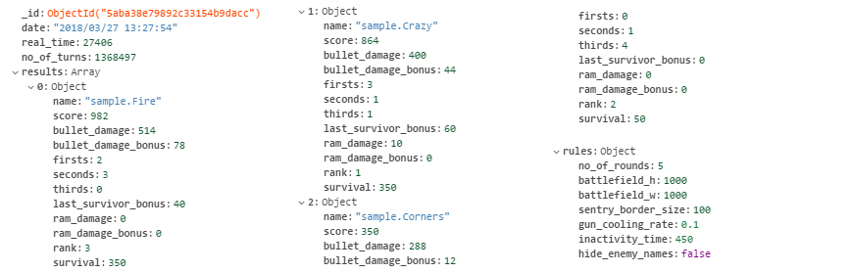

Figure 17 - Robocode Results Data Structure Example

The data structure would contain *n* number of objects in an array, where each object has 12 key value pairs. Each key value pair is such that the key is the attribute name, and the value is the respective value. Each battle will output a single document with a single attribute called “results” whose key is the aforementioned array of objects.

The figure above shows an example of this data structure. The battle contained three robots, “sample.Corners”, “sample.Crazy” and “sample.Fire”. The array called “results” therefore contains three objects, each with the 12 attributes. Finally, there is an object called “rules” which contains all the battle configuration options that were used.

### [4.2.3] Final Robocode Package Class Diagram

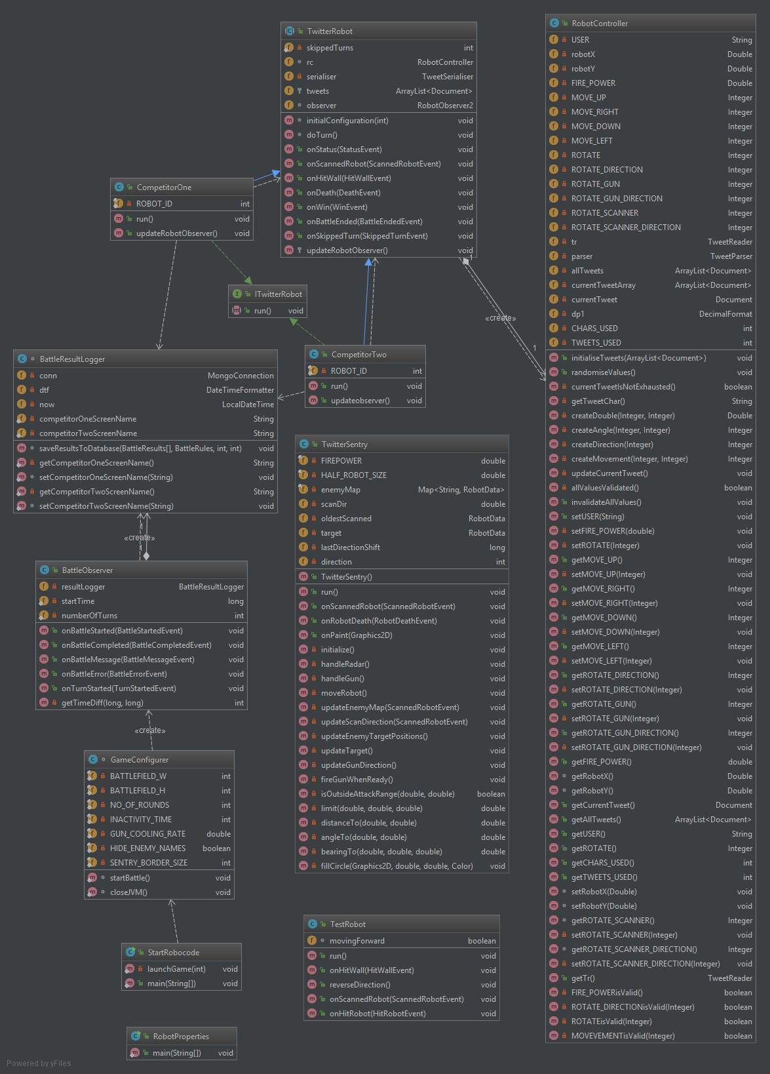

Figure 18 - Java Program Robocode Package Class Diagram

## [4.3] Data Visualisation & NodeJS

### [4.3.1] MVC Folder Structure

The ExpressJS Framework utilises MVC (Model, View, and Controller). MVC splits the program into 3 main, inter-connecting parts that makes managing and developing the project easier. The file structure for this NodeJS project is as follows;

* /bin (**Server Configuration)**
* /db (**Model**)
* /node_modules (**Modular Functionality)**
* /public (**Controller**)
  + js (**JavaScript** **Functionality**)
  + css (**Styling** **Mark-up**)
* /routes (**Page Routing)**
* /views (**View**)
* app.js (**Application Middleware)**

### [4.3.2] Page Structure

The web application is going to be a single-page website with a navigation bar that links the user to the respective sections of the page. The site will be split up into the following five sections;

* Overview
* Analysis
* Visualisation
* Results
* Reflection

Overview

This section is the introduction to the page and will simply provide the title of the project, a brief description of it and a link to this report.

Analysis

The analysis section will contain an analysis of the Tweets that were downloaded it. It will use JavaScript functionality to connect to the MongoDB Atlas Cluster and download the documents onto the page. D3.JS will be used to graph the frequency of characters into a bar chart and a collection of pie charts. Furthermore, it will contain a breakdown and analysis of each Twitter user that Tweets had been collected from. This will calculate percentages of certain characters and languages used in the Tweets.

Visualisation

This section is the main data-visualisation element. It will download the data from the Robocode results and create a statistical overview. Furthermore, D3.JS will be used again to create a dynamic scatter plot graph that shows the trend of the data via a regression line.

Results

This section will simply be an visual overview of the data that I collected and the results that come from the Robocode battle simulations.

Reflection

Finally, this section will reflect on what went well, what went wrong and what I would do in the future if I were to improve the project or do it again.

## [4.4] Mathematical Analysis

### [4.4.1] JavaScript Functions

# [5] Program Development

This section documents the development stages throughout the project. Any Object-Orientated programming is written in Java, and the code snippets are taken from the program written in IntelliJ IDEA. Web Application development is done via the MEAN Stack of technologies and code snippets are taken from WebStorm.

## [5.1] Twitter

The first stage of development is everything Twitter related. This includes accessing the Twitter API, downloading Tweets and any other functionality related to them.

### [5.1.1] Twitter Authentication & API Connection

The first task was to connect to the Twitter API so that the program has access to its methods. As previously mentioned in the Background Research, the Twitter4J Library was selected for this purpose. I downloaded the .JAR files from their site and installed on the classpath by adding them as a new module to the project in IntelliJ.

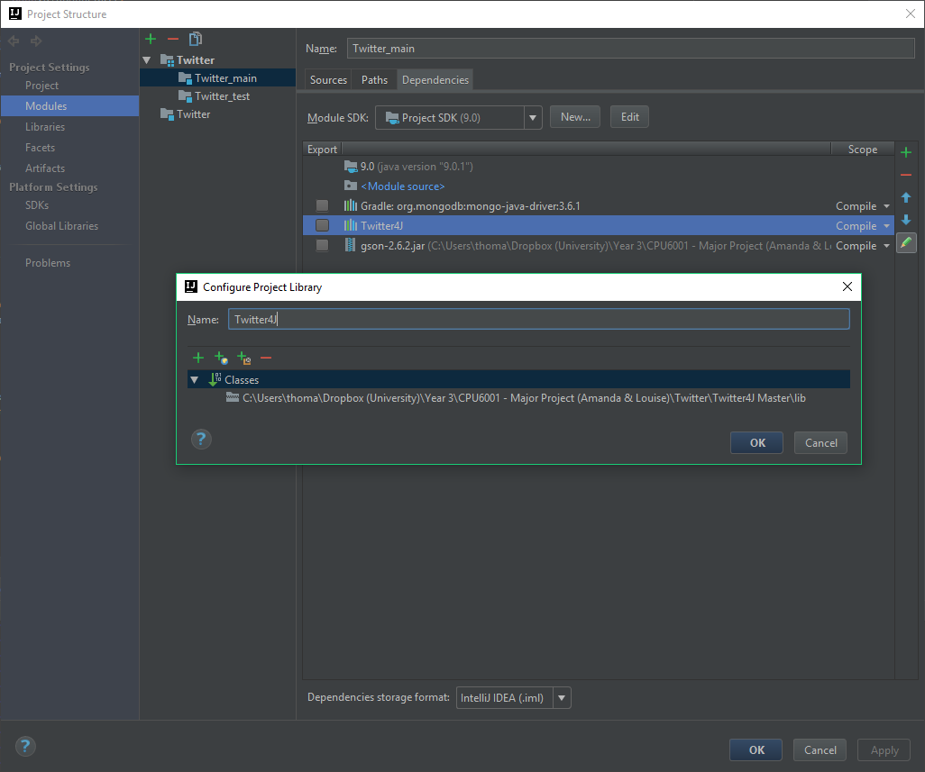

Figure 19 - Adding Twitter4J .JAR to IntelliJ Project

I then included the import statements at the top of my class and used the wildcard asterisk character to include all available classes in the .JARs. This meant I could now invoke all necessary methods from the Twitter4J Library in my Class.



Figure 20 - Java External Library Import Statements

Twitter utilises the Open Authorisation (OAuth) 2.0 Framework, an open protocol used to protect data on web applications and server-side API’s (OAuth, 2017). Developers are provided with an access token and a secret token that can be used to make API requests to Twitter via an ‘Application’ (Twitter, 2017). The screenshot below shows both the Access Token and Access Token Secret keys. This also allows for the OAuth authentication to function correctly as previously mentioned in the background research.

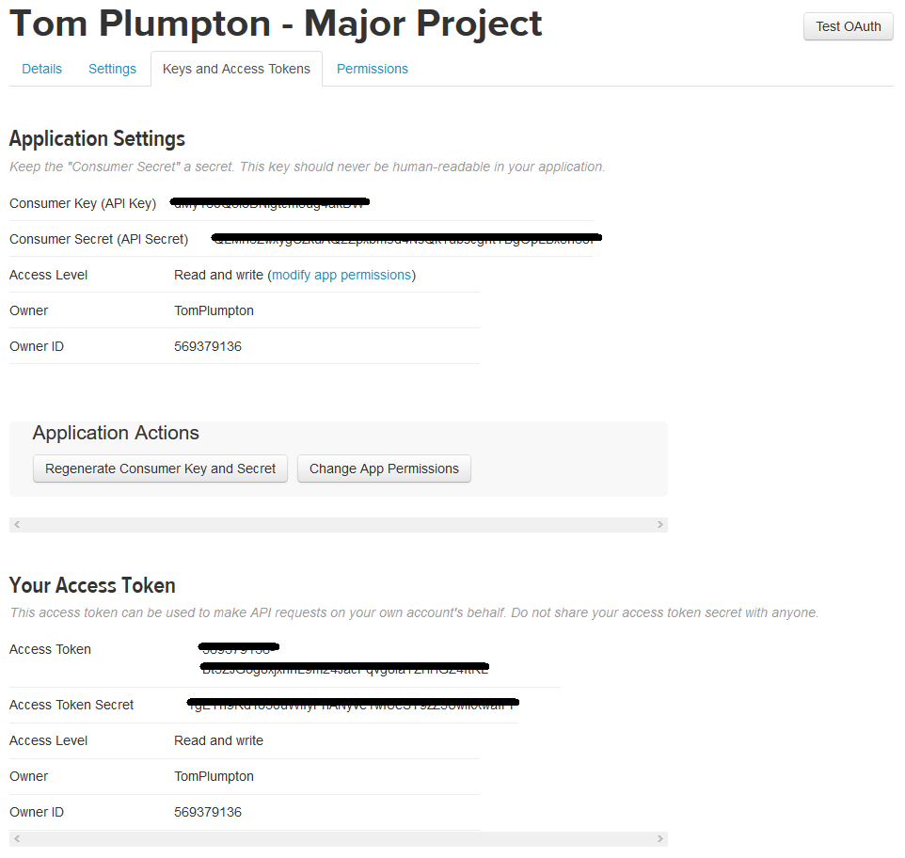

Figure 21 - Twitter Developer Application Access Tokens

Now that I had my access token, the documentation states that I had to create a ConfigurationBuilder. I wrote a method that instantiates a new ConfigurationBuilder Object, sets all the relevant keys, and then returns it. This method will be invoked upon in other methods further on, facilitating the TwitterFactory.



Figure 22 - Twitter ConfigurationBuilder Method

### [5.1.2] Mongo Atlas Cluster Connection & Inserting Documents

During the early stages of project development, I decided that it would be better to simply store the tweets in the Mongo Database Cluster, rather than serialising them into .CSV files on local storage. This would mean the data is available online anywhere, making it easier to develop when using multiple different computers. Furthermore, given the significant quantity of stored data, file sizes would get rather large and start to bloat the local disk.

I decided to install ‘Gradle’ as a module in IntelliJ for the Twitter project. Grade is an open source build automation system that uses domain-specific language (DSL) instead of XML to declare project configuration. (Wikipedia, 2017) IntelliJ has Gradle integration out-of-the-box, meaning that I simply had to navigate to **New**>**Module**>**Gradle** and configure the settings as necessary. I added the latest version of MongoDB Driver to the dependencies object in **build.gradle** which gave my program access to the MongoDB Driver API. The library could have been installed on the classpath manually, but installing Gradle made it, and future libraries, easier to install and manage.

Firstly, I registered an account with MongoDB Atlas, a free cloud database service for MongoDB, and created a new cluster called ‘major-project’. All the back-end configuration is handled automatically on the server-side and is ready to use in a few minutes. I then installed Mongo Compass, a free program by MongoDB that allows you to connect to a cluster and view the database document in a GUI.

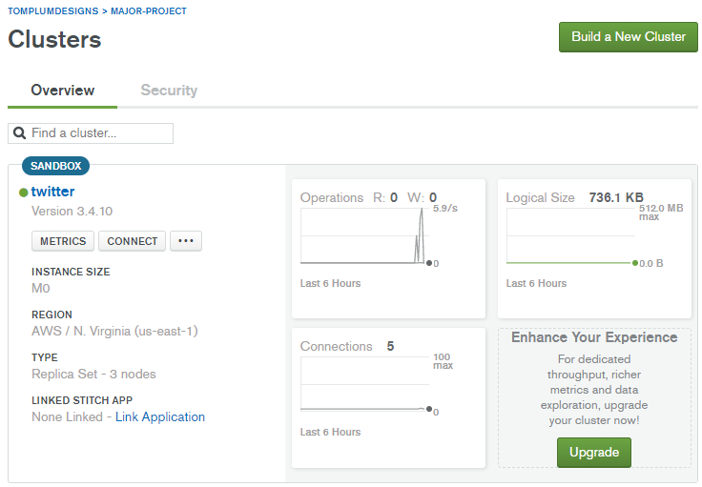

Figure 23 - MongoDB Atlas Cluster

Now that the database was setup, I wrote a Java Class that connected to Twitter, downloaded Tweets, converted them to JSON Objects, then committed them to the MongoDB. Considering these operations are all time-consuming, non-blocking asynchronous code is required to allow time for each operation to complete and call-back. I made use of the ‘CompleteableFuture’ class to achieve this. The following code snippet shows the method that I wrote to handle this functionality. The method invokes four asynchronous operations.

1. Download the Twitter Status Objects, which contain all the information.
2. Extract the relevant information and create an Object of type ‘Document’.
3. Insert them into the MongoDB Atlas Cluster.
4. Print out some statistics and confirmation, the close the connection to the cluster.



Figure 24 - Asynchronous CompletableFuture Method

The **handleTweets()** method uses the ‘conn’ variable which is declared at the top of the Class like so;



Figure 25 - Private Visibility MongoConnection Member

This is using composition to instantiate an Object of type ‘MongoConnection’ which is derived from the class I wrote to connect to the database. This code snippet below shows the MongoCollection Class. It declares a String that holds the URI of the Mongo Atlas Cluster. It also declares a new MongoClient Object, available from the API that was configured in Gradle, and passes it a new MongoClientURI Object with the String. I the declared the relevant methods for retrieving the collection from the database, inserting documents and disconnecting when finished.



Figure 26 - User Defined MongoConnection Class

Once everything was cleaned up, I wanted to insert the maximum number of Tweets from an account in one API call, which was 3200. I pass the TweetHandler Object Constructor the name “CNN” and ran the program. It successfully stored all 3200. For good measure, I tried it with another account “BBC” and successfully had a collection of 6400 documents. The screenshot below shows the GUI view in MongoCompass. However, I immediately noticed that the formatting was off in some of the text attributes, and emojis were also being parsed. This was not something I anticipated during early research and planning phases and would now need to be dealt with. I aimed to write a method that sanitises the text strings before they’re appended to the Documents.

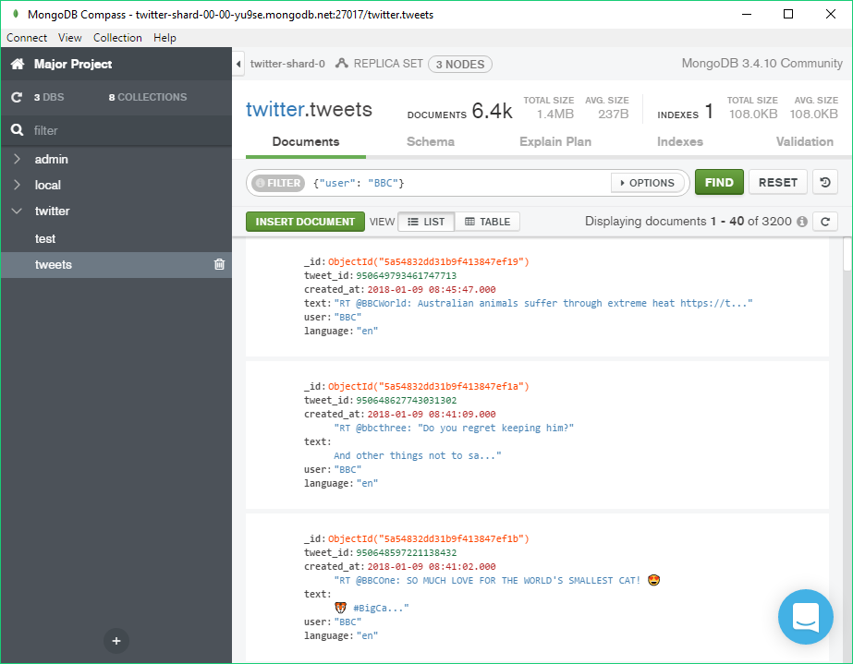

Figure 27 - MongoDB Compass Collection with 6400 Tweets Inserted

### [5.1.3] Sanitising Tweets

As previously mentioned in the last sub-section of this chapter, the Tweet strings needed to be sanitised to remove or re-format it in such a way that it could be properly parsed by Robocode in the future. This includes bytes such as white-spaces, line-breaks, emojis and other symbols. A new TweetSanitiser Class was created with methods that re-format Tweet strings in some way. For example, remove all white-spaces, emojis and line-breaks.

The code snippet below shows three methods that achieve them respectively. **removeWhiteSpaces()** and **removeLineBreaks()** use regex (Regular Expressions) to identify what to replace.



Figure 28 - TweetSanitiser Class Snippet

### [5.1.4] Analysing Tweets

Tweet analysis was required for the web application further down the timeline of the project. I wrote a Java class that retrieves the Tweets from the MongoDB Cluster and iterates over them. It then counts the characters and calculates the frequency of which they occur. Furthermore, it calculates the minimum, average and maximum number of characters in a Tweet a long with the number of emoji used.

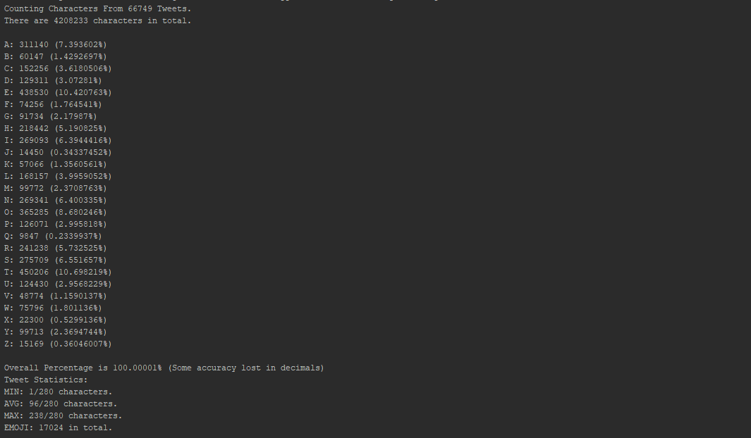

Figure 29 - TweetAnalyser Class Console Output

I also wrote a method that build a document object with the above results and saved them to the MongoDB Cluster using the MongoConnection class that I created earlier.



Figure 30 - TweetAnalyser Class saveToDatabase() method

### [5.1.5] Serialising Tweets

Several weeks into the project I encountered a problem regarding the Tweets and loading them into the program for the robots. This operation takes too long for Robocode as it is not thread safe and caused the battle to begin for the Tweets had downloaded. To overcome this issue I decided to download the Tweets for both robots before the battle starts and temporarily serialise them into .ser files so the robots can quickly read them before the battle begins. To do this I wrote a TweetSerialiser class that can serialise and de-serialise the Tweets to and from the local storage.

The method in the code snippet below shows the serialisation of the Tweets. I wrote a method called **setRandomUser()** which simply connects to the MongoDB Cluster, downloads a list of the users and select a random one using the pseudo-random **Random()** constructor from the Random class. I then get the Tweets from a TweetReader object just for the user selected. The try/catch statement then attempts to create a FileOutputStream to serialise the ArrayList of Tweets onto the local disk in the same directory as the robot class files. It then writes the file and closes the stream.



Figure 31 - TweetSerialiser serialseTweets() method

A similar method was written in order to reverse this operation and read the Tweets from the previously serialises .ser file.

### [5.1.6] Parsing Tweets

For the first iteration of development, I decided to keep the complexities to a minimum by keeping the logic of the algorithms simple. I used to the TweetSanitiser class to strip the Tweet string of all emojis, symbols and numbers so that only alpha-numeric characters remained. I then wrote a method called **getValue()** which accepts a letter and finds the letter in a array containing the alphabet. It then returns the respective index value from 0-25.



Figure 32 - TweetParser Class

## [5.2] Robocode

After finishing the Twitter related stage of development and testing each of the methods and functionality that I had written, I started on the second stage. This involved integrating the Robocode application within my IntelliJ project, and creating a new class that extends the Robocode AdvancedRobot class and interacts with the Twitter related classes from the previous section.

### [5.2.1] Integrating Robocode with IntelliJ

As previously mentioned in the Background Research chapter, I copied the entire Robocode master repository into my IntelliJ Project to overcome a problem with output paths. This wasn’t technically necessary to run Robocode from the project, it would just mean that each computer the project was used on had Robocode installed in the same local directory. However, by keeping it local to the project source itself, it could be run anywhere during development.

To get Robocode running, I created a new ‘Application’ configuration in IntelliJ. The configurations menu can be accessed from the upper pane in the IntelliJ window.

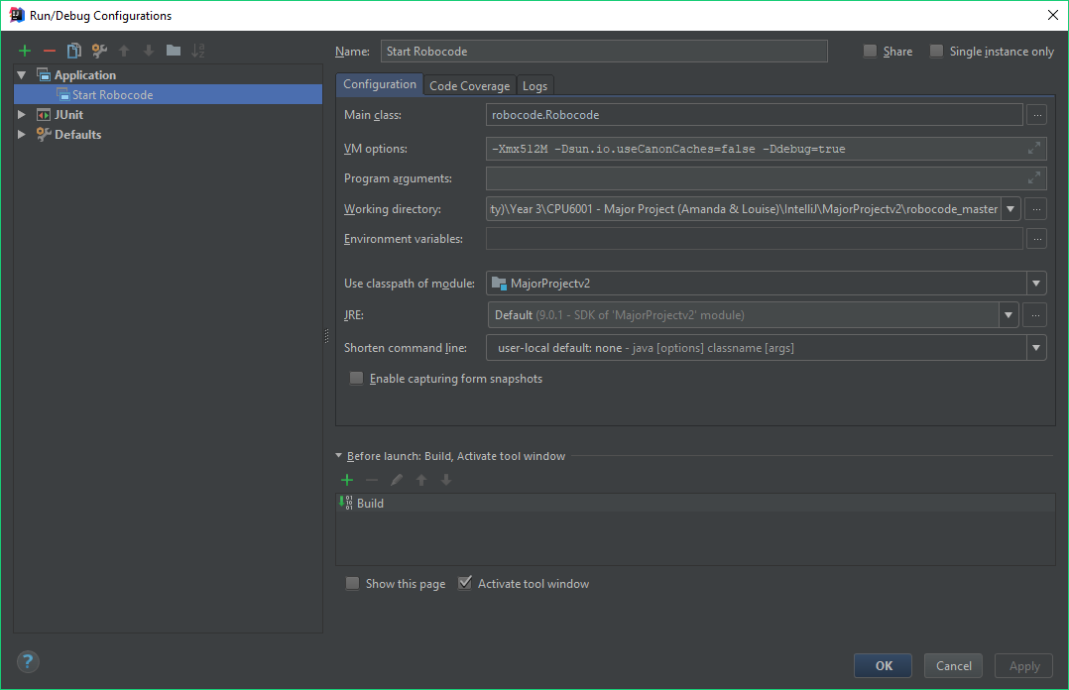

Figure 33 - Start Robocode Application Run Configuration

The screenshot above shows the configuration of the Application. The three configuration options I used are the ‘Main class’, the ‘VM Options’ and the ‘Working directory’.

Main Class**:** robocode.Robocode

This line is pointing to the ‘robocode’ package that I have on the project classpath. This is the main robocode.jar file that contains all of the classes and interfaces that make up the game itself, allowing my program to build and compile. It then drills down further into the root of the package and points to the ‘Robocode’ class. This is the main class that contains the functionality for starting the game.

VM Options**:** -Xmx512M -Dsun.io.useCanonCaches=false -Ddebug=true

The VM (Virtual Machine) options specifies what the JVM (Java Virtual Machine) should do differently than its default configuration. The **‘-Xmx512M’** part tells the JVM that it can use up to a maximum of 512MB of RAM off the heap. **‘-Dsun.io.useCanonCaches=false’** is a workaround to prevent security exceptions from occurring when a robot tries to access a file. Finally, **‘-Ddebug=true’** tells Robocode that is should not give skipped turns just because the developer paused the robot in debugger mode. (Robowiki, 2017)

Working Directory**:**

As the name suggests, this is the folder directory in which the application should look for the files that it needs. Since I added the Robocode source files to the project path, I simply pointed the working directory to the ‘robocode_master’ folder in IntelliJ.

### [5.2.2] Creating an Advanced Robot Class

Initially, I created a new class called ‘TwitterRobot’ and created the common layout used by many Robocode robots.



Figure 34 - TwitterRobot Class with Default Template

As previously mentioned in the background research, I had changed the output path in IntelliJ to the ‘robots’ folder in the root of the Robocode master repository. The screenshot bellows shows the project file structure. You can see that IntelliJ has created directories for the respective packages in my source root.

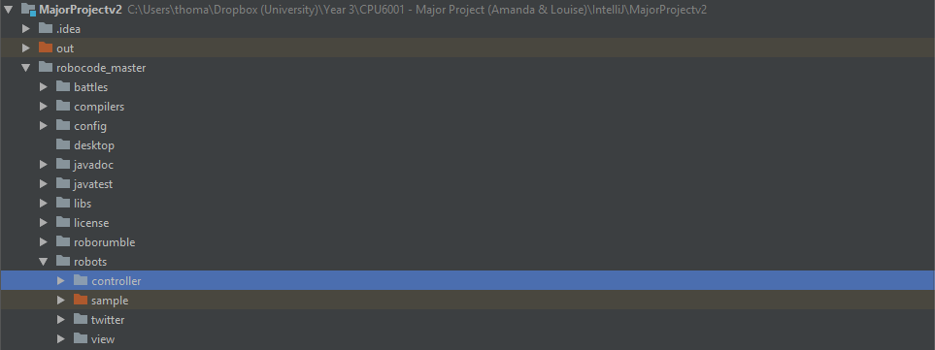

Figure 35 - IntelliJ Project Structure Pane

I started up Robocode from IntelliJ, created a new battle and could see that it had read the controller folder and found the TwitterRobot class in the correct directory. I then had the ability to add new TwitterRobots to the battle.

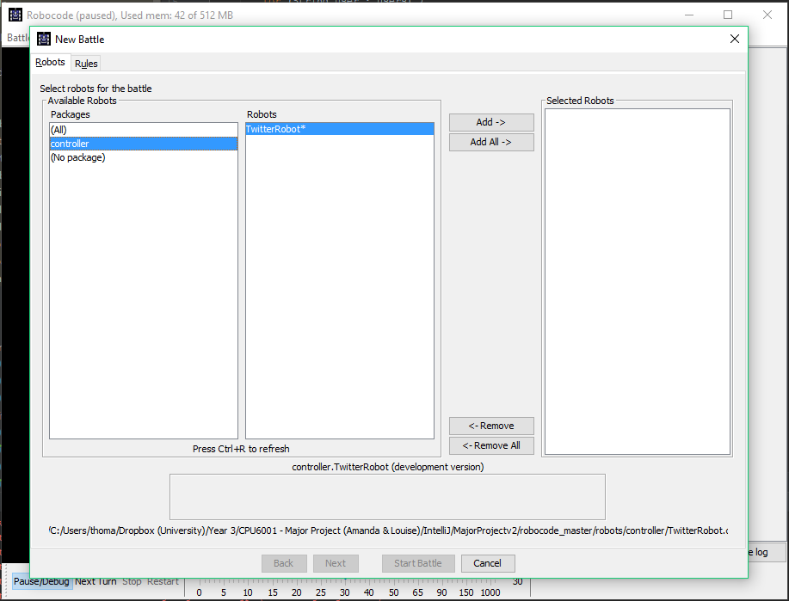

Figure 36 - Adding TwitterRobot's to Battle

### [5.2.3] Overcoming Security Exceptions

Robocode has built in security that prevent Robots from reading and writing files that are not core to the game. This is to stop Robots from cheating in RoboRumble battles and to ensure that community downloaded robots cannot cause a threat to your system by writing malicious code onto the local computer.

Because my TwitterRobot class was instantiating objects of classes that are not part of core Robocode, the security manager was banning my robots from the game and destroying them upon starting a new battle.

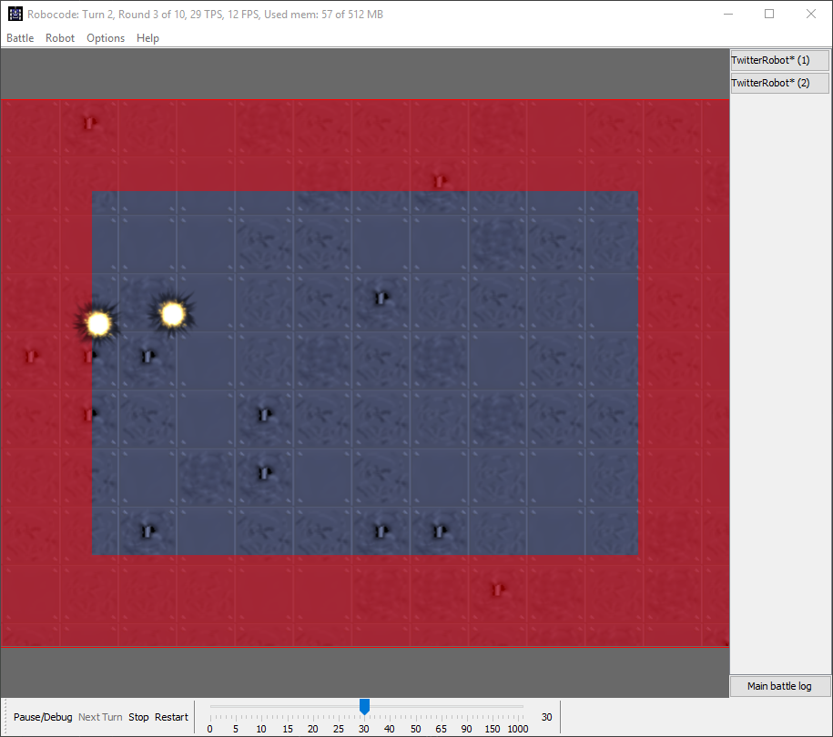

Figure 37 - Robocode Security Manager Destroying Robots



Figure 38 - Robocode Security Manager Logging Violation

To overcome this issue, I simply had to add an argument to the JVM Options in the application run configuration for Robocode in IntelliJ. This argument is **-DNOSECURITY=true**.

### [5.2.4] Controlling the Robots

To control the robots, I created the RobotController class. This class instantiated objects of many of the other classes and brings the whole program together. At the top of the class I declared lots of private members, one for each of the values that is to be produced to influence the robots’ actions. They are all immediately instantiated to an invalid value.



Figure 39 - RobotController Class Members (Robot Values)

The major functionality comes from a method called **randomiseValues()**, and as the method signature suggests, it randomises all the above values. However, instead of using the **random()** method from the Math class, it utilises the TweetParser to produce an integer or a double for the robot it is controlling. Below is a snippet of pseudo-code taken from the class but with the value setting removed. It jumps into an infinite loop, then first checks if the current working Tweet is exhausted. This Tweet is taken from the top of the collection that is read from the serialised file. If the Tweet does have a length, it then checks if all the values are validated. Otherwise, it will update the current Tweet by taking another one from the top. If all values are validated, the loop breaks, and the robot will take its turn in the battle with the values. If they’re not valid, which they won’t on the first loop as they’re instantiated to an invalid value, then it will set them.



Figure 40 - RobotController randomiseValues() Pseudo Code

To provide some context on the setting of the robot values, below is an example of the fire power being set. This snippet, along with all the other values, is inside the inner if statements’ else clause where it says ‘//ROBOT VALUES ARE SET HERE’ above.



Figure 41 - RobotController Setting Fire Power

Each value is checked for validity first. Then, a number of integers are generated by passing the return value from **getTweetChar()** to the **getValue()** method from the TweetParser class. This takes the final character from the current Tweet, passes it to the parser, and then returns an integer from 0-25 relative to its position in the alphabet. These integers are then passed to the respective setter method while wrapped in a method that builds the value. In this example, because the fire power value is a double with a single decimal place, it is wrapped in **createDouble().**



Figure 42 - RobotController Create Double Method

The code snippet above shows the **createDouble()** method. It takes two integers, makes them positive and then creates a double value for use by a robot. The RobotController class also contains **createMovement()**, **createDirection()** and **createAngle()** methods which also take a number of integers as parameters are create the relevant value. These methods are used by the other value setter methods in the if statement mentioned earlier.

Finally, a method called **invalidateAllValues()** resets all the robot value members to their original invalid values. At the start of each turn, the robots call **randomiseValues()**, do their turn and use the values from the getters, then call **invalidateAllValues()** to ensure they fail validation and get randomised again next turn.

### [5.2.5] Utilising the Robocode Engine

Once I had the ability to add custom Robots to battles without them being banned due to security exceptions, I decided to create a class that would automatically configure the battle and add the robots without having to use the GUI.

The class was called GameConfigurer. I started by defining some private member constants for the BattleSpecification.



Figure 43 - GameConfigurer BattleSpecification Constants

Next, I invoked a couple of static methods from the RobocodeEngine that enabled log messages and errors for debugging purposes. Then, I created a RobocodeEngine object and passed it the working directory of my project which contains the Robocode game files. I then added a BattleListener which I created myself called ‘BattleObserver’. This class is used to log in-game messages and errors from Robots. I then set the visibility to true so that the GUI window renders.



Figure 44 - GameConfigurer Robocode Engine Configuration

I then configured the battle specification by creating a new BattleSpecification object and passed it the relevant constants and robots in the correct order of the constructor. The RobotSpecification[] array contains CompetitorOne and CompetitorTwo classes that extend TwitterRobot.



Figure 45 - GameConfigurer Battle Specification Setup

Next, I had to download Tweets for each of the robot competitors. Initially, I had them download once the battle had started and attempted to pause running threads while it waited. Instead, I decided to serialise the Tweets into a .ser file and then read them upon battle start. This vastly increased performance and decreased the loading time. I ensure that the MongoConnection is closed upon serialising the Tweets.



Figure 46 - Game Configurer Serialise Robot Tweets

Finally, I invoke **runBattle()** upon the RobocodeEngine object, pass it the battleSpec that we created and then pass it true. The Boolean tells the program to wait until the battle has finished before continuing. Upon battle completion, the engine is closed.



Figure 47 - GameConfigurer Start Battle

### [5.2.6] Adding a BorderSentry

After simulating a few test battles, I noticed that the robots were sometimes getting stuck on the walls. This meant they took no action, skipped turns and ended up being disabled and zapped by the game until they died. The Robocode API provides another type of Robot called a ‘Sentry’. These robots stay on the edges of the battlefield and patrol the sentry border, which can set manually to a number of pixels. I created a new class called ‘TwitterSentry’ which implemented the BorderSentry interface from the Robocode API. (Larsen, 2017)

There was no need for me to spend lots of time developing my own BorderSentry Robot, so I simply used to open-source ‘BorderGuard’ Sentry written by Robocode author Flemming Larsen. (Larsen, 2018)

Below is a screenshot of a battle with both competitors and a TwitterSentry patrolling the border and firing at a robot that is over the border.

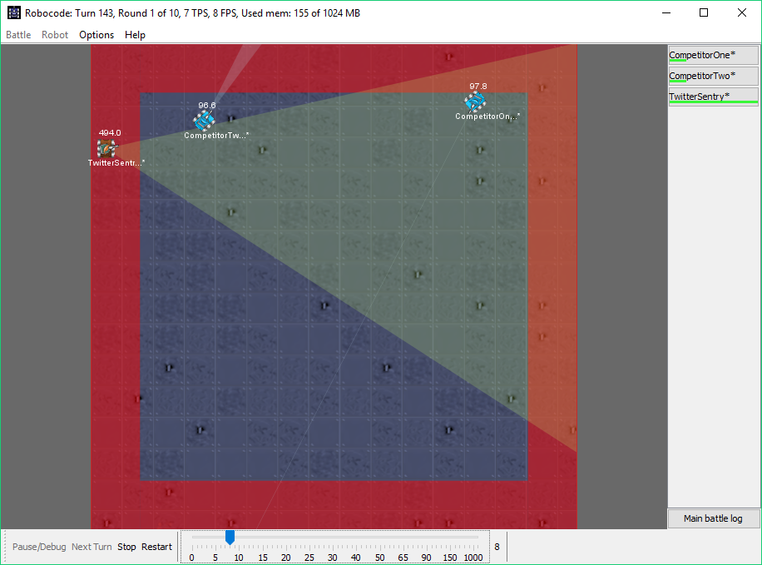

Figure 48 - TwitterSentry (BorderGuard) in Battle

### [5.2.7] Automating Battles & Data Collection

Once I had the Java program at the stage where I could run battles continuously to collect data, I needed a way to automate the process. The IDE I was using, IntelliJ IDEA, did not support such functionality. I wrote a very simple batch script with a single for-loop that executed my Java program *n* number of times. In this example, ‘n’ is 600.



Figure 49 - Windows Batch Script - Automating Data Collection

When the battle finishes, the BattleObserver class that I wrote automatically connects to the MongoDB Atlas Cluster, builds a JSON Object containing all the relevant data and stores it in the database in a collection called ‘results’.

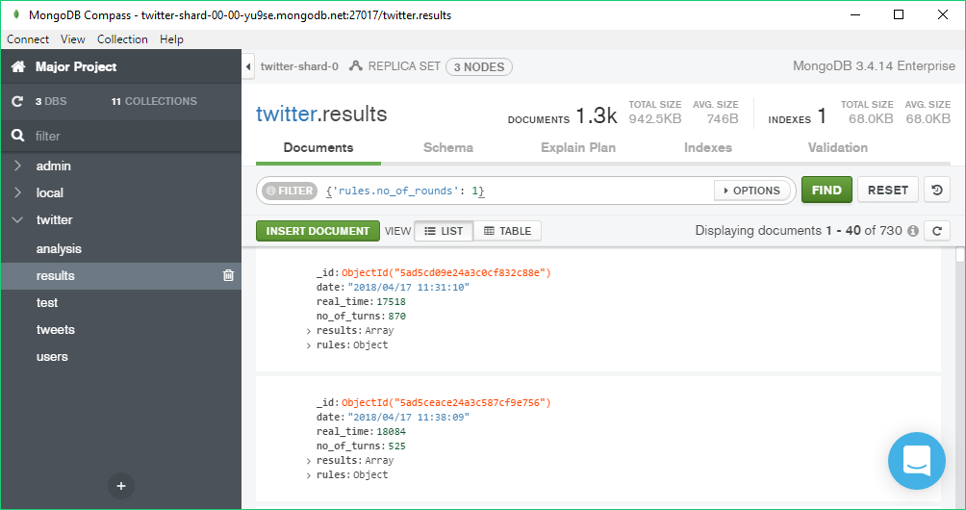

Figure 50 - MongoCompass Robocode Results

## [5.3] Data Visualisation & NodeJS

This sub-chapter contains all of the development related to the NodeJS Web Applications. Including configuration, development of the page and D3.JS data visualisation.

### [5.3.1] Configuring NodeJS & ExpressJS Framework

The first step was to configure the HTTP Server for NodeJS and point it to the main app.js file which will initialise all the middleware and page routes for the application. This file is called ‘www’ and is stored in the bin folder and is what will be run by NodeJS.



Figure 51 - Configuring HTTP Server in NodeJS

I installed the relevant packages for the project. Including the ExpressJS Framework, MongoDB, Connect, BodyParser etc. This was done from the command line terminal using the command **npm install *package-name* –save**. The save flag ensured that the dependencies are updated in the package.json file.

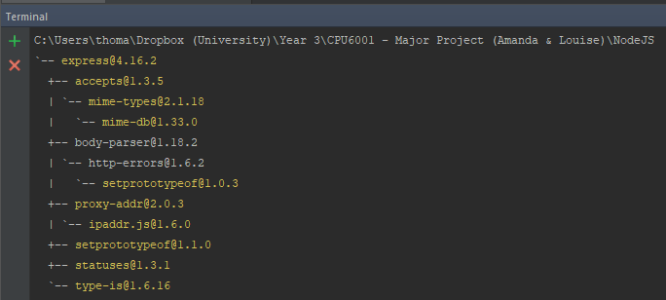

Figure 52 - Installing ExpressJS Framework via NPM Command Line

Then I created the app.js file in the root directory so that the aforementioned www file can see it. I imported the required npm packages that were installed earlier. I setup the pug view engine so that .pug files are used instead of .html. Then, I configure the ‘public’ folder as a static directory for all assets and controller code. Next, I add the required middleware to the app variable. Finally, I configure the first page routing file.



Figure 53 - Configuring Middleware Stack & Page Routing in NodeJS

The following code snippet shows the package.json file for the project. The object defines some attributes for the project, including name, description, version etc. Then it has a dependencies object which is update each time a new npm package is installed with the **–save** flag.



Figure 54 - NodeJS package.json file contents

The property called “scripts” is an object contains key:value pairs. The key is an npm command, and the value is what to do with it. I declare a new pair with the key “start” and the value “node ./bin/www”. This tells npm to run the www file with the server configuration upon the command **npm start bin/www** from the project root directory.

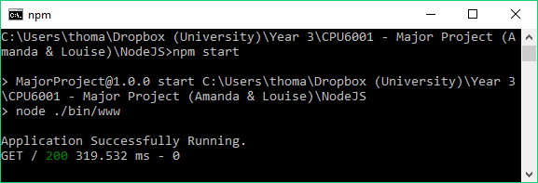

Figure 55 - Running NodeJS Application from NPM Command Line

### [5.3.2] Automating NodeJS Runtime in JetBrains WebStorm

In the previous sub-section, it was noted that to run the NodeJS application, the developer had to open a NodeJS Command Prompt, navigate to the project root directory, and execute the command **npm start bin/www**. WebStorm provides an easier method of doing this, while also provides further benefits.

I created a new Node.js Run Configuration in WebStorm. I set the working directory to the project root directory, and the JavaScript file to bin/www. This meant I could now run the application from within WebStorm, as it has access to the NodeJS interpreter application and knows where the www file is.

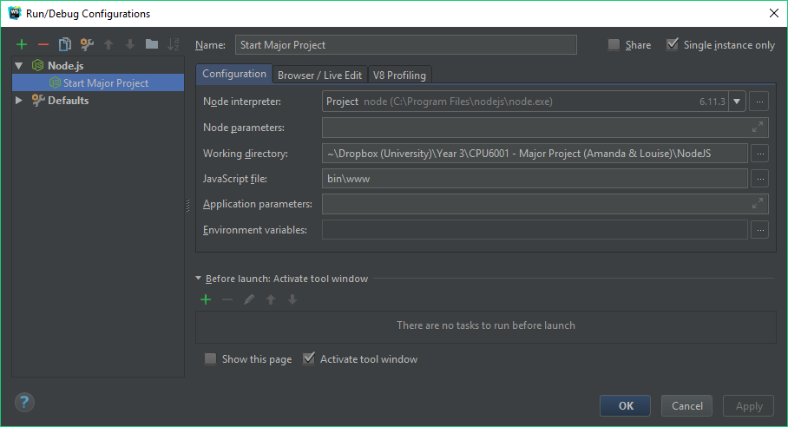

Figure 56 - JetBrains WebStorm NodeJS Application Run Configuration

Simply clicking the green play button in WebStorm causes the application to run successfully. Any command line output is printed to the run console within the IDE, now eliminating the need to use a separate NodeJS Command Line window.

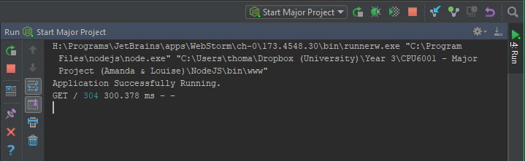

Figure 57 - Running NodeJS Application from WebStorm

### [5.3.3] Creating the Page & Integrating D3.JS

I decided to create a single-page website, split into logical sections. These sections are Overview, Analysis, Visualisation, Results & Reflection. The page structure is written suing the PugJS View Engine which is compiled to HTML5 upon rendering in the browser.

Integrating D3.JS is as simple as linking the script file from the CDN (Content Delivery Network). I removed the explicit protocol (HTTP or HTTPS) so that the page would look for the correct type. This is because the domain that the site is hosted on is encrypted with an SSL certificate and requires all data to be delivered via HTTPS.



Figure 58 - D3.JS Script Tag

Now that the script is loaded onto the page, any subsequently loaded scripts will have access to the **d3** variable that can invoked upon.

### [5.3.4] Twitter Analysis Overview

In the ‘Analysis section of the website, I wanted to provide some statistical analysis of the Tweets that I had collected in the MongoDB Cluster. I used a combination of VanillaJS, D3.JS and EasyPieCharts to visualise some statistics of the Tweets.

The first part I wanted to include was a simple overview of the number of tweets, characters and emoji in the Tweets that I had collected. I made a request to the MongoDB Cluster upon rendering the page which returned the analysis record that were saved from the Java program.



Figure 59 - Web Application GET Request with Database Access

As you can see from the GET request above, the HTTP response object renders the index.pug file and sends an object. This object contains key value pairs of data, including the page title, the number of tweets, characters, emoji and users. I then wrote some trivial JavaScript code that renders the values to the page with an animation (Not shown for clarity).

I then make an AJAX call upon page-load that sends a POST request to the following server-side script.



Figure 60 - Character Analysis POST Request

It sends the analysis data back that was calculated and stored from the Java program. Upon AJAX Success, the data is passed into a function that renders the bar chart to the browser. Below is a screenshot of the analysis section.

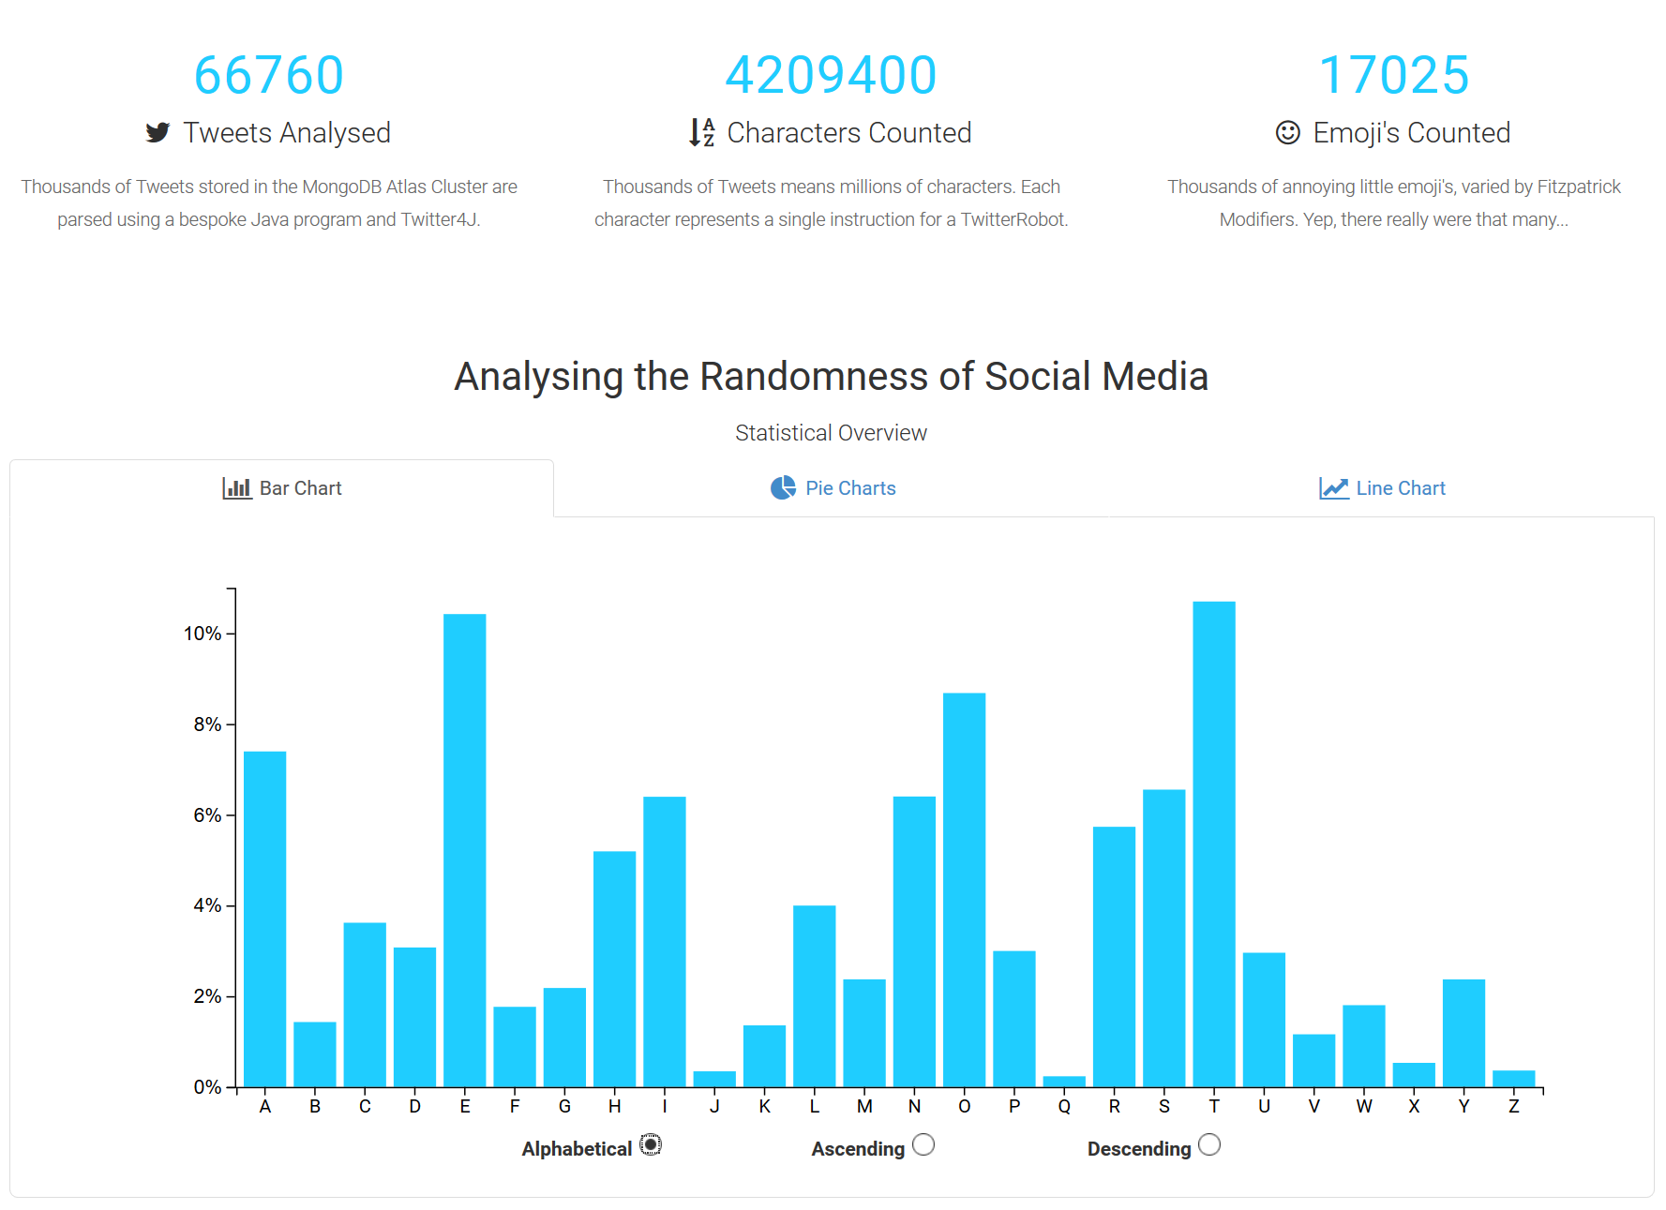

Figure 61 - Web Application Statistical Analysis Overview

### [5.3.5] Scatter Plot & Simple Linear Regression (JavaScript)

The second D3.JS visualisation I scripted was the scatter plot from the first set of data that I collected. Version 1 of the TwitterRobot was pitched against itself, with different Twitter users’ Tweets of course, and simulated in a loop ~1000 times. The initial code for the scatter plot graph is not so complicated. It contains the usual variables for **width**, **height**, **margin**, **svg**, **x**, **y**, **xAxis** and **yAxis**.

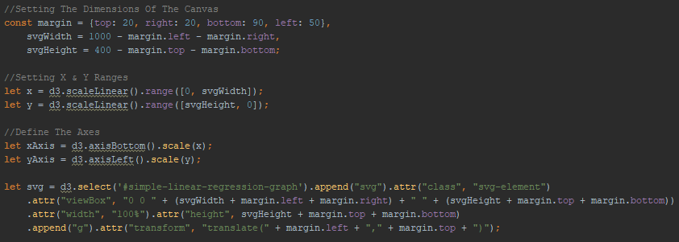

Figure 62 - simpleLinearRegression.js Scatter Graph Variables

Next, I wrote a function called **renderSimpleLinearRegression(data)** which is called upon the successful return of an AJAX call that loads the Robocode results from the MongoDB Atlas Cluster. It passes the data into the function and is converted into the correct format for D3 (Which has been removed from the code snippet below for clarity). The function sets the x and y domains, calculates the regression line and appends everything to the svg element that we created earlier.



Figure 63 - simpleLinearRegression.js renderSimpleLinearRegression(data)

## [5.4] Mathematical Analysis

The final section of development is for the statistical and mathematical analysis of the Robocode battle result data.

### [5.4.1] Calculating the Regression of Least Squares

The function **calcLinear()** is defined below. It takes a dataset and the minimum x and y values to work out the (x1, y1), (x2, y2) coordinates of the line.



Figure 64 - simpleLinearRegression.js calcLinear()

### [5.4.2] Calculating Standard Deviation & Variance

As discussed in Chapter 2.5.2 of the Background Research, the equations for standard deviation ( $σ)$ and variance ( $σ^{2})$ are as follows;

$σ= \sqrt{\frac{Σ{\left|x- \overline{x}\right|}^{2}}{n}}$ $σ^{2}= \frac{Σ{\left|x- \overline{x}\right|}^{2}}{n}$

Another way of writing the standard deviation equation is;

$$σ= \sqrt{\frac{1}{N}\sum_{i=1}^{N}{{(x_{i}- μ)}^{2}}}$$

Where $N$ is the number of elements in the dataset, $μ$ is the mean of these values and $x_{i}$ is each element in the dataset ( $x_{1}$ is the first element, $x_{2}$ is the second etc…). I wrote a function called **calculateStandardDeviation(results)** that accepts the dataset from the database. It then calculates the mean, the squared differences and the mean of the squared differences (better known as variance). The variance is then square rooted to find the standard deviation which is returned in an object.



Figure 65 - Calculating Standard Deviation in JavaScript

### [5.4.3] Calculating Score Quartiles

I also wanted to calculate the quartiles of the data to better understand its spread. I wrote a function called **getMinMaxAvg()** that calculates the minimum score, average, maximum, lower quartile, median, upper quartile and inter-quartile range.



# [6] Testing Phase

This section documents the various testing phases that were undergone at the end of each stage of development. Furthermore, any issues that were discovered as a result, are documented along with any changes that were made in correction.

## [6.1] Twitter

### [6.1.1] Accessing the MongoDB Atlas Cluster

After writing the first draft of code for storing the Tweets in the database, I tested it by inserting a single document with a single attribute into a test collection. I simply added a main method to the MongoConnection Class, so it was runnable.



Figure 66 - Testing with MongoConnection Main Method

After the first stage of development was complete and functional, the program was tested with some randomly selected accounts to see if the JSON objects would successfully commit to the Mongo Cluster where they could be viewed in Mongo Compass. The program ran successfully, and the test document appeared in Compass.

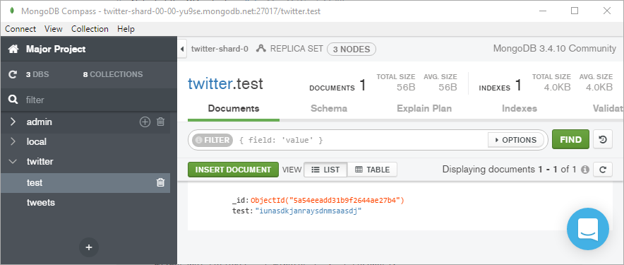

Figure 67 - MongoDB Compass Test Document

### [6.1.2] Committing Twitter Status Objects to the MongoDB Atlas Cluster

To ensure that the program worked correctly, I tried inserting 3200 Tweets for several different Twitter users. The first one I tried as I wrote the program was “cnn”. The Tweets were committed successfully but I noticed the user field was “CNN” (capital casing), just how the handle was displayed (@CNN) on the profile. I questioned the **status.getUser().getName()** method invocation I was using to store the username, so I tried a few other users.

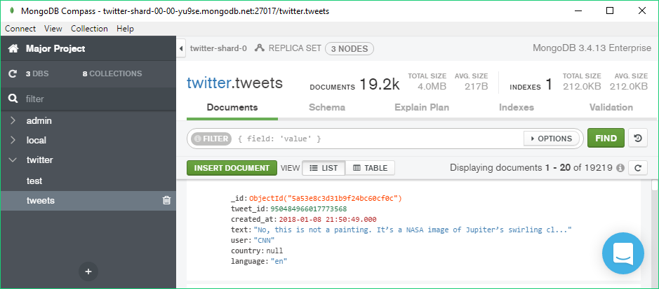

Figure 68 – MongoDB Compass Displaying 19200 Documents

### [6.1.3] Sanitising Tweets

I wrote a TweetSanitiserTest class with a series of Junit 5 tests. I declared a **downloadTweets()** method that is to be run before all tests. It downloads a list of usernames from the MongoDB Atlas Cluster, picks a pseudo-random one, and downloads all the Tweets from that user.



Figure 69 - TweetSanitiser JUnit Test Method - downloadTweets()

I then wrote several tests that verify the working functionality of each method in the TweetSanitiser Class. Below are examples of a test passing and failing.

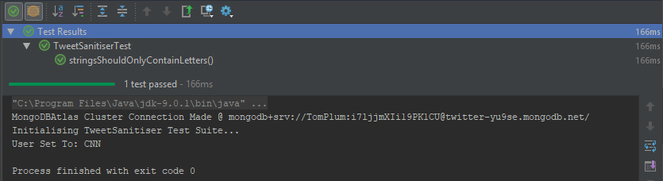

Figure 70 - TweetSanitiser JUnit Test Pass

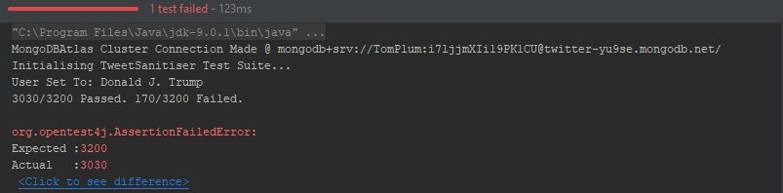

Figure 71 - TweetSanitiser JUnit Test Fail

## [6.2] Robocode

### [6.2.1] Adding Custom Robots to Robocode

Adding my own custom-made robot classes to the Robocode game was the biggest obstacle that I encountered during the development of the project. Once I had decided to use the RobocodeEngine class to configure the game properties and add the robots via the RobotSpecification, the engine could not find the classes that I had made. The project development was stagnant for several weeks as I scoured forums and articles online regarding similar issues to no avail. Eventually, I conversed with one of the main contributors to Robocode, Flemming N. Larsen, who actually found the issue in the source code, patched the game with the appropriate changes and sent me the new version in a .JAR file.

Once I had replaced the broken .JAR with the patched one, my code ran successfully and loaded my custom robots in the battle.

### [6.2.2] Robot Controller Random Values

The RobotController is the most complex class in the program and therefore had the most potentiality to produce errors. I wrote a Junit test class to test the production of random values for the robot. I created a method that ran before all others to download the tweets, serialise them and set a user. Then, another method than ran at the end to print the results. I then had a test method for each robot value that ran in between these two.

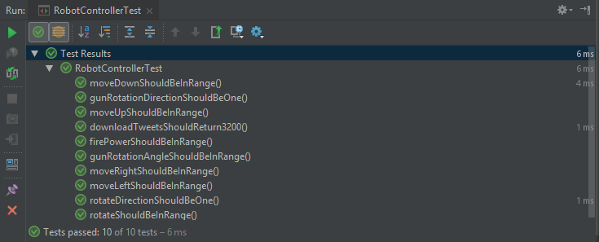

Figure 72 - RobotController JUnit Tests Passing

Printing out the results of the values at the end of the test gave me a very useful insight into what was going wrong should a test fail.

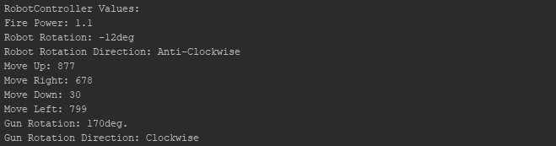

Figure 73 - RobotController JUnit Console Print

## [6.3] NodeJS Web Application

### [6.3.1] Website Loading Performance

Browser network stack waterfall. Pingdom.com waterfall too. Mention reduction of image file sizes to decrease loading times. Also removed unnecessary scripts, used .min.js instead.

One of the more important aspects of the site that needed testing was the performance of the site when loading it in the browser. There are several ways to do this. Such as reducing the sizes of larger assets, changing the order of scripts to ensure the page renders as quickly as possible, increase the amount of files cached in the browser, and reducing number of redirects.

<https://www.pingdom.com/> is a website by Solarwinds that allows users to test the performance of their website for free. They offer a premium software package, however, their free in-browser tool still provides a comprehensive analysis of your sites performance. The first section is a summary of the sites performance. It provides a grade for the site based on Google’s PageSpeed rating, the time it took to load, how much faster it is compared to other sites tested, the overall page size, the number of requests, and where in the world the server was that tested it. Immediately, this information is very useful as it lets the developer know if performance tweaks are required. Before-hand, the performance grade was ~50 and the loading time and page size was much greater.

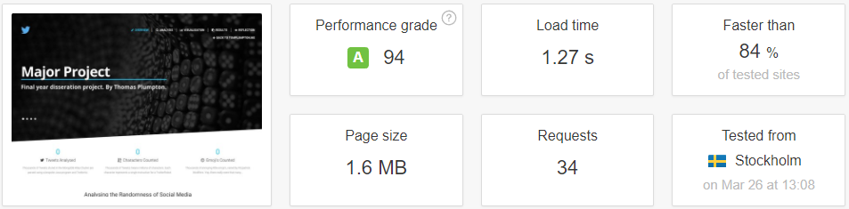

Figure 74 - Pingdom.com Summary

The next section then breaks down the performance grade into its constituent parts that form the average. Some of these were already very good at 90+, however, some where very low. The main problem I had here was ‘Leverage browser caching’. This meant that my site was not telling the browser to cache many of the commonly used files such as CSS stylesheets and JavaScript scripts. To improve this, I had to add an expiry map variable to the NGINX server block.

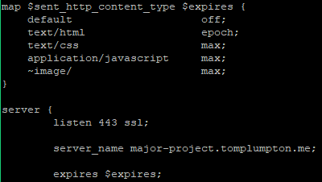

Figure 75 - Nginx Content Expiry Map

After adding this variable, re-testing the Nginx configuration and restarting the service, pingdom.com awarded the site a higher score for that insight which increasing the average significantly.

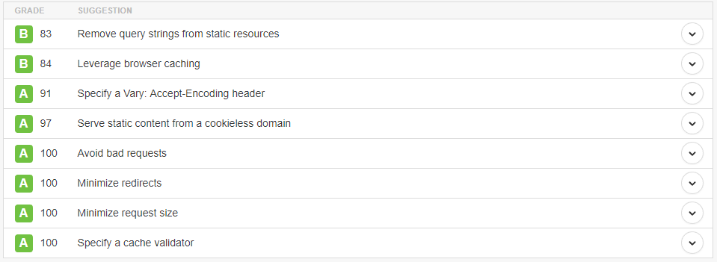

Figure 76 - Pingdom.com Performance Insights

The third section is an analytical overview of the content on the site. It provides two overview, one by content size and one by requests. It is immediately obvious that the images on the site make up the majority of the content by size, while Images, Scripts and CSS are roughly a third each of the requests.

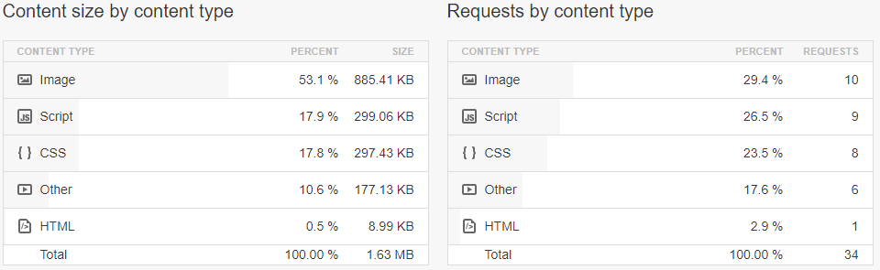

Figure 77 - Pingdom.com Content Size & Content Type

The fourth section extends the previous one and shows both the content size and requests by domain. We can see that the vast majority of these are on the sites domain itself, not from externally linked files on CDNs (Content Delivery Networks). This means that all the performance tweaks can actually be performed by myself as the external scripts and fonts only take up a marginal percentage of the site.

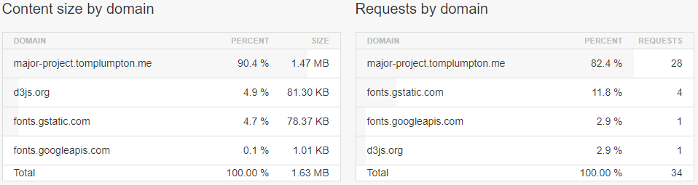

Figure 78 - Pingdom.com Content Size & Requests by Domain

The final section is the network performance waterfall. This shows a waterfall diagram of all the requests and assets of the website, how big they are and how long it took them to load. It provides a very useful and visual overview of what is bottlenecking the sites loading time. It allowed me to clearly see certain images that were taking too long to load. This section also allows you to sort them by file size, type, URL and load time.

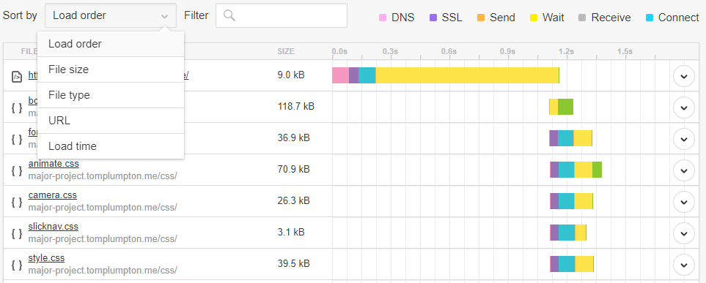

Figure 79 - Pingdom.com Network Performance Waterfall

The problem with some of the images on the site is their resolution. In order to ensure that they scale correctly on larger view ports at full-width, they needed to be high resolution. This also meant that their file size increase significantly. Once I had identified the images that were too large, I opened them in Adobe Photoshop CC 2018 and used the legacy option ‘Export for Web’ which removed a lot of the unnecessary meta from the image and scales down the quality slightly. The image ends up look almost identical, but with a vastly smaller file-size.

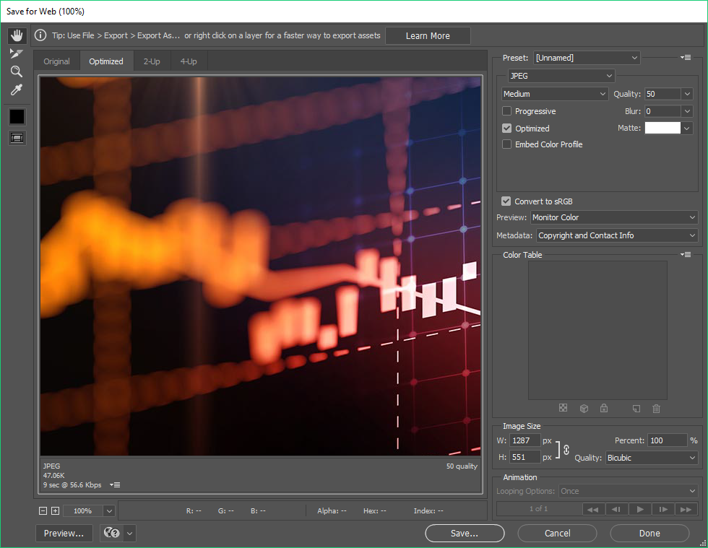

Figure 80 - Adobe Photoshop CC 2018 Save for Web Tool

After making all the aforementioned performance tweaks, plus removing any unnecessary images and scripts, the sites loading performance was increase dramatically. I also used the Google Chrome Developer tools that are built into the browser to monitor the status and performance of the site while developing.

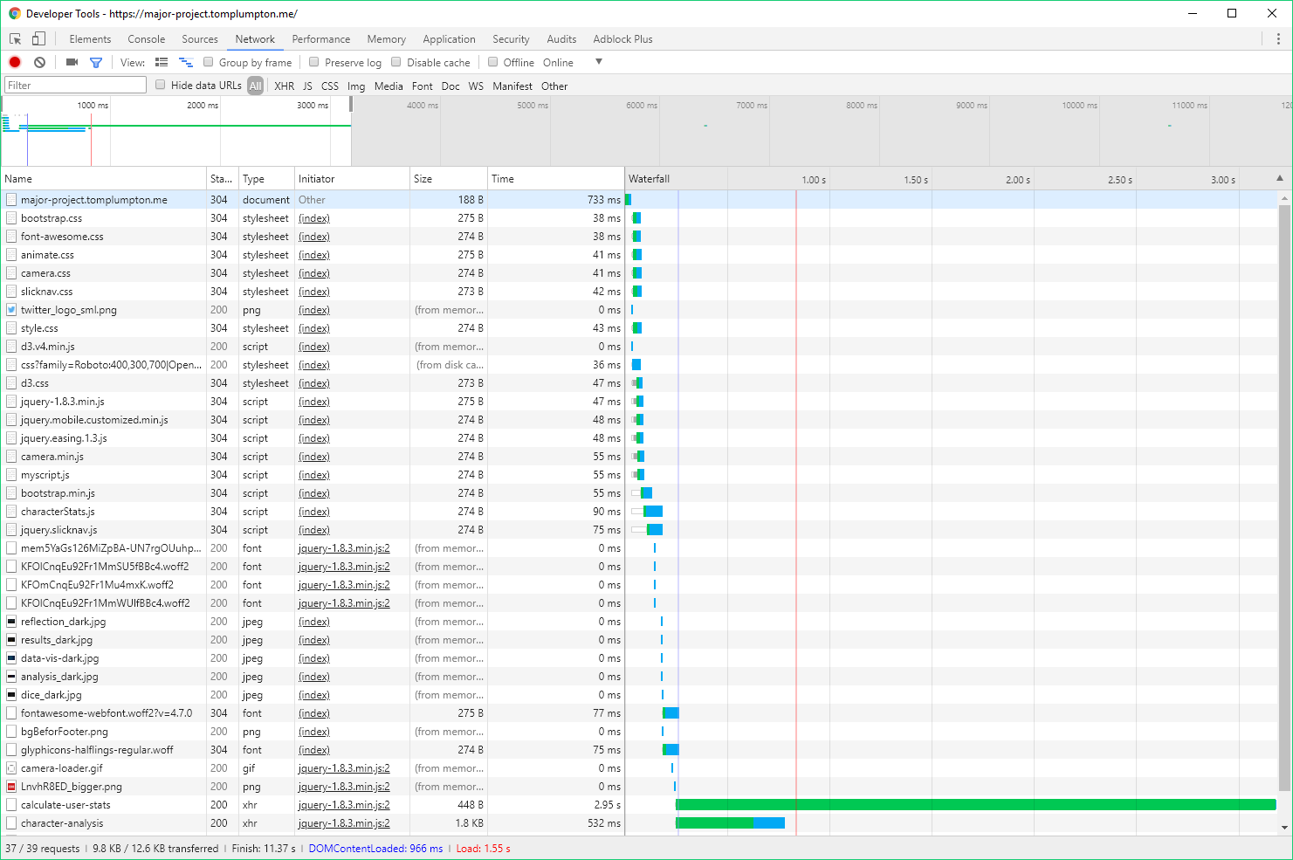

Figure 81 - Google Chrome Dev Tool - Network Performance

### [6.3.2] SSL Certificate & HTTPS

The website is hosted on a subdomain of my main website ‘https://tomplumpton.me’. This subdomain, ‘major-project.tomplumton.me’ needed the same SSL certificate as the main domain. I added it to the list of domains for the certificate, added the necessary HTTP redirects in the NGINX server blocks and pointed it to the certificate files.

In order to test the server configuration files, NGINX provides a Linux command **nginx -t** which will run a set of pre-written tests that checks all the configuration files for the server and all site-enabled.



Figure 82 - Nginx Reverse Proxy Service Configuration Testing

Once the test had successfully passed, I restarted the NGINX service using **sudo service nginx restart** and checked the website in several browsers to ensure that the SSL certificate had installed correctly, and that the server was serving files over HTTPS. The screenshots below show the green lock icon in multiple browsers.

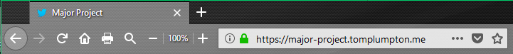

Figure 83 - Mozilla Firefox HTTPS recognition

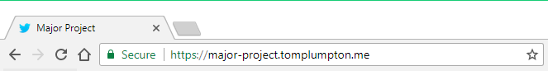

Figure 84 - Google Chrome HTTPS recognition



Figure 85 - Safari (iOS) HTTPS recognition

## [6.4] Mathematical Analysis

### [6.4.1] Validating the Regression Line

# [7] Results

This section displays the results from the final section of development. All collected data was stored in a MongoDB Atlas Cluster across several logically separated collections.

## [7.1] Tweets Collected

In total, I downloaded and stored 66,760 Tweets from 20 different Twitter users. The Tweets contained a total of 4,209,400 characters and 17,025 emoji.

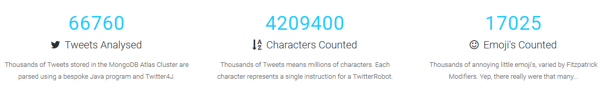

Figure 86 - Tweet Statistics Overview

The table below shows an overview of the collections in the MongoDB Atlas Cluster from the MongoCompass GUI.

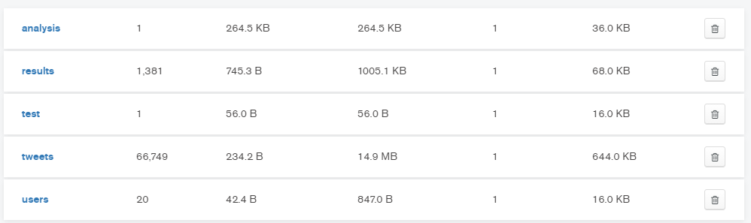

Figure 87 - Overview of MongoDB Atlas Collections

## [7.2] Data Visualisation

The following figures are the results of the data produced by the project. These figures will be used in the evaluation chapter for reference.



Figure 88 - Frequency of Characters Results

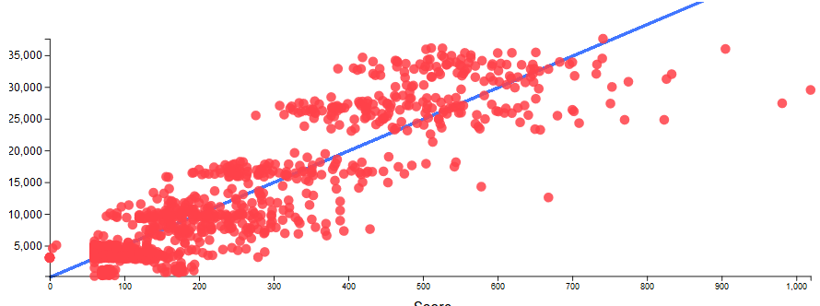

Figure 89 - Robocode Battle Data Results

## [7.3] Statistical & Mathematical Data

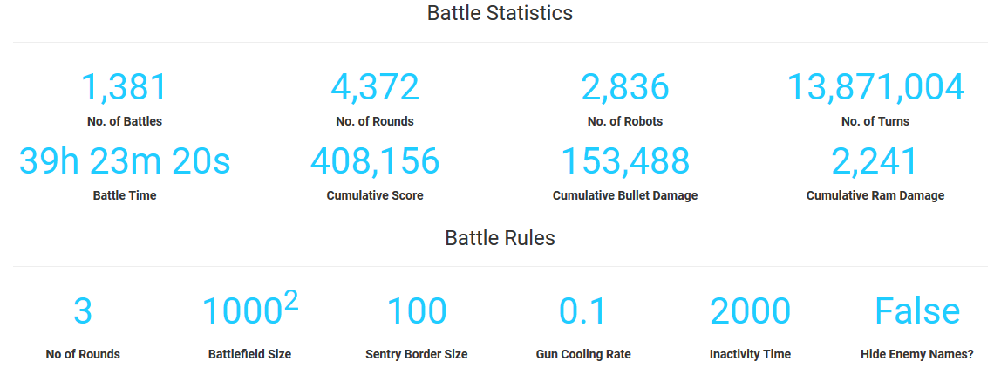

Figure 90 - Battle Statistics Results

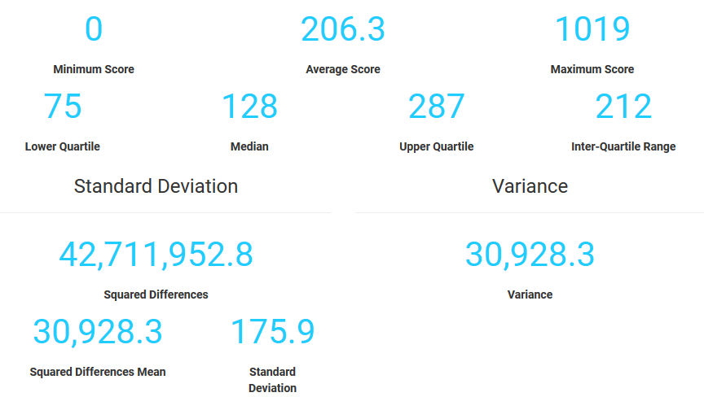

Figure 91 - Statistical Analysis Results

# [8] Evaluation

This section discusses the thought process and steps taken to evaluate the results that were collected from the project. As discussed in the Literature Review, the most difficult part of this project is making the decision that will form the conclusion. That decision is whether the data shows a pseudo-random or truly-random nature of generation. Several methods of mathematics and statistical analysis were carried out on the data in order to analyse it from lots of different angles. Each approach provided different information that affects the evaluation.

## [8.1] Tweet Analysis

Before graphing any of the Robocode battle results, I wanted to take a look into the Tweets and their characters as these would be the values that would be controlling the robots’ behaviour. I started by creating a bar chart graphing each letter in the alphabet and its relative frequency. I added in JavaScript functions to sort the bars in Ascending, Descending and Alphabetical. I also added mouse cursor hover events that allowed me to see the percentage as a decimal to two decimal places. Furthermore, I created a section on the page that allows you to look into the statistics of a particular users’ Tweets. It then shows the percentage of Tweets that container hyperlinks, Twitter mentions, hashtags and the word ‘Twitter’. It also shows the longest, average and shortest Tweet and the languages used.

### [8.1.1] Frequency of Characters

As illustrated in Chapter 2.1.3, the frequency of characters different from that of the Oxford English Dictionary. There were some letters that were drastically greater than the other source. We would expect the vowels to be the most common. Letters E, O and A did come up at 2nd, 3rd and 4th respectively. However, the most common occurring character in the Tweets I had collected was the letter ‘T’ at 10.7%. This seemed unusual until I realised that social media posts on Twitter tend to contain a lot of hyperlinks to webpages. The HTTP/HTTPS protocol contains two letter ‘T’s. Furthermore, the word ‘Twitter’ itself contains 3 letter ‘T’s. That’s why I decided to analyse those two statistics in the user analysis.

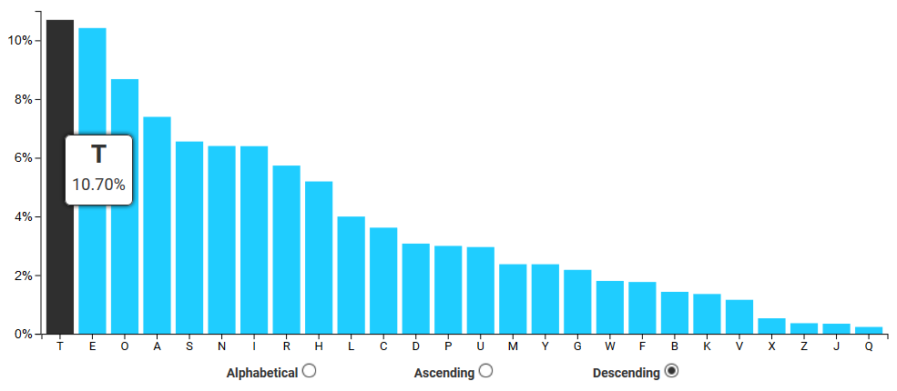

Figure 92 - Tweet Character Frequency Bar Chart (Sorted Descending)

### [8.1.2] Twitter Users

To evidence this hypothesis, 96.5% Tweets from Twitter user ‘CNN’ contained hyperlinks. Given that the sample for each user was 3200 is size, there are 6400 letter ‘T’s in the hyperlinks alone. However, only 0.5% of the Tweet strings contained the word ‘Twitter’.

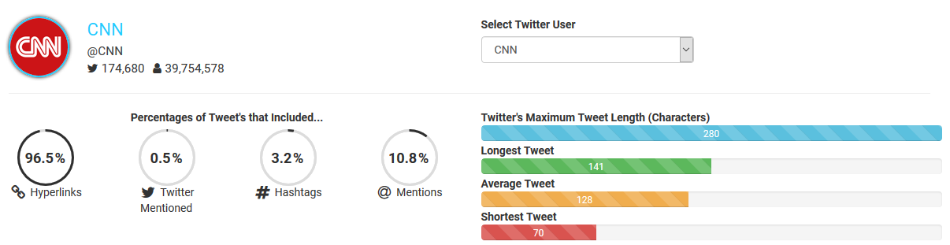

Figure 93 - Twitter User Analysis (CNN)

If we take a look at a different Twitter user of a different type, we can see a vast difference. A comedian such as Ed Byrne. Only 15% of his Tweets contained hyperlinks, whereas, 90.1% contained mentions. This means his Tweets have a large number of @ symbols. Although they were not parsed by the TweetParser for the RobotController, it still shows an interesting difference between the two users.

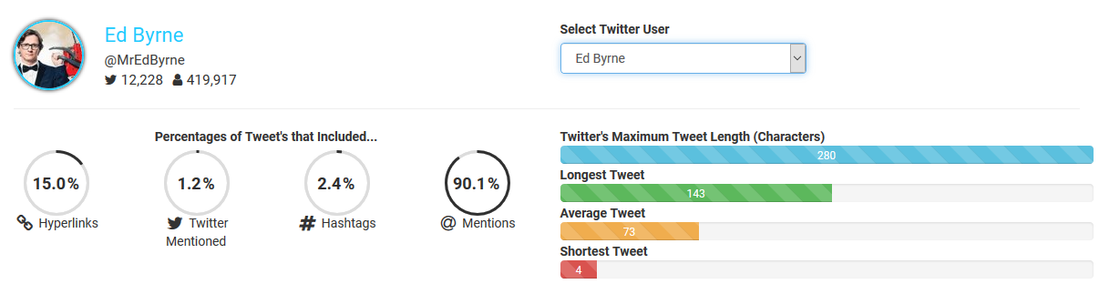

Figure 94 - Twitter User Analysis (Ed Byrne)

## [8.2] Scatter Plot Diagram

The first visualisation I produced with D3.JS was the scatter plot of all battles. I plotted one point per battle, where the x axis was the total score of the battle winner and the y axis was the number of turns taken during the battle. Usually, when Robocode is used, the Robot AI is hardcoded. We would except the score of the robot to increase as the number of turns increase. However, given that I had used the Tweets to control them, I wanted to evaluate the relationship between them with the data I had collected. Below is a statistical overview of the data that I collected.



Figure 95 - Robocode Battle Data Statistics

I ran simulations for ~40 hours. The battles had 1, 3, 5, 8 and 10 rounds, where the average number of rounds was 3.

### [8.2.1] Visual Analysis

The first battles I simulated has only a single round. I ran about 100 of them and plotted the on the graph. What I first noticed was that the spread of data was not very large. The score floor was 60 and the ceiling was 88. Even so, the data was quite sparse as you can see the spread across both the x and y axis. However, there were small groups where scores had collected along the y axis where the scores were the same but the number of turns differed.

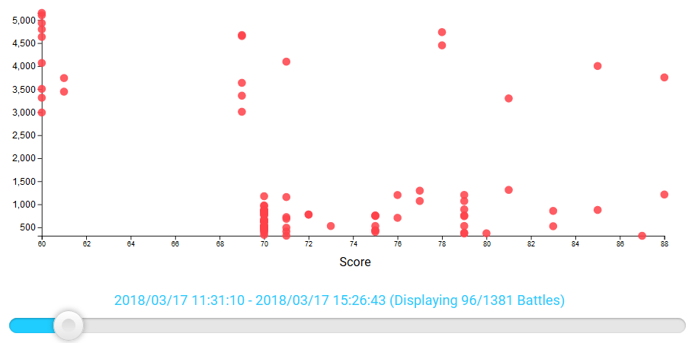

Figure 96 – Scatter Plot Graph (96 Battles)

I needed a greater range of data to validate the previous results. I changed the GameConfigurer constant for the number of rounds to 3 and simulated some more. I did this for 5, 8 and 10 rounds to increase both the sample size and the score ceiling. Increasing the number of displayed battles to 700 shows an obvious bias. Ignoring the anomalous results on the far left (circled in green), we can see 2 major groups of data. The largest of the two is towards the top of the plot. It starts when the score is greater than 60 and ends at about 130. The number of turns start about 3000 and end at about 5250. The second group is a smaller collection towards the bottom (circled in blue). I believe that because I simulated so many battles with the same specification, the results are bias and appear this way relative to the other results around the edges from the previous simulation.

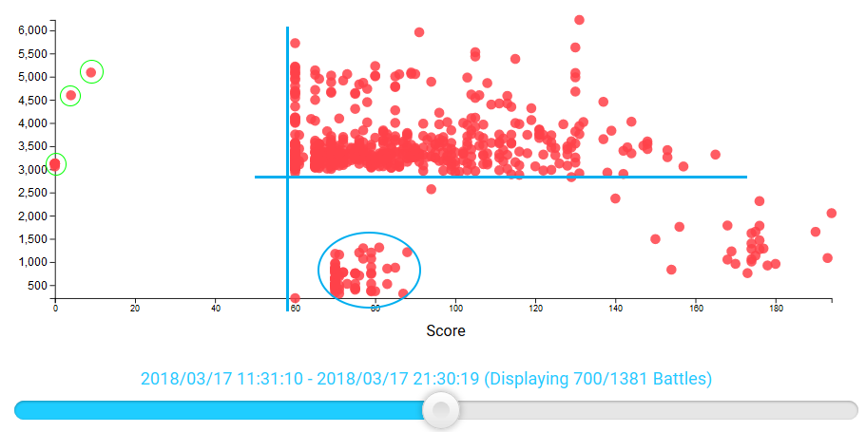

Figure 97 - Scatter Plot Graph (700 Battles)

If we zoom in on the larger group of plots, the data itself is spread out across both axes. This section of data essentially represents the ~600 battles that were simulated with the new number of rounds.

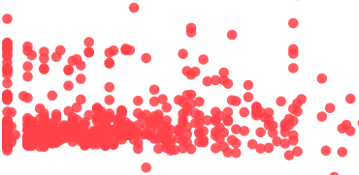

Figure 98 - Scatter Plot Graph (700 Battles Zoomed)

Displaying 1100 battles on the graph starts to show the latter end of the number of rounds. The score ceiling is significantly greater at ~650. We can now start to see a positive correlation following on from the cluster of results previously mentioned. There are a couple of anomalous battle results on the far right of the graph which push the score ceiling higher. However, removing these would simply stretch the graph to the right and still show the same trend and correlation.

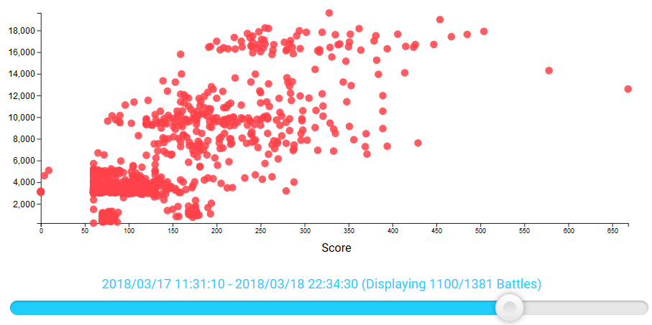

Figure 99 - Scatter Plot Graph (1110 Battles)

Finally, showing all the results simply strengthens the correlation. As the number of turns increases, the score of the battle winner also increases. We can see a strong positive correlation of scatter points on the graph when including 1, 3, 5, 8 and 10 rounds.

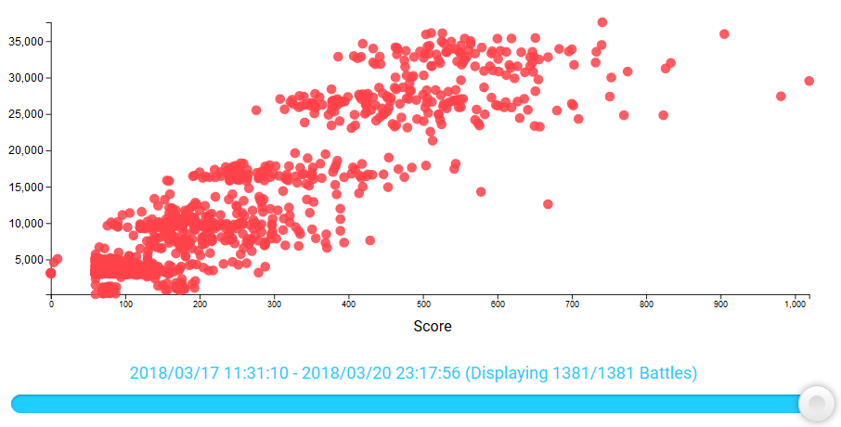

Figure 100 - Scatter Plot Graph (1381 Battles)

### [8.2.2] Regression of Least Squares

As discovered in the Background Research, there are lots of different types of linear regression and have different uses. The major use for this project is discovering trends in the data. The results of the statistical analysis of the scatter plot provide an equation in the form of y = mx + b where m is the gradient of the line and b is the y-axis intercept. The screenshot below shows the scatter diagram with all 1381 battles plotted.



Figure 101 - Simple Linear Regression (All Battles)

The equation of the regression line is shown below, where the gradient *m* and the y-intercept *b* are fixed to 2 decimal places.

$$y=51.27x-529.66$$

The gradient or ‘slope’ of the regression line is 51.27. This is a very steep gradient and tells us that as the value of x (Score) increases by 1, the value of y (Number of Turns) increases by 51.27. The number of turns therefore isn’t proportional to the score in a linear fashion. The y intercept can sometimes tell us something about the data, and sometimes not. In this case, the regression line intercepts the y-axis at -529.66. This makes no sense as there cannot be a negative number of rounds in a battle. Therefore, we cannot interpret anything about our data from the value of the y-intercept. (Rumsey, n.d.)

### [8.2.3] Data Sample Size

As mentioned in the Background Research, Chapter 2.1.2, sample size is an important factor to be considered during the evaluation. We know that the sample size effects the reliability and margin of error. Therefore, I made sure to simulate several hundred battles for each quantity of rounds in the battle. Also, I implemented the slider that allows you to scrub through a timeline of all records and updates the graph accordingly. Starting from the earliest record on the far left, scrubbing through to the right shows how the sample size effects the data and it increases in size.

A good demonstration of this is the equation of the regression line. At approximately 335 battles, the equation of the regression line is $y=1.38x+2826.02$. If we were to stop collecting data at this point, the interpretation from this equation would be completely different. This suggests that the number of rounds increases almost proportionally to the score as the gradient of the line is 1.38. However, as we saw, increasing the dataset size increase the accuracy of the data and slowly bring the equation to its final form of $y=51.27x-529.66$.

### [8.2.4] Median, Range & Quartiles

I thought that this mathematical approach was very useful. Truly-random numbers should not have any discernible patterns. Therefore, knowing the spread of the values might tell us something about the numbers produced. The greater the standard deviation value, the greater the spread is.



Figure 102 - Robocode Score Data (Scores & Quartiles)

The figure above shows the overview of results for this section. I wrote JavaScript functions that calculated the minimum, average and maximum score. The lower quartile, median, upper quartile and inter-quartile range. Then the standard deviation and the variance. We can first see that although the minimum score is 0, and the maximum is 1019, the average is very low at 206.3. That’s approximately 20% of the way into the score range. The lower quartile ($q_{1}$) is quite low at 75 and the upper quartile ($q_{3}$) is very low at a mere 287. This means that our inter-quartile range ( $q_{3}- q_{1})$ is 212. The interquartile range (IQR) describes the middle 50% of the score values when they are ordered from lowest to highest and is not affected by outliers. Because the IQR is so low, we can see that there was a clear bias in the range of scores produced by the robots in Robocode. (ABS, 2013)

### [8.2.5] Standard Deviation & Variance



Figure 103 - Robocode Score Data (Standard Deviation & Variance)

The variance and standard deviation are measures of the spread of the data around the mean, where the mean is the average value from the dataset. They summarise how close each datum is to the mean value. A dataset that has a small spread has values that are very close to the mean, resulting in a small variance and standard deviation. Conversely, a dataset that is more dispersed, the values are further away from the mean, leading to a larger variance and standard deviation. The smaller the variance and standard deviation, the more the mean value is indicative of the whole dataset. The mean value from the Robocode battle dataset is 206.3 (1 D.P). The standard deviation is 175.9 (1 D.P). This value is very close to the mean value given that the range of the data is 1019 ($Range=MAX\left(1019\right)-MIN(0))$. This suggests that the spread of the data is not very large. (ABS, 2013)

## [8.3] Robocode Vs JavaScript Random

Before I made the conclusion, I wanted to solidify the evidence found the evaluation by comparing the results of the battles with random numbers generated by the pseudo-random function **random()** in the Math class.

# [9] Conclusion

Short Answer

Pseudo-Random.

Long Answer

Let me explain.

To recap, the difference between pseudo-random and truly-random numbers is that pseudo-random number generators produce numbers that are deterministic. If we can determine them, they must have a discernible trend, pattern and correlation. On the other hand, truly-random generated numbers are the opposite. Like the decay of a radioactive isotope, they are un-predictable. However, given our increasingly better understanding of computing, technology and algorithms, we are able to write pseudo-random number generators that are very close to true ones. This means that the numbers they produce are for all intents and purposes ‘random’, albeit they are pre-determined from a table of values and are therefore technically not *truly­*-random.

With the aforementioned definitions in mind, it didn’t take too long to come to the conclusion that the numbers generated by the Robots in Robocode from the Tweets are not truly-random. As discussed in the evaluation, there are clear patters and correlation to the data plotted on the scatter graph. The relationship between the battle score and number of turns was as expected, as one increases, so does the other. However, it’s not all bad. Although the data was restricted to a range of 0-1019, the spread of the data inside that range was quite sparse. The statistical analysis of the standard deviation and variance does not support this as the standard deviation was quite close to the median value. However, I believe that because the majority of the battles had 3 rounds, it created a bias and skewed the data in favour of that sub-dataset. This is most likely why the interquartile range is so small. Instead, if we take an even number of data from each number of rounds, we can see that they are actually quite sparse within the overall range.

Nonetheless, it doesn’t change the fact the data is definitely not truly-random.

# [10] Reflection

This chapter of the report was completed after the project had finished and the conclusions had been drawn.

## [10.1] Issues & Limitations

I knew from the outset of the project that it would provide lots of academic challenge. I had picked a project idea that involved lots of technical skills. Although I was familiar with all the basics of Java, JavaScript, MongoDB and D3.JS, there were lots of parts that I had to learn and figure out.

Academic Challenge

As I progressed deeper into project development, I realised that I’d bitten off more than I could chew. The complexity of the algorithm required to parse the Tweets for Robocode that I had planned was far too great. Looking ahead at what needed be done, and the possible issues that could arise, I decided to simplify the algorithm. Instead of parsing every character in the Tweets (Letters, Numbers, Symbols, Emojis etc.), I decided to sanitise the strings and keep only the letters. These letters would produce a value between 0 and 25. I understood that this would reduce the quality of the data and therefore reflect in the results and conclusion, however, I had to make sure that I could finish the development and build the JavaScript elements for the analysis.

Issues with Robocode & Java

During the Java development stage of the agile process, I had to write a Java program that interfaced with both the Twitter and Robocode API’s. Twitter wasn’t too much of an issue, simple trial and error saw me through the development of the Twitter related classes. Once I had the Tweets downloaded and serialised, I could then work on the Robot classes. I had an issue with loading custom Robot classes into the RobocodeEngine in my GameConfigurer. Weeks elapsed with no progression, I’d tried countless different methods to resolve the issue. After conversing with Flemming N. Larsen, one of the major contributors to the source code of Robocode, I told him my issue and he agreed to take a look. After studying my code and its problem, he debugged it and found the cause. He patched and updated the game, releasing the .JAR of the new version for me. It turned out it was technically impossible for me to fix the problem as it was an issue with the game itself.

Time Limitations

Considering the aforementioned problems regarding the academic challenge, plus all the other smaller issues that I haven’t mentioned, it posed a deadline issue. I decided to cut the development short and produce results with the simplified algorithm, with intention to go back at the end and improve it, if there was time. After developing the website with all the JavaScript functionality, analysis, results, evaluation and conclusion, there just wasn’t enough time.

D3.JS Performance

Because D3 works by manipulating SVG elements in the DOM (Document Object Model), large datasets can cause performance problems for the browser. The scatter diagram had over 1000 records passed to it, meaning that it created over 1000 SVG circles, mouse over and on click events for the browser to handle. This quickly uses up the available memory and causes the animations to lag.

## [10.2] The Positives

Not everything went wrong, lots of parts of the project were very positive, productive and enjoyable.

Developing the Web Application

The third stage of the program development was the smoothest and easiest stage. Because of the prior experience I had with the MEAN Stack, I was able to quickly create and configure the application, set up the basic page and host it on my personal AWS (Amazon Web Services) EC2 (Elastic Compute Cloud) Linux instance. This was useful for the project as it freed up time for me to work on the more important parts of the project such as the development of the JavaScript functionality that was used to visualise the data and perform the statistical analysis.

Project Management & Organisation

I planned a lot of the project during the early stages, as documented in Chapter 4 – Analysis & Design. This made the development stages run smoother as I knew what I had to create. There were of course lots of parts that were unexpected and had to be modified or developed on-the-fly, but the vast majority of it was as planned. Furthermore, the usage of Git VCS and GitHub made pushing the web application to the live server easier and provided peace of mind the project files were backed up and audited via Git’s version history of commits. The project was also synced via my personal Dropbox account which ensured that all the files were synched and up-to-date across all my devices during development. This again ensured there was another backup and meant that no duplicates were created, or work was lost.

Drawing a Conclusion

This may just be a testament to the correlation and trends in the final visualisation of the results, but the conclusion was an easy decision to make. I knew right from the very start of planning the project that if the data was to produce results and visualisations that had ambiguous correlation, that the decision-making process would be very difficult. It would have required further research into determining whether or not numbers were pseudo or truly random. The fact that the numbers turned out to be pseudo-random does not make the project a failure, in fact, it was something that was expected as a possible outcome due to the nature of the project.

## [10.3] What Have I Learnt?

Technical Skills

Throughout the project I had to familiarise myself with new libraries and concepts that I hadn’t used before. For example, I had never created a scatter plot diagram with D3 before. I’ve also refreshed my Java skills by using it for the Robocode and Twitter development. This has also introduced me to several new concepts in Object Orientated Programming that will definitely be helpful in the future. I was introduced to the Twitter API which also meant I learnt more about RESTful APIs and Rate Limiting.

Mathematical & Statistical Knowledge

The final section of the project involved the use of statistical methods such as linear regress, standard deviation, variance and quartiles. I learned a few things about data and its sparsity and also how to calculate such figures in JavaScript. It’d had been a while since I last used this kind of maths and it was a good refresher for some of it.

Agile Development

Having used agile development methodologies for this project, I have gained a better appreciation and understanding for its use. Splitting the project into logical, manageable chunks made the project easier to work on and more responsive to change. The project changed a lot as it evolved to improve or avoid road blocks. The agile process made it easy to adapt to these changes and refactor parts of the code easily without losing lots of progress. Using the traditional waterfall methodology for a project of this type would have most like resulted in a catastrophic failure due to the unclear requirements at the start.

Planning is Important

As mentioned, there were issues with completing the project to its full potential which caused time limitations. These issues made it clear just how important it is to plan the project in advance and maybe even test pieces of pseudo-code to see if it is a valid plan for the timeline that was available to work in. Before the major project was started, I produced a Gantt chart that planned out the duration of each task. In theory, this plan should allow all tasks to be completed within the given time window. However, in practice, unexpected issues and road-blocks cause certain tasks to overflow their given time allocation and further tasks themselves are created as the project develops and evolves.

## [10.4] What Would I Improve/Change?

Initial Planning Phase

Given that the Gantt chart solution did not provide any helpful time management for the project, a different approach to the initial planning phase would definitely be helpful if I were to do the project, or something similar, again.

Data Visualisation Library

If I were to do the project again, or improve the existing state of it, I would choose a different data visualisation library for JavaScript that is better suited to large data sets. Such library would have to work differently to D3 in the backend and use something like the HTML canvas instead. This would vastly improve the performance of the graphs on the webpage and would open up the possibility to work with even larger datasets.

Robocode Tweet Parsing Algorithm

One major element of the program that needed improving was the Java code that parsed the Tweets and produced the values for the Robots. This was the major variable in the whole process that determined the results of the project. As mentioned, there was not enough time to make the algorithm as complex as I would have liked. Therefore, if I were to improve the project in the future, I would spend more time improving and testing the TweetParser class that the RobotController uses.

Data Collection & Visual Analysis

As discussed in the conclusion, I felt that the data was skewed and created a bias due to the fact that I had not simulated an even number of battles for each number of rounds. If I were to do the project again or re-collect the data, I would ensure that I keep the sub-sample sizes the same size to ensure that the experiment is fair and eliminates this factor from the analysis.

# [11] Glossary of Terms

|  |  |
| --- | --- |
| **Term** | **Definition** |
| Agile | Relating to or denoting a method of project management, used especially for software development that is characterized by the division of tasks into short phases of work and frequent reassessment and adaptation of plans. |
| AJAX | Asynchronous JavaScript and XML is a method of building interactive applications for the Web that process user requests immediately. |
| AI | Artificial Intelligence, the simulation of human intelligence processes by machines, especially computer systems. |
| API | A set of functions and procedures that allow the creation of applications which access the features or data of an operating system, application, or other service. |
| Cache | An auxiliary memory from which high-speed retrieval is possible. |
| CDN | A content delivery network (CDN) is a system of distributed servers (network) that deliver pages and other Web content to a user, based on the geographic locations of the user, the origin of the webpage and the content delivery server. |
| Class | In object-oriented programming , a class is a template definition of the methods and variables in a particular kind of object. |
| Classpath | Classpath is a parameter in the Java Virtual Machine or the Java compiler that specifies the location of user-defined classes and packages. The parameter may be set either on the command-line, or through an environment variable. |
| CSV | A CSV is a comma separated values file which allows data to be saved in a table structured format. CSVs look like a garden-variety spreadsheet but with a .csv extension. Traditionally they take the form of a text file containing information separated by commas, hence the name. |
| D3.JS | A JavaScript library for producing dynamic, interactive data visualizations in web browsers. |
| DOM | The Document Object Model (DOM) is an application programming interface (API) for valid HTML and well-formed XML documents. It defines the logical structure of documents and the way a document is accessed and manipulated. |
| Dropbox | Dropbox is a personal cloud storage service (sometimes referred to as an online backup service) that is frequently used for file sharing and collaboration. |
| DSL | Domain-Specific Language. A computer language specialized to a particular application domain. This is in contrast to a general-purpose language (GPL), which is broadly applicable across domains. ... Simpler DSLs, particularly ones used by a single application, are sometimes informally called mini-languages. |
| Facebook | Facebook is a popular free social networking website that allows registered users to create profiles, upload photos and video, send messages and keep in touch with friends, family and colleagues. |
| GET | GET is a HTTP request usually intended to retrieve some data, and is expected to be idempotent (repeating the query does not have any side-effects) and can only send limited amounts of parameter data to the server. |
| Git | A version control system for tracking changes in computer files and coordinating work on those files among multiple people. It is primarily used for source code management in software development, but it can be used to keep track of changes in any set of files. |
| GitHub | GitHub (originally known as Logical Awesome LLC) is a web-based hosting service for version control using git. |
| Gradle | An open-source build automation system that builds upon the concepts of Apache Ant and Apache Maven and introduces a Groovy-based domain-specific language (DSL) instead of the XML form used by Apache Maven for declaring the project configuration. |
| GUI | Graphical User Interface. A type of user interface that allows users to interact with electronic devices through graphical icons and visual indicators such as secondary notation, instead of text-based user interfaces, typed command labels or text navigation. |
| Heap | The heap memory segment is an area of memory used for dynamic allocations, meaning that blocks of memory can be allocated and freed in an arbitrary order and accessed multiple times (as opposed to the stack, which is Last-In-First-Out). |
| HTML | Hypertext Markup Language, a standardized system for tagging text files to achieve font, colour, graphic, and hyperlink effects on World Wide Web pages. |
| HTTP | Hyper Text Transfer Protocol. HTTP is the underlying protocol used by the World Wide Web and this protocol defines how messages are formatted and transmitted, and what actions Web servers and browsers should take in response to various commands. |
| HTTPS | Hypertext Transfer Protocol Secure (HTTPS) is a variant of the standard web transfer protocol (HTTP) that adds a layer of security on the data in transit through a secure socket layer (SSL) or transport layer security (TLS) protocol connection. |
| IDE | An integrated development environment (IDE) is a software application that provides comprehensive facilities to computer programmers for software development. |
| Instagram | Instagram is a free, online photo-sharing application and social network platform that was acquired by Facebook in 2012. |
| Java | A general-purpose computer programming language designed to produce programs that will run on any computer system. |
| JDK | The Java Development Kit (JDK) is a software development environment used for developing Java applications and applets. |
| JRE | The Java Runtime Environment (JRE) is a set of software tools for development of Java applications. |
| JSON | JSON (JavaScript Object Notation) is a lightweight data-interchange format. It is easy for humans to read and write. It is easy for machines to parse and generate. |
| JVM | Java Virtual Machine is the runtime engine of the Java Platform, which allows any program written in Java or other language compiled into Java bytecode to run on any computer that has a native JVM. |
| JavaScript | An object-oriented computer programming language commonly used to create interactive effects within web browsers. |
| MB | Megabyte. a unit of information equal to one million or, strictly, 1,048,576 bytes. |
| Method | A method in object-oriented programming is a procedure associated with a class. A method defines the behavior of the objects that are created from the class. |
| MongoDB | MongoDB is a cross-platform and open-source document-oriented database, a kind of NoSQL database. |
| OAuth | OAuth (Open Authorization) is an open standard for token-based authentication and authorization on the Internet. |
| OOP | Object-oriented programming (OOP) refers to a type of computer programming (software design) in which programmers define not only the data type of a data structure, but also the types of operations (functions) that can be applied to the data structure. |
| Oracle | A company that specializes primarily in developing and marketing database software and technology, cloud engineered systems and enterprise software products. |
| PRNG | Pseudo-Random Number Generator. A program written for, and used in, probability and statistics applications when large quantities of random digits are needed. |
| Quartile | Each of four equal groups into which a population can be divided according to the distribution of values of a particular variable. |
| RAM | Random Access Memory is a type of computer memory that can be accessed randomly; that is, any byte of memory can be accessed without touching the preceding bytes. |
| Robocode | Robocode is a programming orientated game, where the goal is to develop a robot battle tank to battle other tanks in Java or Microsoft .NET. |
| Server | A computer or computer program which manages access to a centralized resource or service in a network. |
| Standard Deviation | A quantity expressing by how much the members of a group differ from the mean value for the group. |
| SVG | Scalable Vector Graphics (SVG) is an XML-based vector image format for two-dimensional graphics with support for interactivity and animation. |
| Syntax | The structure of statements in a computer language. |
| TRNG | True-Random Number Generator. A mathematical construct, either computational or as a hardware device, that is designed to generate a random set of numbers that should not display any distinguishable patterns in their appearance or generation. |
| Tweet | See ‘Twitter’. |
| Twitter | An online news and social networking service where users post and interact with messages, "tweets", restricted to 140 characters. Registered users can post tweets, but those who are unregistered can only read them. |
| UI | User Interface, the means by which the user and a computer system interact, in particular the use of input devices and software. |
| UML | Unified Modeling language (UML) is a standardized modeling language enabling developers to specify, visualize, construct and document artifacts of a software system. |
| UX | User Experience, the overall experience of a person using a product such as a website or computer application, especially in terms of how easy or pleasing it is to use. |
| Variance | Variance is the expectation of the squared deviation of a random variable from its mean. Informally, it measures how far a set of (random) numbers are spread out from their average value. |
| VCS | Version Control System. A component of software configuration management, version control, also known as revision control or source control, is the management of changes to documents, computer programs, large web sites, and other collections of information. |
| VM | Virtual Machine. An emulation of a computer system. Virtual machines are based on computer architectures and provide functionality of a physical computer. |
| XML | Extensible Markup Language. A metalanguage which allows users to define their own customized markup languages, especially in order to display documents on the Internet. |

# [12] Bibliography

360logica, n.d. *Agile Development – Advantages, Disadvantages and when to use it?.* [Online]   
Available at: http://www.360logica.com/blog/agile-development-advantages-disadvantages-and-when-to-use-it/  
[Accessed 30 11 2017].

ABS, 2013. *Statistical Language - Measures of Spread.* [Online]   
Available at: http://www.abs.gov.au/websitedbs/a3121120.nsf/home/statistical+language+-+measures+of+spread  
[Accessed 27 04 2018].

Anon., 2017. *The Importance and Effect of Sample Size.* [Online]   
Available at: https://select-statistics.co.uk/blog/importance-effect-sample-size/

Anon., n.d. *The frequency of the letters of the alphabet in English.* [Online]   
Available at: https://www3.nd.edu/~busiforc/handouts/cryptography/letterfrequencies.html  
[Accessed 19 01 2018].

Anon., n.d. *Linear Regression.* [Online]   
Available at: http://www.stat.yale.edu/Courses/1997-98/101/linreg.htm  
[Accessed 19 12 2017].

Atwood, J., 2008. *Understanding Model-View-Controller.* [Online]   
Available at: https://blog.codinghorror.com/understanding-model-view-controller/  
[Accessed 05 03 2018].

Bell, L., 2017. *What is caching and how does it work?.* [Online]   
Available at: http://www.wired.co.uk/article/caching-cached-data-explained-delete

Bostock, M., 2017. [Online]   
Available at: https://d3js.org/

Bostock, M., 2017. *Data-Driven Documents.* [Online]   
Available at: https://d3js.org/  
[Accessed 06 12 2017].

Chavan, Y., 2016. *Disable java mongoDB application console logging.* [Online]   
Available at: http://www.technicalkeeda.com/java-mongodb-tutorials/disable-java-mongodb-application-console-logging  
[Accessed 01 03 2018].

Cunningham, A., 2014. *The bizarre, mind-numbing, mesmerizing beauty of “Twitch Plays Pokémon”.* [Online]   
Available at: https://arstechnica.com/gaming/2014/02/the-bizarre-mind-numbing-mesmerizing-beauty-of-twitch-plays-pokemon/  
[Accessed 12 03 2017].

Dua, T., 2016. *The year in emojis, in 5 charts.* [Online]   
Available at: https://digiday.com/careers/year-emojis-5-charts/  
[Accessed 09 01 2018].

Emogi, 2016. *2016 Emoji Report.* [Online]   
Available at: http://cdn.emogi.com/docs/reports/2016_emoji_report.pdf  
[Accessed 18 01 2018].

Emojipedia, 2018. *FAQ.* [Online]   
Available at: https://emojipedia.org/faq/  
[Accessed 18 01 2018].

Foote, K., 2016. *A Review of Different Database Types: Relational versus Non-Relational.* [Online]   
Available at: http://www.dataversity.net/review-pros-cons-different-databases-relational-versus-non-relational/  
[Accessed 12 12 2017].

Gee, T., 2014. *Getting Started with MongoDB and Java: Part I.* [Online]   
Available at: https://www.mongodb.com/blog/post/getting-started-with-mongodb-and-java-part-i  
[Accessed 08 01 2018].

Haahr, D. M., 2017. *Pseudo-Random Number Generators (PRNGs).* [Online]   
Available at: https://www.random.org/randomness/  
[Accessed 06 12 2017].

Haahr, M., 2017. *Introduction to Randomness and Random Numbers.* [Online]   
Available at: https://www.random.org/randomness/

Heller, B., 2016. *Analytics 101: Choosing the right database.* [Online]   
Available at: https://reflect.io/blog/analytics-101-choosing-the-right-database/  
[Accessed 25 12 2017].

Hern, A., 2015. *Don't know the difference between emoji and emoticons? Let me explain.* [Online]   
Available at: https://www.theguardian.com/technology/2015/feb/06/difference-between-emoji-and-emoticons-explained  
[Accessed 18 01 2018].

itinfo, 2017. *Software Development Methodologies.* [Online]   
Available at: http://www.itinfo.am/eng/software-development-methodologies/  
[Accessed 26 11 2017].

Jenkov, J., 2015. *Java Lambda Expressions.* [Online]   
Available at: http://tutorials.jenkov.com/java/lambda-expressions.html  
[Accessed 11 01 2018].

JetBrains, 2017. *DataGrip.* [Online]   
Available at: https://www.jetbrains.com/datagrip/  
[Accessed 18 12 2017].

JetBrains, 2017. *Gradle.* [Online]   
Available at: https://www.jetbrains.com/help/idea/gradle.html  
[Accessed 08 01 2018].

JetBrains, 2017. *IntelliJ IDEA.* [Online]   
Available at: https://www.jetbrains.com/idea/  
[Accessed 13 12 2017].

JetBrains, 2017. *jetbrains.com.* [Online]   
Available at: https://www.jetbrains.com/  
[Accessed 22 12 2017].

JetBrains, 2017. *WebStorm.* [Online]   
Available at: https://www.jetbrains.com/webstorm/  
[Accessed 13 12 2017].

Larsen, F. N., 2017. *Interface BorderSentry.* [Online]   
Available at: http://robocode.sourceforge.net/docs/robocode/robocode/BorderSentry.html  
[Accessed 20 04 2018].

Larsen, F. N., 2018. *BorderGuard.java.* [Online]   
Available at: https://github.com/robo-code/robocode/blob/master/robocode.samples/src/main/java/samplesentry/BorderGuard.java  
[Accessed 20 04 2018].

Leonhard, M., 2010. *StackOverflow.* [Online]   
Available at: https://stackoverflow.com/questions/88838/how-to-convert-strings-to-and-from-utf8-byte-arrays-in-java  
[Accessed 08 11 2017].

Mathew Nelson, F. L. R. M. P. S., 2017. *Class AdvancedRobot.* [Online]   
Available at: http://robocode.sourceforge.net/docs/robocode/robocode/AdvancedRobot.html  
[Accessed 22 02 2018].

MathsIsFun, 2017. *Standard Deviation and Variance.* [Online]   
Available at: http://www.mathsisfun.com/data/standard-deviation.html  
[Accessed 19 12 2017].

MathsIsFun, 2017. *Standard Deviation and Variance.* [Online]   
Available at: http://www.mathsisfun.com/data/standard-deviation.html  
[Accessed 06 04 2018].

mathsteacher.com, 2017. *Quartiles.* [Online]   
Available at: http://www.mathsteacher.com.au/year9/ch17_statistics/06_quartiles/quartiles.htm  
[Accessed 26 04 2018].

McLaughlin, M., n.d. *What Is Agile Methodology?.* [Online]   
Available at: https://www.versionone.com/agile-101/agile-methodologies/  
[Accessed 30 11 2017].

Microsoft, 2017. *.Net Framework system requiremets.* [Online]   
Available at: https://docs.microsoft.com/en-us/dotnet/framework/get-started/system-requirements  
[Accessed 16 12 2017].

MongoDB, 2018. *Java Driver Example.* [Online]   
Available at: https://docs.atlas.mongodb.com/driver-connection/#java-driver-example  
[Accessed 08 01 2018].

MongoDB, 2018. *MongoDB Java Driver.* [Online]   
Available at: https://mongodb.github.io/mongo-java-driver/  
[Accessed 08 01 2018].

mykong, 2013. *Mykong.com.* [Online]   
Available at: https://www.mkyong.com/java/how-to-read-and-parse-csv-file-in-java/  
[Accessed 08 11 2017].

Nations, D., 2017. *What Is a Tweet on Twitter?.* [Online]   
Available at: https://www.lifewire.com/what-is-a-tweet-3486211  
[Accessed 03 12 2017].

Nelson, F., 2013. *ReadMe for Robocode.* [Online]   
Available at: http://robocode.sourceforge.net/docs/ReadMe.html  
[Accessed 16 12 2017].

Nivas, 2015. *StackOverflow.* [Online]   
Available at: https://stackoverflow.com/questions/3666007/how-to-serialize-object-to-csv-file  
[Accessed 08 11 2017].

OAuth, 2017. [Online]   
Available at: https://oauth.net/

Oloruntoba, S., 2015. *S.O.L.I.D: The First 5 Principles of Object Oriented Design.* [Online]   
Available at: https://scotch.io/bar-talk/s-o-l-i-d-the-first-five-principles-of-object-oriented-design  
[Accessed 18 12 2017].

Oracle, 2017. *Oracle Fact Sheet.* [Online]   
[Accessed 11 01 2018].

Powell-Morse, A., 2016. *Rapid Application Development (RAD).* [Online]   
Available at: https://airbrake.io/blog/sdlc/rapid-application-development  
[Accessed 06 12 2017].

Raj, J., 2014. *An Introduction to the MEAN Stack.* [Online]   
Available at: https://www.sitepoint.com/introduction-mean-stack/  
[Accessed 23 12 2017].

Random.org, 2017. *Analysis.* [Online]   
Available at: https://www.random.org/analysis/  
[Accessed 19 12 2017].

Robocode, 2017. *Robocode.* [Online]   
Available at: http://robocode.sourceforge.net/

Robocode, 2017. *Robocode Home.* [Online]   
Available at: http://robocode.sourceforge.net/  
[Accessed 12 12 2017].

Robowiki, 2017. *Frequently Asked Questions.* [Online]   
Available at: http://robowiki.net/wiki/Robocode/FAQ  
[Accessed 22 02 2018].

Robowiki, 2017. *Game Physics.* [Online]   
Available at: http://robowiki.net/wiki/Robocode/Game_Physics  
[Accessed 19 01 2018].

Robowiki, 2017. *Robocode/Robot Anatomy.* [Online]   
Available at: http://robowiki.net/wiki/Robocode/Robot_Anatomy  
[Accessed 19 01 2018].

Robowiki, 2017. *Running Robocode From Eclipse.* [Online]   
Available at: http://robowiki.net/wiki/Robocode/Eclipse/Running_from_Eclipse  
[Accessed 22 02 2018].

Robowiki, 2018. *AdvancedRobot.* [Online]   
Available at: http://robowiki.net/wiki/AdvancedRobot  
[Accessed 22 02 2018].

Rumsey, D. J., n.d. *How to Interpret a Regression Line.* [Online]   
Available at: http://www.dummies.com/education/math/statistics/how-to-interpret-a-regression-line/  
[Accessed 24 04 2018].

Singhal, V., 2015. *20 best JavaScript charting libraries.* [Online]   
Available at: https://thenextweb.com/dd/2015/06/12/20-best-javascript-chart-libraries/  
[Accessed 18 12 2017].

Singh, R., 2017. *Java 8 CompletableFuture Tutorial.* [Online]   
Available at: https://www.callicoder.com/java-8-completablefuture-tutorial/  
[Accessed 08 01 2018].

Skau, D., 2013. *Why D3.js is So Great for Data Visualization.* [Online]   
Available at: https://visual.ly/blog/why-d3-js-is-so-great-for-data-visualization/  
[Accessed 01 01 2018].

Solutions, S., 2013. *What is Linear Regression?.* [Online]   
Available at: https://www.statisticssolutions.com/what-is-linear-regression/  
[Accessed 06 04 2018].

StackOverflow, 2018. *Javadoc.* [Online]   
Available at: https://stackoverflow.com/questions/19172015/what-exactly-is-javadoc  
[Accessed 18 01 2018].

TheEclipseFoundation, 2017. *Desktop IDE's.* [Online]   
Available at: https://www.eclipse.org/ide/  
[Accessed 16 12 2017].

tutorialspoint, 2017. *Java - Serialization.* [Online]   
Available at: https://www.tutorialspoint.com/java/java_serialization.htm  
[Accessed 08 11 2017].

tutorialspoint, 2017. *MongoDB - Advantages.* [Online]   
Available at: https://www.tutorialspoint.com/mongodb/mongodb_advantages.htm  
[Accessed 13 12 17].

Twitch, 2017. *About.* [Online]   
Available at: https://www.twitch.tv/p/about  
[Accessed 08 03 2017].

Twitter, 2017. [Online]   
Available at: https://apps.twitter.com

Twitter, 2017. [Online]   
Available at: https://developer.twitter.com/en/docs/basics/rate-limiting

Twitter, 2017. *Counting characters.* [Online]   
Available at: https://developer.twitter.com/en/docs/basics/counting-characters  
[Accessed 03 12 2017].

Twitter, 2017. *Twitter.* [Online]   
Available at: https://twitter.com/  
[Accessed 30 12 2017].

Twitter4J, 2017. *Twitter4J.* [Online]   
Available at: http://twitter4j.org/en/index.html  
[Accessed 16 12 2017].

TwitterDev, 2017. *Tweet data dictionaries.* [Online]   
Available at: https://developer.twitter.com/en/docs/tweets/data-dictionary/overview/tweet-object  
[Accessed 03 12 2017].

TwitterDeveloper, 2017. *Rate Limiting.* [Online]   
Available at: https://developer.twitter.com/en/docs/basics/rate-limiting  
[Accessed 16 12 2017].

TwitterDeveloper, 2017. *Twitter libraries.* [Online]   
Available at: https://developer.twitter.com/en/docs/developer-utilities/twitter-libraries  
[Accessed 16 12 2017].

TwitterInc., 2018. *Streaming API.* [Online]   
Available at: https://developer.twitter.com/en/docs/tweets/filter-realtime/api-reference/post-statuses-filter  
[Accessed 22 01 2018].

Veracode, 2017. *WHAT IS AN INTEGRATED DEVELOPMENT ENVIRONMENT (IDE)?.* [Online]   
Available at: https://www.veracode.com/security/integrated-development-environments  
[Accessed 12 12 2017].

versionone.com, 2017. *What Is Agile Software Development?.* [Online]   
Available at: https://www.versionone.com/agile-101/  
[Accessed 28 11 2017].

VisualParadigm, 2017. *UML Association vs Aggregation vs Composition.* [Online]   
Available at: https://www.visual-paradigm.com/guide/uml-unified-modeling-language/uml-aggregation-vs-composition/  
[Accessed 11 01 2018].

VSauce, 2014. *What Is Random?.* [Online]   
Available at: https://www.youtube.com/watch?v=9rIy0xY99a0  
[Accessed 06 12 2017].

Wikipedia, 2017. *Gradle.* [Online]   
Available at: https://en.wikipedia.org/wiki/Gradle  
[Accessed 08 01 2018].

Wikipedia, 2017. *Java (programming language).* [Online]   
Available at: https://en.wikipedia.org/wiki/Java_(programming_language)  
[Accessed 11 01 2018].

Wikipedia, 2017. *Java version history.* [Online]   
Available at: https://en.wikipedia.org/wiki/Java_version_history  
[Accessed 11 01 2018].

Wikipedia, 2017. *JetBrains.* [Online]   
Available at: https://en.wikipedia.org/wiki/JetBrains  
[Accessed 22 12 2017].

Wikipedia, 2017. *Twitch Plays Pokémon.* [Online]   
Available at: https://en.wikipedia.org/wiki/Twitch_Plays_Pok%C3%A9mon  
[Accessed 05 03 2017].

Wikipedia, n.d. *Twitch Plays Pokémon.* [Online]   
Available at: https://en.wikipedia.org/wiki/Twitch_Plays_Pok%C3%A9mon  
[Accessed 05 03 2017].

# [13] Appendices

## [13.1] Terms of Reference

Student Details

**Name:** Thomas Plumpton

**Identification Number:** 1500936

**Email:** tp2amt@bolton.ac.uk

Project Title

Analysing the Random Nature of Social Media

Date of Production

13/10/2017

Background & Overview

Randomness is a mathematical concept that is commonly misunderstood. Computer-generated random numbers are not *truly* random, they are actually *pseudo*-random. This means that although they appear to be random, they are really pre-determined. Although Pseudo-Random Number Generation (PRNG) is efficient and deterministic, these are not desirable attributes in scenarios that require True-Random Number Generation (TRNG). Such scenarios include the generation of data encryption keys and cryptography or simulation of natural phenomena like weather.

This project aims to analyse and determine the random nature of the social media platform ‘Twitter’ by parsing a number of Tweets and using them to control the virtual robots in a game called ‘Robocode’. The data produced will be analysed to determine whether it is pseudo or truly random in an attempt to produce a new method of generating truly random numbers. The inspiration for this project originates from a social experiment called ‘Twitch Play Pokémon’.

Twitch is the world’s leading social video platform for streaming gaming oriented content around the world. It was founded in June 2011 and currently amasses nearly 10 million visitors every day. The site is popular among both veteran and aspiring YouTubers and attracts the attention of big e-sports players and tournaments. (Twitch, 2017)

Twitch Plays Pokémon (TPP) was a social experiment by an anonymous Australian programmer and involves streaming a game of Pokémon on Twitch in the Game Boy emulator ‘VisualBoyAdvance’. The anonymous programmer developed an Internet Relay Chat (IRC) bot, written in Python, which captures messages from the Twitch chat and parses those strings directly into commands for the game. The stream soon became popular and reached approximately 60,000 concurrent playing users. It took nearly 16 continuous days to complete the first game ‘Pokémon Red’. Since then, numerous other Pokémon games from the franchise have been hosted and streamed on Twitch for the users to collaborate on. (Wikipedia, n.d.) (Cunningham, 2014)

Robocode is a lightweight, open-source, programming game developed by Mathew A. Nelson as a personal endeavour in 2000. The goal is to create a virtual robot by writing the code yourself in Java or Microsoft .NET. The game acts as an intermediary between Twitter and the data visualisation by converting the parsed Tweets into instructions to control the robots and run the game.

Mathematics plays an important role in the conclusion of the project. Methods such as statistical regression and standard deviation should be used to determine the random nature of the results output from Robocode and graphed via D3.JS. This will conclude whether Twitter can be used as a TRNG.

Objectives

1. Design & implement a program to download Tweets from Twitter.
2. Investigate how to parse the downloaded Tweets for Robocode.
3. Investigate how to build upon the existing Robocode source code.
4. Create Java code for Robocode and investigate User Experience (UX).
5. Investigate Java connection to databases to store data output.
6. Create web application in NodeJS to host D3.JS Data Visualisation.
7. Connect database to NodeJS and graphically visualise data.
8. Use statistical techniques to determine random nature of the output data.
9. Conclude and evaluate results, consider real world applications.

Constraints

* Robocode requires Java or Microsoft .NET
* Twitter REST API allows only 15 calls every 15 minutes. It also restricts the request to a maximum of 3200 tweets per call.
* Consent to access public profiles

Resources

All software and online resources are open-source and therefore freely available, with the exception of the JetBrains Suite which is free to students.

Software:

* Java IDE (JetBrains IntelliJ IDEA)
* Editor / Web Development Environment (JetBrains WebStorm)
* SQL IDE (JetBrains DataGrip)
* Internet Connection

Technical Skills:

* Java 8
* HTML5 / Pug / Jade (Web Mark-up Languages)
* CSS3 (Cascading Stylesheet)
* JavaScript (Client & Server Side)
* NodeJS (Runtime Environment)
* D3.JS (Data Driven Documents) JavaScript Library

Services:

* Twitter Development API
* Robocode Development API
* Twitter4J Development API

Reporting

1. **Name:** Abdul Razak

**Role:** Project Supervisor

**Responsibilities:** Overseeing project. Weekly meetings will be held to ensure the work is on track and completed in a competent manner.

1. **Name:** Andrew Parker

**Role:** Research Guidance

**Responsibilities:** Provide guidance and helpful tips on database and object-orientated related tasks.

1. **Name:** Amanda Dewhurst & Louise Ashby

**Role:** Report & Literature Guidance

**Responsibilities:** Fortnightly meetings to review current project documents and ensure deadlines are correct and on track.

## [13.2] Literature Review

[1] Introduction

This project aims to analyse and determine the random nature of the social media platform ‘Twitter’ by parsing Tweets and using them to control the virtual robots in a programming game called ‘Robocode’. The data produced will be analysed to determine whether it is pseudo or truly random in an attempt to produce a new method of generating truly random numbers. The inspiration for this project originates from a social experiment called ‘Twitch Play Pokémon’.

Twitch is the world’s leading social video platform for streaming gaming-oriented content around the world. It was founded in June 2011 and currently amasses nearly 10 million visitors every day. The site is popular among both veteran and aspiring YouTubers and attracts the attention of big e-sports players and tournaments. (Twitch, 2017)

Twitch Plays Pokémon (TPP) was a social experiment by an anonymous Australian programmer and involves streaming a game of Pokémon on Twitch in the Game Boy emulator ‘VisualBoyAdvance’. The anonymous programmer developed an Internet Relay Chat (IRC) bot, written in Python, which captures messages from the Twitch chat and parses those strings directly into commands for the game. The stream soon became popular and reached approximately 60,000 concurrent playing users. It took nearly 16 continuous days to complete the first game ‘Pokémon Red’. Since then, numerous other Pokémon games from the franchise have been hosted and streamed on Twitch for the users to collaborate on. (Wikipedia, 2017) (Cunningham, 2014)

Robocode is a lightweight, open-source, programming game developed by Mathew A. Nelson as a personal endeavour in 2000. The goal is to create a virtual robot by writing the code yourself in Java or Microsoft .NET. The game acts as an intermediary between Twitter and the data visualisation by converting the parsed Tweets into instructions to control the robots and run the game. (Robocode, 2017)

Mathematics plays an important role in the conclusion of the project. Methods such as statistical regression and standard deviation should be used to determine the random nature of the results output from Robocode and graphed via D3.JS. This will conclude whether Twitter can be used as a TRNG.

This literature review intends to report on knowledge and ideas established from the given research findings. It assesses the relative strengths and weaknesses of such research and provides an opinion on the various findings. The latter end of the review evaluates and reflects on the research findings and justifies the choices that were ultimately made.

[2] Approach & Methods

The approach to the project requires a high degree of technical and mathematical knowledge. It makes extensive use of both object-orientated and procedural programming. Web development knowledge is also required which warrants the need for languages such as HTML, CSS, JavaScript and other libraries that provide helpful ‘out-of-the-box’ functionality. The required mathematical knowledge is mainly statistical. The author of this project has prior knowledge and experience with high-level statistics from studying Mathematics at A-Level and such skills are directly transferrable to this project.

In order to write a literature review, it is essential that a wide range of relevant literature is assessed to produce research on the given topic. This includes sources such as websites, books, journals and sampled research such as questionnaires. However, given the obscurity of this projects' specification, there is little scholarly research available online that is directly relevant to the scope of the project. This is not the case for all of the research topics covered, nonetheless, the majority of literature sources for this review are available online.

[3] Research Findings

The following section describes the research that was carried out on the project specifics. This includes discovering possible technologies and development methodologies.

[3.1] Twitch Plays Pokémon

Twitch Plays Pokémon is the social experiment that inspired the initial idea for this project. Therefore, it is important to research into the inner workings of the experiment to gain a better understanding of how it works and how it was developed.

The original concept was developed by an anonymous Australian programmer, so there is no official developer documentation available. However, what we do know is that the script responsible for parsing chat commands on Twitch was written in a programming language called Python. The script interfaced with a Gameboy emulator called ‘VisualBoyAdvance’. The script captures directional commands such as “A”, “B”, “Select” and “Start” which are sent to the emulator to control the game. An additional webpage was developed in JavaScript which was used to display a tally of moves that are shown within the stream. (Wikipedia, 2017)

This project takes this loose concept of controlling a game via an external influence but takes a tangential approach. Instead of text input from an IRC, the text contents of a Tweet will be used to control the Robots in Robocode.

[3.2] Software Development Methodologies

A software or system development methodology is a framework used to structure, plan and control the process of the development of an information system. The ‘traditional’ methodology is called ‘Waterfall’ but has since been superseded by newer modern methods that yield far greater efficiency, time management and cost savings. Such methodologies include Agile Software Development, Scrum, Rapid Application Development (RAD) and Extreme Programming (XP). There are many more out there all with their own advantages that cater to specific use cases. (itinfo, 2017)

Considering that all the aforementioned development methodologies are designed for software, *in theory*, any of them could be used and therefore be deemed ‘suitable’. However, given the modularity and highly technical nature of the project, there are a few which stand out from the crowd.

**Agile Software Development**

Agile Development is an umbrella term for several iterative and incremental software development methodologies. Some of the more popular agile methodologies include Extreme Programming (XP), Scrum, Crystal and Feature-Driven Development (FDD). Although there are various agile methodologies that have their own unique approach, they all ultimately have the same vision and core values. The fundamentals of an agile methodology include iteration with continuous feedback to successively refine and deliver a software system. (versionone.com, 2017)

Such methodologies allow changes to be made at any point during development and ensure customer satisfaction. They allow the project to adapt to changes in circumstances meaning the software can be dynamic. This can ultimately save time and money as other methodologies may require the project to be started from the beginning if the requirements change. (360logica, n.d.)

**Rapid Application Development (RAD)**

Rapid Application Development is another software development methodology which heavily emphasizes rapid prototyping and iterative delivery. This method is a sharp alternative to the conventional waterfall model which heavily relies on having absolute system requirements and sequential design practices. (Powell-Morse, 2016)

One of the major advantages of RAD is that the methodology itself was designed around software development. To elucidate, given that software development is malleable and in constant evolution, a methodology that revolves around iterative delivery and experimentation is a perfect match. (Powell-Morse, 2016)

**Feature-Driven Development (FDD)**

The third and final suitable methodology for this project is Feature Driven Development. This is another variant of agile methodology and begins by establishing an overall model shape. However, unlike other methodologies, FDD uses the idea of “design by feature, build by feature”. Short iterations of development produce these small features that are useful to the clients. Developing my feature is one of eight development practices. Others include; Domain Object Modelling; Configuration Management and Inspections. (McLaughlin, n.d.)

[3.3] Software Design Principles

There are many design principles, patterns and general etiquette which a programmer must conform to when writing high quality, extensible code. Referred to as the ‘First Five Object-Orientated Design Principles’, S.O.L.I.D is an acronym that stands for such. It stands for the following principles;

* **S**ingle Responsibility Principle (SRP)
* **O**pen Closed Principle (OCP)
* **L**iskov Substitution Principle (LSP)
* **I**nterface Segregation Principle (ISP)
* **D**ependency Inversion Principle (DIP)

To summarise each of these design principles;

The Single Responsibility Principle says that a class should have one and only one reason to change, meaning that a class should only have one job. The Open Closed Principle says that Objects or entities should be open for extension, but closed for modification. The Liskov Substitution Principle states that functions that use pointers or references to base classes must be able to use objects of derived classes without knowing it. The Interface Segregation Principle says that a client should never be forced to implement an interface that it doesn’t use, or clients shouldn’t be forced to depend on methods they do not use. Finally, the Dependency Inversion Principle states that entities must depend on abstractions, not on concentrations. High-level modules must not depend on the low-level module, but they should depend on abstractions. (Oloruntoba, 2015)

[3.4] Development Tools

Given the technical nature of this project, it is desirable from a development standpoint to choose tools that provide a smooth and efficient workflow. The first part of the project involves Java programming. Therefore, a Java Integrated Development Environment (IDE) is required.

An IDE is an application that facilitates software and application development. They are designed to encompass all programming tasks in one application. Subject to the language they include a code editor for writing source code. This differs from a regular text editor as it can provide intelligent suggestions to improve your code and has syntax highlighting to make code more readable. They have compilers built in and automatically compiles code each time you save, removing the need for the developers to manually compile from the command line. They also include debugging tools that can help developers find and fix problems in the code by ‘stepping through’ each line of execution to find the bug. Finally, some IDE’s have build automation tools that help automate some of the developers’ common tasks to increase workflow efficiency and save time. (Veracode, 2017)

Eclipse is a very popular IDE famous for Java but also supports C, C++ and PHP. It provides all of the desired functionality and advantages that a developer would expect from an IDE. (TheEclipseFoundation, 2017)

JetBrains, formerly IntelliJ, is a software development company who create tools targeted towards software developers and project managers. (Wikipedia, 2017) Their suite of software has vastly expanded and now has a respectable 4 million users and have been adopted by reputable companies such as Valve, Samsung and NASA. (JetBrains, 2017)

[3.5] Twitter Social Network

**Twitter Java Library**

The first major section of the project involves connect to the Twitter API in a Java program so that Tweets can be downloaded from a user’s timeline. This functionality is not natively supported in the Java API and so a third-party, community-written library is required to achieve this. The official Twitter Developer Documentation lists all known functioning libraries that work with their API and there is only one listed under Java. This library is called ‘Twitter4J’, meaning ‘Twitter for Java’ and was published by Twitter handle @yusuke. (TwitterDeveloper, 2017)

Although Twitter4J is an unofficial Java library for the Twitter API, it is open-source and is available to download from GitHub. The website provides all the necessary .JAR files that can simply be copied in the Java programs’ classpath to be used. The site also provides full Java Documentation (JavaDoc) which makes it easy to understand how the library works and how to use it. (Twitter4J, 2017)

**Constraints**

The Twitter API has a restriction called ‘Rate Limiting’. This means that each user and access token has 15 requests per rate limit window. The HTTP GET request window is 15 minutes (Twitter, 2017). To access a user timeline, the ‘getUserTimeline’ method returns an object upon invocation. This object contains useful information such as date posted, username, profile image and tweet text. Furthermore, this particular method only allows a maximum of 3200 objects to be returned. Therefore, assuming every account used has a posted at least 3200 tweets, a maximum of 48,000 (15 x 3200) Tweets can be downloaded per 15 minutes.

To overcome the rate limiting restriction, the Twitter Development Documentation suggests methods to avoid being rate limited. One suggestion is the use of ‘Caching’. This involves storing the API responses in the application or site if you expect to be using them a lot. The data can then be loaded from the local data store to ensure that calls are made to the API as infrequently as possible. (TwitterDeveloper, 2017)

[3.6] Robocode Programming Game

Robocode also imposes its own constraints on the project. Programming in Robocode is limited to either Java or a language from Microsoft’s .NET Framework such as C#. Subject to the chosen language, there are specific system requirements that must be met.

Java requires that the Java 6 Standard Edition (SE) or newer must be installed on the system. Both the Java Runtime Environment (JRE) and the Java Developer Kit (JDK) must be installed. There are also important environment variables that must be set up prior to running Robocode. Detailed specification can be found on the Robocode ReadMe on Sourcefource.net [here](http://robocode.sourceforge.net/docs/ReadMe.html). (Nelson, 2013)

.NET requires an API Plug-In to be installed on top of Robocode. This can be done by downloading the Robocode .Net .JAR file and running it. Furthermore, the .NET Framework itself needs installing which requires you to be running a Microsoft Windows Operating System and that the computer meets their minimum hardware specification requirements. (Microsoft, 2017)

[3.7] Database Technologies

A database is required to store the results from Robocode so they can be used further on in the project, making it a fundamental piece of technology.

Some examples of database types include; RDBMS; OODMS; ORDBMS and NoSQL. One of the more commonly used Database Management System (DBMS) is the Relational model, which can be used to manage transaction-orientated applications (OLTP). Conversely, non-relational databases, more commonly referred to as ‘NoSQL’, use document and column stores opposed to relations. (Foote, 2016)

This project is highly dependent on large datasets. Therefore, a database that is good at handling large datasets is desirable.

[3.8] Data Visualisation & Web Development

As previously mentioned, this project relies on large quantities of data. Therefore, in order to draw a conclusion from the findings, the data needs to be formatted and visualised so that a mathematical analysis can be conducted. Considering the data is stored electronically in a database, it is quick and easy to send the data to a webpage. Therefore, a charting library will need to be chosen to graphically represent the data objects on the webpage.

There is a wide range of programming libraries for charting available online. The vast majority of them are open-source and therefore freely available. There are many JavaScript libraries that are emerging as the most powerful tools for visualising data in the form of easy to understand, interactive charts. Some examples of the popular charting libraries are Chartist.js, FusionCharts, D3.JS, Dygraphs and Highcharts. (Singhal, 2015)

Many of the JavaScript libraries fit the requirements for the project. However, D3 (Data Driven Documents) is powerful, open-source and conforms to the W3C web standards and is compatible across multiple browsers. D3 is a JavaScript Library for manipulating the DOM in order to bring static data to life. The library manipulates HTML markup by creating SVG elements to create re-sizable data visualisations. (Bostock, 2017)

**Visualisation Format**

The format in which the data is visualised is quite important as it affects how the data can be analysed. Due to the nature of this project, and the agile software development methodology that was adopted, a lot of the latter research is still undergoing and has not been carried out yet. As mentioned in the next section ‘Mathematical Data Analysis’ there are particular statistical methods that will warrant certain visualisation formats. These are likely to include line graphs and scatter graphs.

**MEAN Stack Development**

Furthermore, to facilitate the use of the data visualisation library, a runtime environment will need to be chosen in order to run server-side JavaScript files so that data can be sent to the webpage to be rendered on the client-side.

The term MEAN stack refers to a collection of JavaScript based technologies used to develop web applications. MEAN is an acronym for MongoDB, ExpressJS, AngularJS and NodeJS. From the client to the server to the back-end database, MEAN is full stack JavaScript. (Raj, 2014)

Considering that the best database technology for this project is MongoDB, and that it makes use of JavaScript libraries for graphing functionality, it would make sense to use the MEAN Stack for the web development. Because all of the technologies are JavaScript orientated, it means that no further programming languages are required, making development easier and removing the need to learn new language syntax.

[3.9] Random Number Generation

When we think of randomness, most people think of a coin flip or a dice roll, but what does ‘Random’ actually mean? We can define randomness as something that is un-predictable and contains no recognisable patterns. (VSauce, 2014)

**Pseudo-Random Number Generation (PRNG)**

A PRNG is an algorithm that generates ‘random’ numbers. However, unlike a dice roll or a lottery ticket, the outcome is pre-calculated from tables of data to produce a sequence of numbers that appear to random. Modern PRNG algorithms are good enough now such that the number produced look exactly like they are random. (Haahr, 2017)

To illustrate, Appendix 1 shows two bitmaps produced by different methods. A bitmap is a digital image composed of a matrix of dots. The first bitmap (on the left) is produced by Random.org and uses atmospheric pressure to generate the values used to produce the bitmap. Conversely, the second bitmap (on the right) is produced by the pseudo-random **rand()** function from the PHP API in Microsoft Windows. As you see, this bitmap shows a clear pattern due to the repetition of generated numbers.

**True-Random Number Generation (TRNG)**

A TRNG is similar to a PRNG in as it generates random numbers. However, there is one fundamental difference. The values produced by a TRNG are ‘truly-random’, whereas previously mentioned, those from a PRNG are ‘pseudo-random’.

[3.10] Mathematical Data Analysis

The final section of this project, before a conclusion is formed, is the mathematical analysis of the data. One all the Twitter Tweets have been serialised, passed into the Robocode program, and then exported from the match results, the data will be ready to be visualised and then analysed.

The problem, however, is it is impossible to definitively prove whether a given sequence of numbers is truly-random. The pragmatic approach is to take several sequences of random numbers produced by the RNG in question, then subject them to a series of statistical tests. As the sequences pass more test, our confidence in them (and the generator) increases. However, we also should expect some to fail as random numbers also pose the chance to appear non-random. But if lots of the test fail, we should question the random nature of the generator. (Random.org, 2017)

One approach is a simple visual analysis. As previously mentioned, the data will be graphed via the D3.JS JavaScript Library. Humans are good at spotting patterns; therefore, a visualisation allows use to simply use our eyes and brain to directly analyse the data. Beyond this, statistical attributes such as standard deviation and variance will be measured to gain a more empirical conclusion. Standard deviation is the measure of how spread out numbers are. To calculate it, you simply square root the variance. The variance is calculated by finding the average of the squared differences from the mean. The sample size used is important as the accuracy increases with the size of the dataset. (MathsIsFun, 2017)

Another statistical method useful to the analysis of the data is linear regression. There are different types of regression, but it essentially attempts to model the relationship between two variables by fitting a linear equation (a straight line) to the observed data. The most common method for fitting a regression line is the method of least squares. This method calculates the best-fitting line for the data by minimising the sum of the squares of the vertical deviations from each data point to the line. This method shows any obvious outliers, the general correlation of the data points and how spread they are from the best-fit line. See Appendix 2 for an example of a line of best fit. (Anon., n.d.)

[4] Evaluation & Reflection

The following section evaluates the previous research findings and reflects on the technologies and methodologies discovered. Conclusions are made on the chosen findings and justification is made to back them up.

[4.1] A Different Direction from Twitch Plays Pokémon

Due to the current direction this project is heading and how its objectives differ vastly from Twitch Plays Pokémon, no further research will be conducted on the experiment as this project now has its own foundation. It is clear that Twitch Plays Pokémon was simply the initial spark for an idea that is now heading in its own direction.

[4.2] Agile Software Development Methodology

During the research, there was one common element that was apparent in every agile software development methodology. This element was a team. Considering that this project is being under-taken by a single developer, a lot of the key aspects of the aforementioned methodologies break down and no longer provide the advantages that they should. Alternatively, a different hybrid approach was taken that involved taking inspiration from lots of different agile methodologies and applying them to the project as necessary.

[4.3] SOLID Software Design Principles

There are quite literally thousands of software design principles that can be chosen and implemented by a program developer. However, given the nature of this project and the small scale of the Java program that will be written, the aforementioned five SOLID design principles will be considered during development. Subject to the size and complexity of the program, some principles may not need to be considered as their implementation may heed negligible results or even detriment to the program performance.

[4.4] JetBrains Software Development Suite

The chosen software for the development of this project was the JetBrains Software Development Suite. The first piece of software is ‘IntelliJ IDEA’. IntelliJ is an IDE specifically designed to maximise developer productivity. It includes useful features such as code completion, framework assistance and VCS integration such as Git. All Java programming and management will be done in IntelliJ. (JetBrains, 2017)

The next piece of software is ‘WebStorm’. This is another IDE/Editor that is designed specifically for a JavaScript ecosystem. It shares many of the same advantages and features as IntelliJ but is tailed more towards web, mobile, server and desktop development. (JetBrains, 2017)

Finally, ‘DataGrip’ is a database IDE that is designed for SQL developers. It also shares many of the features and advantages of an IDE, but is tailored towards database development. DataGrip allows the developer to add multiple database connections into the software where they can be managed and manipulated. Currently, DataGrip does not have native NoSQL support, but does have a plug-in that provides this feature. (JetBrains, 2017)

[4.5] Object Serialisation & Comma Separated Values

As mentioned earlier in the findings, there are limitations to the Twitter API. The major issue is with the rate limiting then prevents developers from making more than 15 calls to the API every 15 minutes. There are temporary solutions such as caching which stores the commonly used data in memory to reduce the number of calls made in the session window. However, considering that a large sample size is desirable with regards to data accuracy, a long-term solution is required.

The decision to ‘serialise’ the download Tweets was made. This means that the data is stored locally on the computers disk storage. The data will be formatted in CSV (Comma Separated Value) files. Each line of the file will contain the text from a single Tweet, where each character is delimited by a comma. Each file will contain 48,000 tweets from a single API window. A script can be configured to automate the process and could run every 15 minutes in order to collect a greater number of Tweets.

[4.6] Java Object Orientated Programming

The first major element of this project is handled via Object Orientated Programming. As mentioned in the findings, the virtual robots in Robocode can be programmed in either Oracle’s Java, or in Microsoft’s .NET Framework which utilises languages such as C#, F# or Visual Basic.

Both options provide no realistic performance advantage over the other, therefore, I decided to use Java as I am familiar with the language, it’s syntax, and the API. Furthermore, my chosen development suite, by JetBrains, contains a piece of software called ‘IntelliJ IDEA’ which natively supports Java meaning I can reap the benefits that the IDE provides. Conversely, opting with the .NET Framework would mean learning am entirely new API and having to download and use a separate piece of software to develop in.

[4.7] MongoDB Non-Relational Database

There are quite literally thousands of different database technologies freely available online to choose from. Fortunately, the use-case for this database isn’t very complex. This means that the usual rules you would follow when choosing a database, aren’t too relevant. For example, it is normally important to consider the end result. This can reduce the change of any unpredictable queries popping up and causing serious performance problems. Considering that the queries used in this project are simply dumps of JSON data, consideration of the end result is not important. (Heller, 2016)

The document database ‘MongoDB’ was chosen for the project as it had many advantages over the conventional relational database. Firstly, MongoDB is ‘schema-less’, meaning it does not use schema models. This means that the structure of the data is not strict, and so each datum can have a different number of fields, content and sizes from the others. (tutorialspoint, 2017)

Moreover, MongoDB has a deep query ability using its document-based query language and also scales very well with size. Considering the huge quantity of Tweets that will be stored, of varying lengths, MongoDB caters for it very well.

To summarise, the research has shown that MongoDB is good for big data, clear object structure and deep querying and has therefore been selected as the database of choice for this project.

[4.8] D3.JS Data Visualisation JavaScript Library

D3.JS (Data Driven Documents – JavaScript Library) was chosen for a number of reasons. Firstly, it is very flexible and works seamlessly with existing web technologies and can manipulate any part of the Document Object Model (DOM). This gives it huge advantages over other libraries because it can be displayed however you like and isn’t limited to small regions of a webpage. (Skau, 2013)

D3 is also quick and easy to use as it can be linked and used in an HTML file using one line of markup. Finally, as mentioned earlier in the research findings, D3 also conforms to the W3C web standards and is compatible across all browsers which will ultimately eliminate any potential issues regarding compatibility. (Singhal, 2015)

[4.9] Differentiating PRNG and TRNG

Now we know the difference between pseudo and truly-random number generation, it is important to keep this information in mind during the project. This is especially the case towards the latter end of the project when all the data has been collected and is stored in the database. The mathematical analysis will produce lots of empirical data that will ultimately form the conclusion. However, the values produced from the statistical analysis won’t *really* mean anything without thinking about what they mean and placing them somewhere on the line between pseudo and true.

[4.10] Linear Regression & Standard Deviation

All of the methods in the research findings will be employed for the mathematical analysis of the data. This includes the aforementioned statistical methods such as Regression and Standard Deviation. At the time of writing this, the ‘method of least squares’ is planned to be used. However, future research may warrant the use of another type of regression. This applies to the mathematical analysis in general.

As research shows, there are lots of methods for determining the random nature of a set of numbers, so future research will dictate which methods are chosen to conclude the project.

[5] Version Log

|  |  |  |
| --- | --- | --- |
| **Version** | **Description** | **Date** |
| 1 | First Publication |  |

[6] Glossary of Terms

|  |  |
| --- | --- |
| **Term** | **Definition** |
| AAA | Pronounced ‘Triple-A’, refers to the information classification of mid to major publishers of video games. |
| Agile | Relating to or denoting a method of project management, used especially for software development, that is characterized by the division of tasks into short phases of work and frequent reassessment and adaptation of plans. |
| API | Application Programming Interface. A set of functions and procedures that allow the creation of applications which access the features or data of an operating system, application, or other service. |
| C | C is a high-level and general-purpose programming language that is ideal for developing firmware or portable applications. |
| C# | Pronounced “C-Sharp”. An object-oriented programming language from Microsoft that aims to combine the computing power of C++ with the programming ease of Visual Basic. C# is based on C++ and contains features similar to those of Java. |
| C++ | ++ is a general-purpose object-oriented programming (OOP) language, developed by Bjarne Stroustrup, and is an extension of the C language. It is therefore possible to code C++ in a "C style" or "object-oriented style." |
| Classpath | Classpath is a parameter in the Java Virtual Machine or the Java compiler that specifies the location of user-defined classes and packages. The parameter may be set either on the command-line, or through an environment variable. |
| D3 (.JS) | D3.JS (Data Driven Documents) is a JavaScript library used for creating SVG Data Visualisation on web pages. |
| DOM | Document Object Model. A programming API for HTML and XML documents. It defines the logical structure of documents and the way a document is accessed and manipulated. |
| F# | A strongly typed, multi-paradigm programming language that encompasses functional, imperative, and object-oriented programming methods. |
| FDD | Feature Driven Development. an iterative and incremental software development process. It is a lightweight or Agile method for developing software. FDD blends a number of industry-recognized best practices into a cohesive whole. |
| Game Boy | the first handheld electronic device for playing cartridge games; also called Game Boy Color, Game Boy Advance, Nintendo DS. Usage Note. trademark of Nintendo. Dictionary.com's 21st Century Lexicon. |
| GET | An HTTP command used to request a file from a Web server. GET is widely implemented in HTML files (Web pages) for making database queries that do not involve any updating at the server side. |
| Git | A version control system for tracking changes in computer files and coordinating work on those files among multiple people. It is primarily used for source code management in software development, but it can be used to keep track of changes in any set of files. |
| Handle | In the context of the social media platform ‘Twitter’, Each Twitter handle has a unique URL, with the handle added after twitter.com. Example: http://twitter.com/username. Hashtag -- A Twitter hashtag refers to a topic, keyword or phrase preceded by the # symbol. An example is #skydivinglessons. Hashtags are used to categorize messages on Twitter. |
| HTML | Hyper-Text Markup Language. A standardized system for tagging text files to achieve font, colour, graphic, and hyperlink effects on World Wide Web pages. |
| HTTP | Hyper-Text Transfer Protocol. HTTP is the underlying protocol used by the World Wide Web and this protocol defines how messages are formatted and transmitted, and what actions Web servers and browsers should take in response to various commands. |
| IDE | Integrated Development Environment. A piece of software used for managing and developing applications. |
| IRC | Internet Relay Chat. An application layer protocol that facilitates communication in the form of text. |
| Java | a general-purpose computer programming language designed to produce programs that will run on any computer system. |
| Javadoc | Javadoc (originally cased JavaDoc) is a documentation generator created by Sun Microsystems for the Java language (now owned by Oracle Corporation) for generating API documentation in HTML format from Java source code. |
| JavaScript | An object-oriented computer programming language commonly used to create interactive effects within web browsers. |
| JetBrains | JetBrains is a software development company whose tools are targeted to software developers and project managers. They have a large suite of intelligent software used for programming and web development. |
| MEAN | a collection of JavaScript based technologies used to develop web applications. MEAN is an acronym for MongoDB, ExpressJS, AngularJS and Node.js. From client to server to database, MEAN is full stack JavaScript. |
| NASA | National Aeronautics and Space Administration, the federal agency that is responsible for aerospace research, aeronautics, and the civilian space program. |
| NoSQL | A NoSQL (originally referring to "Non-SQL" or "non-relational") database provides a mechanism for storage and retrieval of data that is modelled in means other than the tabular relations used in relational databases. |
| OLTP | Online Transaction Processing. A class of software programs capable of supporting transaction-oriented applications on the Internet. Typically, OLTP systems are used for order entry, financial transactions, customer relationship management (CRM) and retail sales. |
| OODBMS | Object-Orientated Database Management System. A database management system that supports the creation and modelling of data as objects. OODBMS also includes support for classes of objects and the inheritance of class properties, and incorporates methods, subclasses and their objects. |
| OOP | Object Orientated Programming. A programming language model organized around objects rather than "actions" and data rather than logic. Historically, a program has been viewed as a logical procedure that takes input data, processes it, and produces output data. |
| ORDBMS | Object Relational Database Management System. A database management system (DBMS) similar to a relational database, but with an object-oriented database model: objects, classes and inheritance are directly supported in database schemas and in the query language. |
| PHP | Hyper-Text Processor. A script language and interpreter that is freely available and used primarily on Linux Web servers. |
| PRNG | Pseudo-Random Number Generation. A program written for, and used in, probability and statistics applications when large quantities of random digits are needed. |
| Python | An interpreted, object-oriented programming language developed by Guido van Rossum. The name comes from one of van Rossum's favourite television shows, Monty Python's Flying Circus. Python is very portable since Python interpreters are available for most operating system platforms. |
| RAD | Rapid Application Development. A suite of software development methodology techniques used to expedite software application development. RAD uses predefined prototyping techniques and tools to produce software applications. |
| RDBMS | Relational Database Management System. a database management system (DBMS) that is based on the relational model invented by Edgar F. Codd, of IBM's San Jose Research Laboratory. |
| Robocode | Robocode is a programming orientated game, where the goal is to develop a robot battle tank to battle other tanks in Java or Microsoft .NET. |
| Scrum | A framework for managing software development. It is designed for teams of three to nine developers who break their work into actions that can be completed within fixed duration cycles (called "sprints"), track progress and re-plan in daily 15-minute stand-up meetings, and collaborate to deliver workable software every sprint. |
| SVG | Scalable Vector Graphics (SVG) is an XML-based vector image format for two-dimensional graphics with support for interactivity and animation. The SVG specification is an open standard developed by the World Wide Web Consortium (W3C) since 1999. SVG images and their behaviours are defined in XML text files. |
| TPP | Twitch Plays Pokémon. A "social experiment" and channel on the video game live streaming website Twitch, consisting of a crowdsourced attempt to play Game Freak's and Nintendo's Pokémon video games by parsing commands sent by users through the channel's chat room. |
| TRNG | True-Random Number Generation. A mathematical construct, either computational or as a hardware device, that is designed to generate a random set of numbers that should not display any distinguishable patterns in their appearance or generation. |
| Twitch | Twitch is a live streaming video platform owned by Twitch Interactive, a subsidiary of Amazon.com. In 2015, Twitch announced it had more than 1.5 million broadcasters and 100 million visitors per month. |
| Twitter | witter is a free social networking microblogging service that allows registered members to broadcast short posts called tweets. |
| URL | Uniform Resource Locator. A protocol for specifying addresses on the Internet. |
| VCS | Version Control System. A component of software configuration management, version control, also known as revision control or source control, is the management of changes to documents, computer programs, large web sites, and other collections of information. |
| Visual Basic | Commonly abbreviated to VB, Visual Basic is a programming environment from Microsoft in which a programmer uses a graphical user interface (GUI) to choose and modify preselected sections of code written in the BASIC programming language. |
| Windows | The most widely used operating system for desktop and laptop computers. Developed by Microsoft, Windows primarily runs on x86-based computers (the ubiquitous PC), although versions have run on Intel's Itanium CPUs. |
| XP | Extreme Programming. A software development methodology which is intended to improve software quality and responsiveness to changing customer requirements. |

[7] Appendices

[7.1] Appendix 1 – True-Random Bitmap vs Pseudo-Random Bitmap

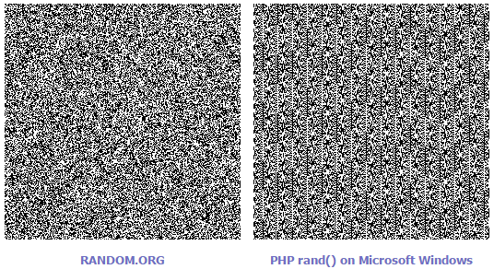

[7.2] Appendix 2 – Linear Line of Best Fit

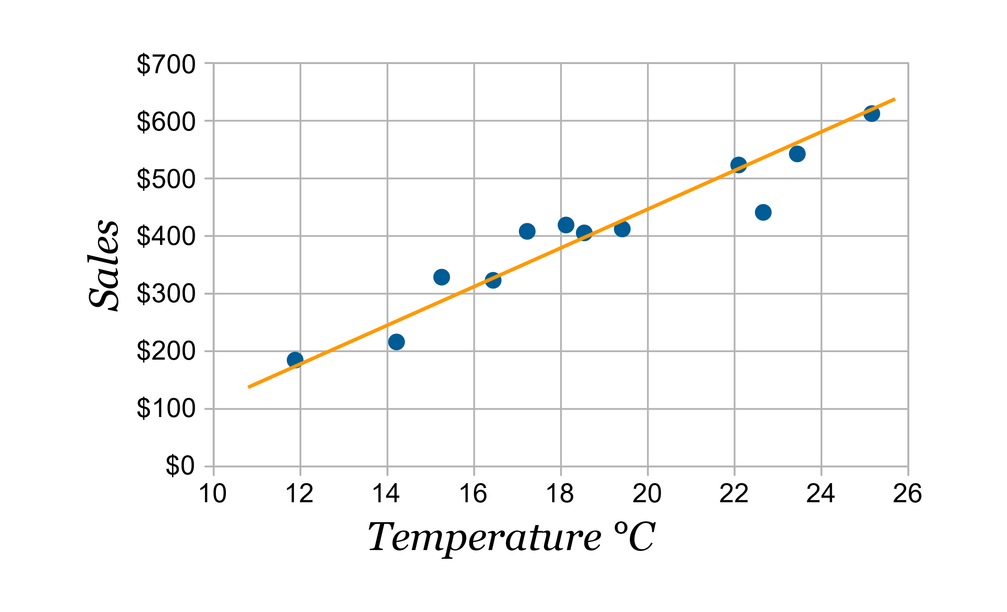

## [13.3] What is Twitch?

Twitch is the world’s leading social video platform for streaming gaming oriented content around the world. It was founded in June 2011 and currently amasses nearly 10 million visitors every day. The site is popular among both veteran and aspiring YouTubers and attracts the attention of big e-sports players and tournaments. (Twitch, 2017)

## [13.4] What is Robocode?

Robocode is a lightweight, open-source, programming game developed by Mathew A. Nelson as a personal endeavour in 2000. The goal is to create a virtual robot by writing the code yourself in Java or Microsoft .NET. The game acts as an intermediary between Twitter and the data visualisation by converting the parsed Tweets into instructions to control the robots and run the game. (Robocode, 2017)

## [13.5] What is Twitch Plays Pokémon?

Twitch Plays Pokémon (TPP) was a social experiment by an anonymous Australian programmer and involves streaming a game of Pokémon on Twitch in the Game Boy emulator ‘VisualBoyAdvance’. The anonymous programmer developed an Internet Relay Chat (IRC) bot, written in Python, which captures messages from the Twitch chat and parses those strings directly into commands for the game. The stream soon became popular and reached approximately 60,000 concurrent playing users. It took nearly 16 continuous days to complete the first game ‘Pokémon Red’. Since then, numerous other Pokémon games from the franchise have been hosted and streamed on Twitch for the users to collaborate on. (Wikipedia, n.d.) (Cunningham, 2014)